INSTRUCTIONS TO STUDENTS.
- This exam counts for 30% of your final mark in this course.
- Appropriate coding style and documentation are expected.
- Attach your SmartRobot.java and SortingHat.java source files (only) to an email to handin entitled Hogwarts at the end of the exam.
- You are allowed access to your textbook and Robots folder.
- You are allowed to access the internet to retrieve and post files through First Class.

One of the first tasks of the new school year at Hogwarts is for the Sorting Hat to place the new wizards into their respective houses. You are to write a simulation of this ceremony, similar to the one shown at,
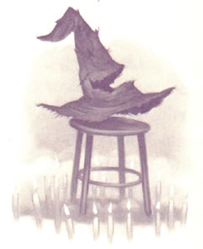

http://srschool.rsgc.on.ca/cdarcy/TIK2O/Robots/Flash/TIK2OHogwarts.html

The driver file is responsible for creating the Hogwarts campus, placing the 20 new wizards (Things) at (2,2), with a HatIcon in one of four colours (black, red, green, or blue).

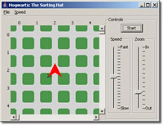  Figure 1. Initial Configuration | 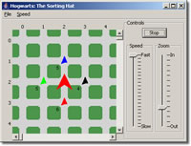  Figure 2. Final Configuration
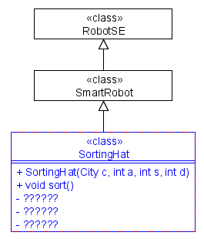
Task. Create a project called Hogwarts and add the driver file, Hogwarts.class and the HatIcon.class file. Also add your SmartRobot class file, SmartRobot.java to the project. You are to develop the SortingHat class, as defined in the UML diagram, that will move the black hats to (3,2), the red hats to (2,3), the green hats to (1,2) and the blue hats to (2,1). Note: All hats must point North on placement. The SortingHat object will return to its original position and orientation when the task is complete.

Assessment. The highest marks will be reserved for those classes that,
- reflect sound Stepwise Refinement strategies
- efficiency (look closely at the sample run-there are no unnecessary turns)
- follow exactly and complete all aspects of this examination

