INSTRUCTIONS TO STUDENTS
- This exam contributes 15% towards your final mark in this course.

- Appropriate coding style and documentation are expected.
- Attach your PoliceDog.java class file to an email to handin entitled 2007 Exam at the end of the exam.
- You are allowed access to Robots folder.
- Internet use is permitted only for the purpose of consulting Becker Robots documentation and the animation at,

http://srschool.rsgc.on.ca/cdarcy/TEE2O/Exams/2007TEEExam.html

Find The Bad Guy

In this project, you are to develop code to enable a PoliceDog object to find a bad guy hiding within the crime scene (City). Following (and picking up) the scent left by the bad guy, the PoliceDog object moves to adjacent intersections until he encounters the criminal. The criminal is a Thing with Icon size less than 0.5.
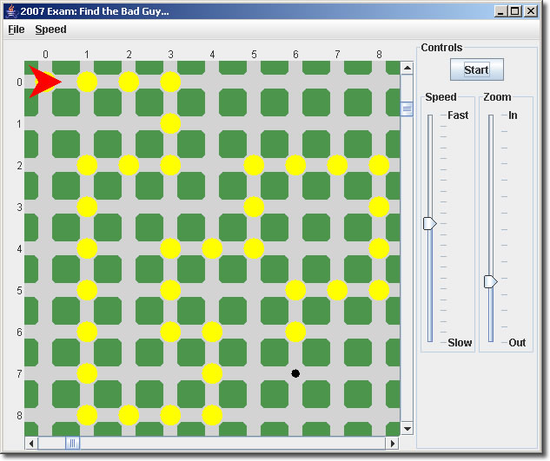
roboDog, our PoliceDog object, picks up the scent at (0,0) in the crime scene. He picks up the scent and moves forward, following the scent until he reaches an intersection without a scent. He is trained to return to the previous intersection and look in each of the remaining three directions to pick up the trail.
As any good law enforcement agent, roboDog always gets his man, and when he does, he sets his label to “WoofWoof”, and waits for backup.

Task
Create a project called Exam2007 and drop in the driver by the same name and CrimeScene.txt files that are provided.

You are to develop and implement the class, PoliceDog, according to the following UML specification,

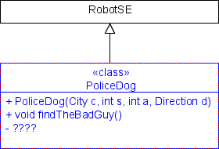

Assessment

The focus of our introduction to Java this year was not about the use of complex methods, or fancy-looking icons (although we dabbled in both), but rather the creation of well-named, robust, single-purpose methods that reflect the problem-solving skills of the author who has broken a large into manageable, bite-sized pieces. The highest marks then, will be reserved for those students that submit a PoliceDog class that,

- reflects sound, well thought out Stepwise Refinement strategies
- superior javadoc-style documentation
- efficiency (look closely at the sample run-there are no unnecessary turns), and,
- follows exactly and complete all aspects of this examination.

