INSTRUCTIONS TO STUDENTS.
- This exam counts for 30% of your final mark in this course.
- Appropriate coding style and documentation are expected.
- It is imperative that you name your files exactly as requested. Attach all (and only) the requested files to your email to handin at the end of the exam.

Julia Sets

You will recall that the Mandelbrot Set consists of the set of points, c, in the Argand (Complex) Plane, whose orbits under the iterative formula, z ← z²+c never reach a magnitude greater than 2.0, where z starts at 0+0i. The algorithm for Julia Sets is very similar in that the orbits are also considered under the iterative formula, z ← z²+c, however c remains fixed over the entire map while,

-2.0 <= Re(z) <= 2.0 and -2.0 <= Im(z) <= 2.0

With Julia Sets it is sufficient to keep the maximum number of iterations reasonable (anywhere from 64 to 256 is plenty). Assigning a colour to a point is similar to the Mandelbrot algorithm. If z does not reach a magnitude of 2 within the allotted number of iterations, colour the point Black, otherwise use the number of iterations to index your palette.

Task. You are to adapt your Mandelbrot project to produce a sequence of 100 jpg frames displaying the sequence of Julia Set images with c ranging from (0.0,0.0) to your specially chosen target below.

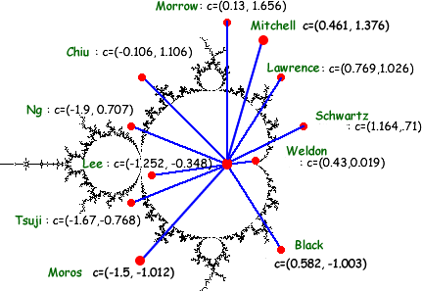

Note. To make it easy for me to mount your video, please name your frames with your last name. For example, Max should name his images, moros_0.jpg, moros_1.jpg, and so on. Go to the URL,

http://darcy.rsgc.on.ca/ICS3M/Exams/ICS3M06Julia.html

to view two sample videos.
Attach all images and all the necessary files for me to recompile and run your application. Documenting the c value for the respective frames allows you to revisit specific coordinates of interest for still images at a later date. To do so, add Java statements similar to,

g.setColor(Color.WHITE);
cString = "c["+zoomLevel+"]=("+df.format(reC)+", "+df.format(imC)+")";
g.drawString(cString,5,HEIGHT-5);

where df is an object declared once as,

java.text.DecimalFormat df = new java.text.DecimalFormat("##.###");

Sample Julia images appear below.

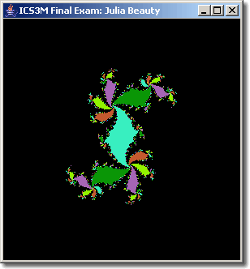  Figure 1. c = 0.38-0.35i; ITERATIONS: 127 | 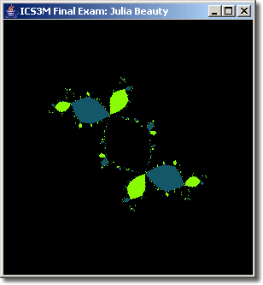  Figure 2. c = -0.123+0.745i; ITERATIONS: 127
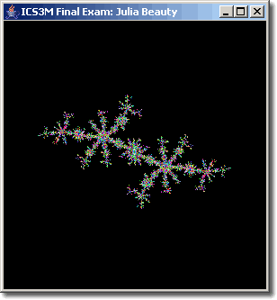  Figure 3. c = -0.6672+0.459i; ITERATIONS: 31 | 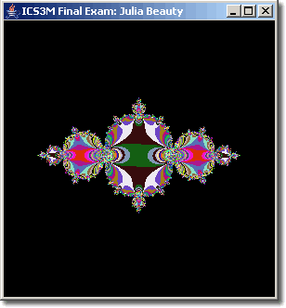  Figure 4. c = -0.765+0.003i; ITERATIONS: 31

