ePumpkin Workshop
Hosted by Cole Norton

Day One: The Blinking Circuit
The focus of the first hour is to assemble a circuit that alternately blinks a pair of orange LEDs. These LEDs will be the pumpkin’s eyes. Here’s a diagram of what you’ll assemble on Day One (all materials supplied),

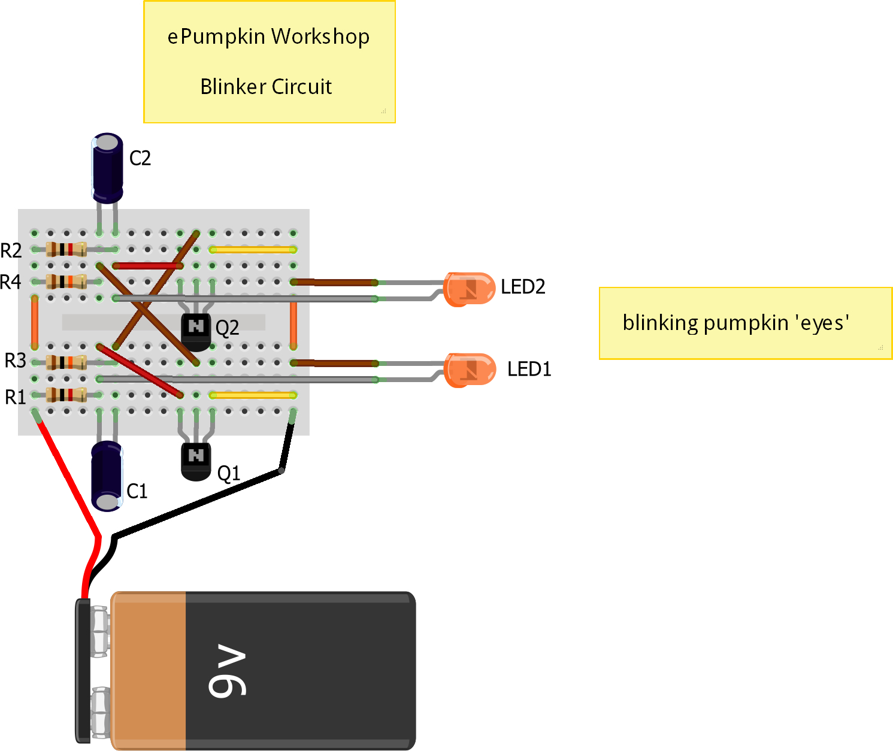

Day Two: Advanced Pumpkin Carving and Installation

The focus of the second hour is to learn and practice some of the tricks-of-the-trade of the master pumpkin carvers as you carve your own pumpkin prior to installing your blinking circuit from Day One. Pumpkins will be provided.
Schematic and Parts List
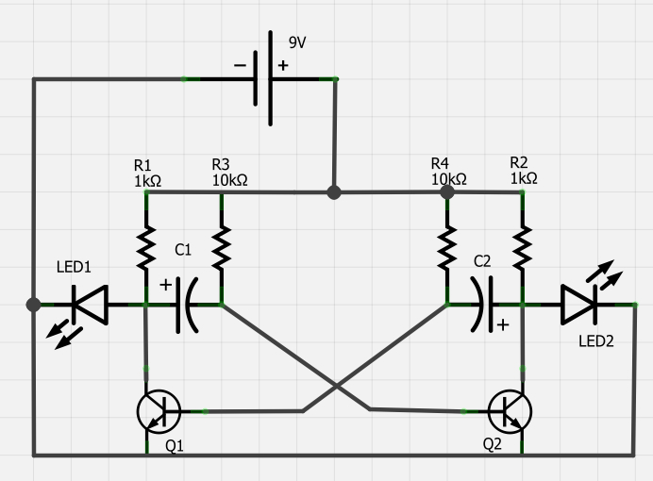
Label | Part Type | Properties
C1 | Electrolytic Capacitor | package 100 mil [THT, electrolytic]; capacitance 0.1mF; voltage 6.3V
C2 | Electrolytic Capacitor | package 100 mil [THT, electrolytic]; capacitance 0.1mF; voltage 6.3V
LED1 | Orange LED - 5mm | package 5 mm [THT]; leg yes; color Orange (620nm)
LED2 | Orange LED - 5mm | package 5 mm [THT]; leg yes; color Orange (620nm)
Q1 | NPN-Transistor | package TO92 [THT]; type NPN
Q2 | NPN-Transistor | package TO92 [THT]; type NPN
R1 | 1k Ω Resistor | package THT; tolerance ±5%; bands 4; resistance 1kΩ; pin spacing 400 mil
R2 | 1k Ω Resistor | package THT; tolerance ±5%; bands 4; resistance 1kΩ; pin spacing 400 mil
R3 | 10k Ω Resistor | package THT; tolerance ±5%; bands 4; resistance 10kΩ; pin spacing 400 mil
R4 | 10k Ω Resistor | package THT; tolerance ±5%; bands 4; resistance 10kΩ; pin spacing 400 mil
VCC1 | Battery block 9V | voltage 9V

