Instructions to TER4M ACES
- This exam contributes 30% towards your final mark.
- Access to your Engineering Report is permitted
- Access to your project files on your laptop is permitted
- Internet access is available for research and reference
- Evaluation will consider correctness and build quality.
- You are to demonstrate your completed prototype and then your permanent circuit to me before leaving the exam. A completed ER submission is to be sent to handin under the Subject Line: Memory by 6 pm tonight.

Memory
The goal of this exam is to construct a permanent working version of Memory. Memory is a recreational activity based on an electronic circuit in which the user is required to remember and recall a random sequence of four red and green flashes in quick succession from a bicolor LED. The user has up to 10s at the end of the sequence to reproduce it by setting each of four switches, from left to right, before submitting his response for confirmation by pressing the TEST switch. If the user’s response is correct, the bicolor LED displays green, otherwise it displays red. A potentiometer (SKILL) can be used to adjust the difficulty of the game by influencing the interval of time between flashes. A RESET switch is used to reboot the microcontroller.

Task

- (10 Marks) (approximately 1 hour) You are to breadboard a standalone prototype of the Memory game from the schematic that appears on the next page using the supplied components. The software has been uploaded to the microcontroller. Rafe can replace the microcontroller on his Arduino with the one provided. Raise your hand when you have completed this stage before bringing your circuit to my desk for a demonstration. Take a photo and video of your working prototype for later inclusion in your ER.
- (15 Marks) (approximately 1 hour) (Matt, Justin, and Kyle) Dismantle the prototype and assemble a permanent circuit on the printed circuit board provided for you. Again, raise your hand when you have completed this stage before bringing your circuit to my desk for a demonstration. (Rafe) Replace the supplied microcontroller with your original and develop the code for the game from scratch using tips found in an email to you.
- (5 Marks) (submitted by 6pm tonight) Add one final Engineering Report entry entitled Final Exam: Memory. Include the sections: Purpose, Reference, Procedure, Schematic, Parts List, and Media. Rafe will also include his documented code. A copy of this exam has been posted to our subject conference to assist with the preparation of your submission. Submit your ER by 6 pm tonight.

The Memory Schematic
A larger screen version of the schematic is available at,

http://darcy.rsgc.on.ca/ACES/TER4M/Exams/images/MemorySchematic.jpg

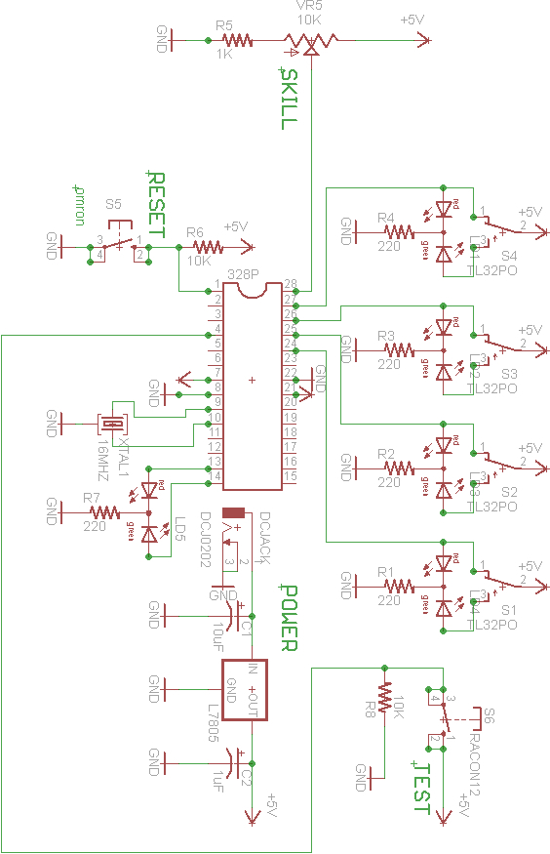
ATMega328P Pin Diagram

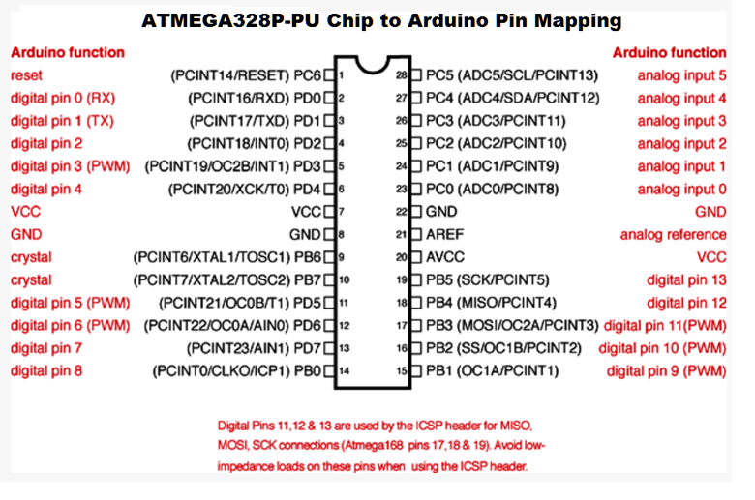

The Parts List

Part Value Device Package Description
328P DIL28-3 DIL28-3 Dual In Line
C1 10uF CPOL-USTAP5-70 TAP5-70 POLARIZED CAPACITOR, American
C2 1uF CPOL-USTAP5-70 TAP5-70 POLARIZED CAPACITOR, American
DCJACK DCJ0202 DCJ0202 DCJ0202 DC POWER JACK
L7805 78XXL 78XXL VOLTAGE REGULATOR
LD1 DUOLED-RG-C DUOLED-C-5MM DUO LED
LD2 DUOLED-RG-C DUOLED-C-5MM DUO LED
LD3 DUOLED-RG-C DUOLED-C-5MM DUO LED
LD4 DUOLED-RG-C DUOLED-C-5MM DUO LED
LD5 DUOLED-RG-C DUOLED-C-5MM DUO LED
R1 220 R-US_0207/10 0207/10 RESISTOR, American symbol
R2 220 R-US_0207/10 0207/10 RESISTOR, American symbol
R3 220 R-US_0207/10 0207/10 RESISTOR, American symbol
R4 220 R-US_0207/10 0207/10 RESISTOR, American symbol
R5 1K R-US_0207/10 0207/10 RESISTOR, American symbol
R6 10K R-US_0207/10 0207/10 RESISTOR, American symbol
R7 220 R-US_0207/10 0207/10 RESISTOR, American symbol
R8 10K R-US_0207/10 0207/10 RESISTOR, American symbol
S1 TL32PO TL32PO TL3XPO TINY SWITCH ON - MOM
S2 TL32PO TL32PO TL3XPO TINY SWITCH ON - MOM
S3 TL32PO TL32PO TL3XPO TINY SWITCH ON - MOM
S4 TL32PO TL32PO TL3XPO TINY SWITCH ON - MOM
S5 10-XX B3F-10XX OMRON SWITCH
S6 RACON12 RACON12 RACON12 ITT SWITCH
VR5 10K TRIM_US-B64Y B64Y POTENTIOMETER
XTAL1 16MHZ 10G7A-12.5KHZ HC49U Resonator

