Digital Logic Gates Constructed from Two NPN Transistors (aka What’s Inside These 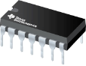 ? )

CONFIGURATION | TWO NPNs in SERIES | TWO NPNs in PARALLEL
Pull DOWN  Resistor  Output | 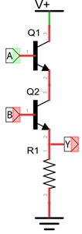  Name: AND  Symbol:  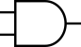  A B Y  0 0 0  0 1 0  1 0 0  1 1 1 | Name: _______  Symbol:  A B Y  0 0  0 1  1 0  1 1
Pull UP  Resistor  Output | 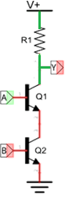  Name: ______  Symbol:  A B Y  0 0  0 1  1 0  1 1 | Name: ______  Symbol:  A B Y  0 0  0 1  1 0  1 1

