INSTRUCTIONS TO JR. ACES
- You have sufficient time to complete the entire task if you remain calm and follow the instructions.
- An electronic copy of this exam can be found attached to the most recent email in our TEL3M First Class subject conference. Download it and place in on your Desktop.
- Be patient, read over all 4 pages of this exam to appreciate the full set of requirements.
- This exam counts for 30% of your final mark in this course.
- Please write your name in the space provide in the header.
- Please keep your work secure at all times.
- In addition to your toolkit, the supplemental parts kit (page 2) contains the necessary parts to assemble the circuit whose schematic appears below. Handle the components with care as replacement parts are not available.
- This is an open examination in that you are free to use your Evil Genius Workbook and the internet for reference purposes only. It remains inappropriate to communicate with anyone.
- When you finish (or when time expires), submit your ER to handin (Subject: Final Exam) and remain seated and quiet until ALL students have had their circuits collected.

This examination requires you to extend your most recent circuit
The NAND Gate Oscillator

and document the results in your Engineering Report.

EVALUATION
You are required to develop a working prototype of the circuit described below and document the outcome in your Engineering Report. Credit will be awarded as follows.

20 Marks. Prototype (Knowledge, Application, Thinking, Inquiry, Problem Solving)
15 a) Works? Credit will be awarded proportionally to the extent your circuit functions as expected.
5 b) Build Quality. Build quality includes layout/arrangement of parts.

10 Marks. Engineering Report (Communication)
7 a) Content. All required elements are included. See below.
3 b) Presentation Skill. These include formatting features (we’ve discussed all year) such as the proper use of styles, pagination, headers & footers, page numbering, image positioning, hyperlinks, table formatting, spelling, grammar, creativity, etc.

MR. D’ARCY’S USE ONLY

PROTOTYPE |  | ENGINEERING REPORT |  | TOTAL
WORKS? | BUILD QUALITY | CONTENT | PRESENTATION SKILL
/15 | /5 | /7 | /3 | /30

SUPPLEMENTAL PARTS KIT
Your supplemental parts kit contains the additional components required to complete the extension of your NAND Gate Oscillator prototype.

QUANTITY | COMPONENT | IMAGE
1 | Hookup Wire Kit
1 | 4510 BCD Up/Down Counter | 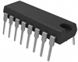
1 | 4511 BCD 7-Segment Decoder
1 | 7-Segment LED Display | 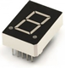
7 | 680Ω 1/4W Fixed Resistor

GENERAL POSITIONING OF THE MAJOR COMPONENTS
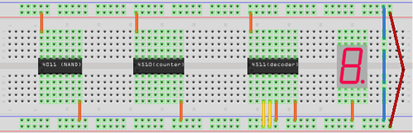

THE PROTOTYPE

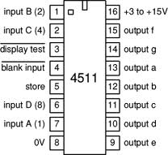
- Currently, the output of your NAND Gate Oscillator circuit generates a clock signal (alternating High/Low) on pin 10 of your 4011 with a frequency determined by RC2 and over a period of time determined by RC1. This clock signal is used as input to pin 15 of a 4516 Up/Down counter. The 4516 uses the clock pulse to maintain an internal 4-bit counter, the state of which it presents on output pins 6, 11, 14, and 2. These signals are currently being used to drive 4 LEDs for visual confirmation of the equivalent hexadecimal (base 16) value of the counter.
- In this examination, you will modify the circuit to present the decimal (base 10) value of the counter on a 7-segment LED display.
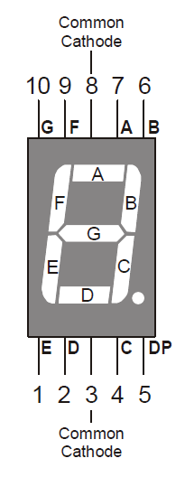
- Whereas the 4516 counter cycles for the full 4 bits (0-15), the 4510 counter cycles in decimal (0-9). Fortunately the pin assigns are identical. Replace the 4516 in your circuit with the 4510. Run the circuit one last time to confirm the decimal count on your four LEDs.
- Remove the four LEDs and their fixed resistors.
- The 4511 BCD 7-segment decoder (above right) takes the 4-bit output of the 4510 as its inputs (input A, B, C, and D). For each 4-bit input, the 4511 determines the correct combination of output pins (Pins 9-15) to drive the seven LEDs on the 7-segment display.
- The pin numbers that correspond to the 7 segments (a through f) are depicted in the image to the right. If each of the output pins of the 4511 is connected to the correct anode pin of each LED in the 7-segment display by a 680Ω fixed resistor, you should see the display cycling the counting from 0-9 for a length of time determined by RC1. View the video. The link is also in the post to our TEL3M subject conference.

http://www.youtube.com/watch?v=4VUk0ijn5wk

PARTIAL SCHEMATIC

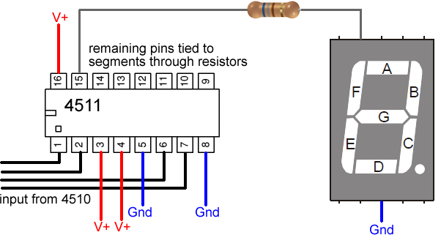

THE TASK

- Prototype. Assemble the prototype as described above to obtain the output highlighted in the video. Be sure to follow good layout design principles.
- Engineering Report. At the top of the first new page after Activity 5. The 3D Christmas Tree, add the entry, Activity 6. Final Exam in Heading 1 style.
- Within Heading 3 style subheadings, include the following
  - Purpose. In your own words explaining what this circuit does.
  - Procedure. Describe the process you undertook to complete this circuit.
  - Parts List. Create a parts list from the information given.
  - General Positioning of Major Components. Obtain a copy of the General Positioning image above and insert it into your ER.
  - Partial Schematic. Obtain a copy of the partial schematic image above and insert it into your ER.
- Photo. Using your laptop, obtain a photo of your working circuit and insert it into your ER, formatting it as you have become accustomed.
- Save your ER and attach it to an email to handin under the Subject Line: Final Exam.
- Remain seated until all circuits have been collected.

----End of Examination----

This concludes our introduction to electrical engineering.
Hopefully, I’ll see many of you in the Grade 11 course, TEI3M.
You can leave all your tools at home on Monday, with the exception of your laptop.

