INSTRUCTIONS TO STUDENT ENGINEERS
- This exam counts for 5% of your final mark in this course.
- Please keep your work secure (covered) at all times.
- Your loot bag contains the necessary parts to build the circuit whose schematic appears below with the exception of a solderless breadboard and wire kit that you will provide. Be gentle with the components. Requests for replacement parts will reduce your score. This includes a replacement battery. When you finish or when time expires, stop working (immediately) and please remain seated until your (all) circuits have been collected.

EVALUATION
4 a) You are required to assemble and test the circuit. Clearly, the majority of the marks are awarded for a working circuit.

1 b) The quality of the assembly will be awarded a maximum of 4 marks.

FUN WITH BARGRAPHS: Introduction
In this examination, you are going to revisit one of your first circuits, The Automatic Night Light. In this early analog Activity, you exploited the concept of a voltage divider as a means to step down a voltage supply. The intent of that project was to light a single LED when the LDR sensed a lack of light. In the final circuit (for this course) you are going to add a digital twist to this analog project.

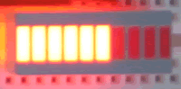
Rather than light a single LED (relying on its intensity to indicate the amount of light) you will to incorporate a sequence of 10 LEDs (packaged as a single component called a bargraph) for your output. The goal of the circuit is to have the number of LEDs lit at any time vary directly with the voltage level available in the ‘middle’ of the voltage divider. Since the 20-pin bargraph is a fairly passive device (similar to the 7-segment display you worked with in that it simply has a set of 10 anode pins on one side of the package and 10 cathode pins on the other), the digital ‘logic’ of this project will have to be performed by an integrated circuit.

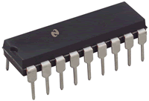
Just as the 4511 IC was specifically designed to drive the 7-segment display, the 18-pin LM3914N IC is specifically designed to drive the bargraph. In a nutshell, here’s how we’ll use the chip to act as a light meter. We’ll wire the ‘middle’ of a voltage divider directly to Pin 5 of the LM3914. The chip compares this voltage level to the overall voltage range it’s working with and, depending on this ratio, turns on as many LEDs as necessary. For example, we continue to use an LDR and a fixed resistor to form our voltage divider. When we cover the LDR completely, all the LEDs on the bargraph will be off. As we slowly allow more light to hit the surface of the LDR, more LEDs will come on until we completely remove the cover and all LEDs are illuminated.

FUN WITH BARGRAPHS: The Schematic
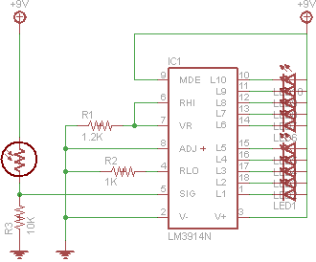
Examine the circuit schematic. The bargraph appears as a set of 10 LEDS on the right. The LM3914N is shown with the pin numbers on the exterior and the function of each pin shown internally. Notice the pins on the bargraph are connected directly to V+ and a pin on the LM3914N, without the need of voltage limiting resistors (this is one of the convenient features of the LM3914N in that the LED resistors are embedded in the chip)

The voltage divider appears on the left, with the ‘middle’ connected to signal Pin 5 on the LM3914N.

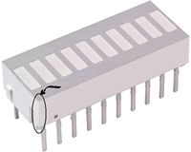
In wiring the circuit, remember 20% of your mark on this part of the exam is for build quality. Pay close attention to the orientation of the two major components. You are quite familiar with how the pin numbering works for ICs. For the bargraph, instead of a reference notch, there is a tiny bevel on one corner as shown in the graphic. This should be taken as Pin 1. Also, as I said earlier, one side of the bargraph in the anode side and one side is the cathode side. You will have to determine which is which through experimentation (caution: don’t blow an LED in your testing-you know how to protect an LED)

OK, wire the circuit and don’t get too excited playing with the animated display (it will disturb the others). When you finish, bring your circuit to the front and I’ll take the photo and video to be included in your CR.

Good luck.

FUN WITH BARGRAPHS: Conclusion
Finally, think of all the possibilities that this project can provide the basis for. Think of the lighting system at concerts that react to sound waves (they’re easily converted to voltage levels). A number of LM3914N ICs can be placed in sequence paired with bargraphs or dot graphs to form longer meters or even pixel boards. This chip is extremely versatile and worth looking into for exciting projects.

