Instruction to Students
- This exam contributes 15% towards your final mark.
- Appropriate coding style and javadoc-style documentation are expected.
- You are allowed access to your former project files on your laptop.
- Internet access is available throughout the exam for the sole purpose of viewing the animation.

Prison Break
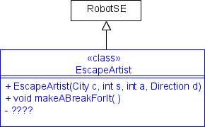
In this exam, you are to break out of a prison. The execution begins with your EscapeArtist object at the center of a prison. The prison is modeled by any number of nested squares (made up of Wall objects) in which each square has a single opening through which you may pass. The single opening may occur in a corner. The inner square is 3×3 with you at the center. The space between each square is one intersection. There is a Thing at the exit of each square. When you encounter a Thing with an icon size greater than 1, you have escaped the prison, at which point you should set the label of the escapee to Freedom and the execution terminates. You can view a sample animation at:

http://darcy.rsgc.on.ca/ACES/TEE2O/Exams/2010RobotsExam.htm

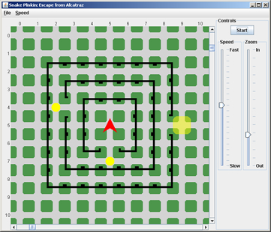

Task
- Read of this exam thoroughly. Review the simulation as often as necessary.
- Create a project called PrisonBreak, and drop in the driver file (PrisonBreak.java) and the sample prison map (Alcatraz.txt). These can be obtained from our subject conference 15 minutes after the start of the exam.
- Develop the class, EscapeArtist, implementing the required elements of the UML diagram on page 1.Using a Stepwise Refinement strategy, coordinate a logical sequence of private method calls to accomplish the activity outlined above.
- Create a new, interesting, prison map called SingSing.txt and test it with a slightly modified driver as necessary.
- Fully javadoc the driver file, PrisonBreak.java and EscapeArtist.java class files.
- In the last 10 minutes, attach your PrisonBreak.java, EscapeArtist.java and SingSing.txt files to an email handin under the Subject Line, PrisonBreak.

Evaluation
The focus of our introduction to Java this term was not about the use of complex methods, or fancy-looking icons (although we dabbled in both), but rather the creation of well-named, robust, single-purpose methods that reflect the problem-solving skills of the author who has broken a large task into manageable, bite-sized pieces. The highest marks then, will be reserved for those students that submit an EscapeArtist class that,

- reflects sound, well-thought-out Stepwise Refinement strategies
- superior javadoc-style documentation
- efficiency, and,
- follows exactly and complete all aspects of this examination

I had a lot of fun this year sharing hardware and software skills with you. For some of you, we get to do it all over again next year!

