Consider the following sketch that configures Timer0, Normal Mode 0.

// PROJECT :Timer0NormalOverflow
// PURPOSE :Register Level implementation of Timer0 Normal Mode 0
// COURSE :ICS4U-E
// AUTHOR :C. D'Arcy
// DATE :2025 12 06
// MCU :328P
// STATUS :Working
// REFERENCE:
// NOTES: Can't use setup & loop as they have already initialized the
// millis() function and, hence, are using ISR(TIMER0_OVF_vect)

#include "prescalers.h" //local library of Timer Prescalers

int main() {
DDRB |= (1 << PB5); //Configure Pin 13 for output
configureTimer0Mode0(); //Timer 0: Normal Mode 0 with
sei(); //enable global Interrupt System
while (1){} //hold
}

ISR(TIMER0_OVF_vect) {
PINB |= (1 << PB5);
}

void configureTimer0Mode0() {
TCCR0A = 0; //Normal Mode 0;
TCCR0B = T0psNone; //Fovf = Fclk/PS
TIMSK0 = (1 << TOIE0); //Timer Overflow Interrupt Enable
}

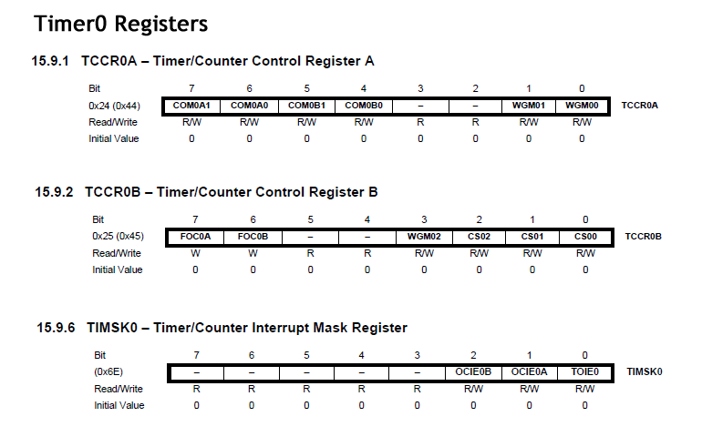

1. Assume an ATmega328p under the following conditions,
- f_{CLK} = 16 MHz
- 8-bit Timer 0 in Normal Mode WGM02:0 = 0 (Mode 0)
- 16-bit Timer 0 in Normal Mode WGM03:0 = 0 (Mode 0)
- ISR for Timer/Counter0 Overflow toggles Pin 13 enabled
- ISR for Timer/Counter1 Overflow toggles Pin 13 enabled
- OCnA and OCnB disconnected
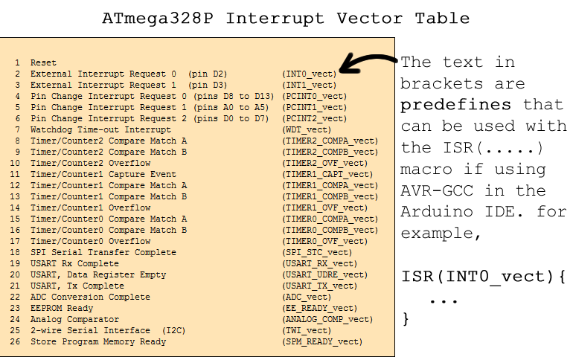

(a) Consider the characteristics of the square wave at Pin 13 and complete the tables below.

  Timer 0 (8-bit)
  Prescaler | Frequency (Hz) | Duty Cycle (%)
  None
  8
  64
  256
  1024
  Timer 1 (16-bit)
  Prescaler | Frequency (Hz) | Duty Cycle (%)
  None
  8
  64
  256
  1024

(b) Create the sketch Timer0NormalOverflow from the code presented. Add the prescalers.h header file from our course page. Run the sketch and satisfy yourself that the calculated frequencies in your Timer0 table above are ‘reasonable’ for the five different prescaler values.

(c) Save the sketch as Timer1NormalOverflow and modify it to run and confirm the same 5 tests for (the 16-bit) Timer1.

(d) Use your handheld scope to confirm a few frequencies for both Timer0 and Timer1.

The square wave generation strategy in the previous exercises suffers from a number of shortcomings that include,

- a limited number of frequency options
- no flexibility for duty cycle
- software-only response to Timer/Counter Event trigger

This next exercise addresses these three issues.

2. Clear Timer on Compare Match (CTC Mode)

Reference: http://darcy.rsgc.on.ca/ACES/Datasheets/ATmega328PTimer1.pdf.

Assume an ATmega328p under the following conditions,
- f_{CLK} = 16 MHz
- 16-bit Timer 1 in Clear Timer on Compare Match (CTC) Mode WGM13:0 = 4 (Mode 4)
- OC1A (Pin 9) under COM1A1:0 = 1
- OC1B (Pin 10) under COM1B1:0 = 0
- OCR1A set to 0x7FFF
- OC1A (Pin 9) configured for output and an LED attached to ground for confirmation
- ISR for Timer/Counter1 Compare Match A disabled (all hardware for this one)
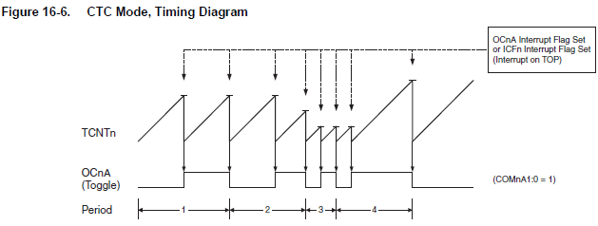
(a) Complete the table under the conditions specified above.

 | 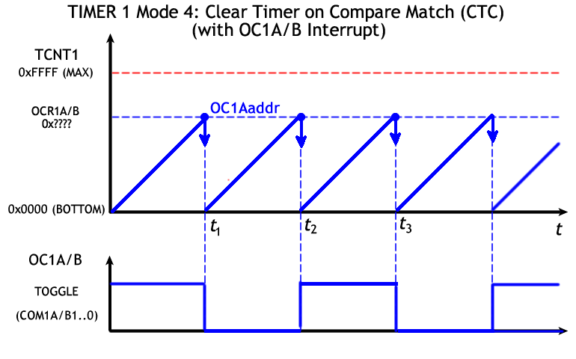  ACES 3.5 mm Audio Jack BoB  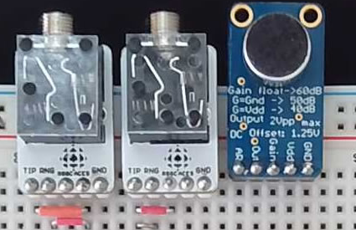
  Timer 1 (16-bit)
  Prescaler | Frequency (Hz) | Duty Cycle (%)
  None
  (T1psNone)
  8
  (T1ps8)
  64
  (T1ps64)
  256
  (T1ps256)
  1024
  (T1ps1024)

(b) Develop and run a register-level sketch Timer1CTCMode4 under the conditions specified above.
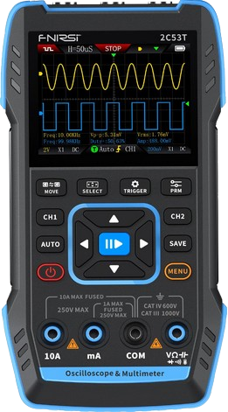
(c) Confirm the results suggested in the table above with your handheld scope. Adjust your calculations as necessary.

(d) The formula for the oscillation frequency, f_{osc}, under these conditions can be expressed as,

$$f_{\text{osc}}=\frac{f_{\text{clk}}}{2×\text{PS} ×(1+\text{OCR1A})}$$

The middle A (Octave 4) has a frequency of 440 Hz. Using a prescaler (PS) of your choice, determine a value for OCR1A, that will provide a 440 Hz square wave signal on OC1A. Adjust your sketch and confirm with your scope.

(e) Using the online tone generator linked from our course page to play 440 Hz. Now, connect OC1A to the Tip pin of your ACES Audio breakout board (see above) plug and listen to the tone on your headphones. Do they match?

(f) Finally, enable an interrupt for the Timer/Counter1Compare Match A event and implement the ISR to toggle the ATmega328p’s onboard LED.
3. Dual Tone Multi Frequency (DTMF)

Reference: https://onlinesound.net/download/frequency-tone-sounds/dtmf

The North American standard for Dual Tone Multi Frequency (DTMF) telephony signals was established in 1963 by Bell Laboratories and remains in use today. Each of the 12 keys were assigned a low and high frequency, paired together on transmission, as summarized in the chart below, right.

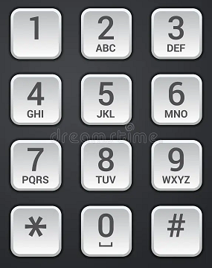 | 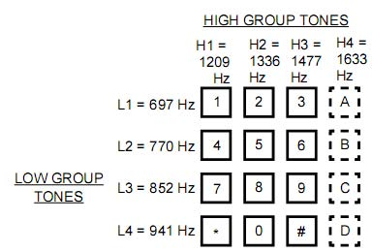

In addition to the frequency pairs for the 12 telephone keys, a fourth column (A, B, C, D) for optional implementation was established as were frequency pairs for Dial Tone (350 Hz and 440 Hz), Ringing Tone (400 Hz and 440 Hz) and Busy Tone (480 Hz and 620 Hz).

(a) Play the Dial Tone file on our ACES web site, http://darcy.rsgc.on.ca/ACES/TEI4M/WaveFormGeneration/DTMFDialTone.mp3

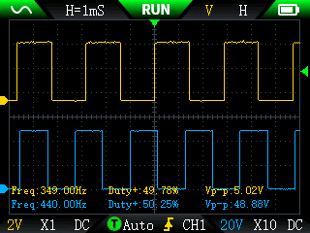
(b) You are asked to recreate the DTMF Dial Tone signal (square waves for now) and confirm it both on your headphones and your scope. Here are my suggestions.

(i) Use Timer1 and Timer2 for the low and high tones, respectively. Leaving Timer0 available for the millis(), micros() and delay() functions is advantageous (ie. the Busy Tone with timed pauses).
(ii) Use the CTC mode. Timer1 (Mode 4) and Timer2 (Mode2).

4. Servo Driving. Fast PWM. Influencing the Duty Cycle.

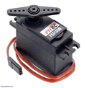
To this point the Normal and CTC Timer modes have limited their influence to frequency alone. In this exercise we’ll investigate modification of the waveform’s duty cycle as well and discover the behaviour behind the Arduino’s high level analogWrite() function to enable Pulse Width Modulation (PWM) waveforms on select MCU pins.

The investigation below focuses on creating a continuous back and forth sweep of the horn of the FS5103B servo you received in your Grade 11 toolkit (https://www.pololu.com/product/3424).

Of the multiple PWM modes provided by the AVR Timers, Timer1 Mode 15 provides the best fit for this purpose. In this mode OCR1A sets the TOP of the counting, thereby affecting the waveform’s frequency. OCR1B determines the duty cycle. Examine the timing diagram below to appreciate how both characteristics are determined.

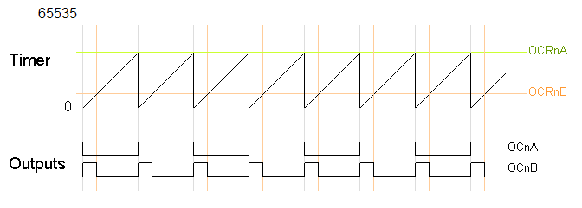
This exercise recreates the OC1B (Pin 10) waveform at the bottom of the graph. The signal wire of your FS5103B servo (white) receives this waveform. Here’s how Timer 1 Mode 15 unfolds,

- Timer1’s counter, TCNT1, counts continuously from 0 to the TOP defined by OCR1A before starting again at 0 (BOTTOM).
- Manipulation of OCR1A defines the frequency.
- For Servo driving, OCR1A should be defined to create a 50 Hz waveform (20 ms period)
- OC1B (Pin 10) is configured to be to set at the BOTTOM and cleared when TCNT1 reaches OCR1B.
- Manipulation of OCR1B defines the duty cycle.
- For correct positioning of the Servo’s horn, OCR1B should be defined to limit the duty cycle to between 5% (0° or 1 ms) and 10% (180° or 2 ms).
- Implementation of the TIMER1_COMPA_OVF interrupt can be used to modify OCR1B, thereby affecting a horn sweep.

Not all servos are precise enough to respond in an identical manner so some experimentation of the high and lower values for OCR1B should be undertaken.
5. AnalogWrite() Revisited. Familiarity with AVR Timer architecture allows us to examine the analogWrite() function more closely.

Each of the three Timers offers one or more Phase Correct Modes in which count both increases and decreases. Compare matches can be triggered in both directions resulting in periods that are half their one-direction counterparts as shown in the graph below.
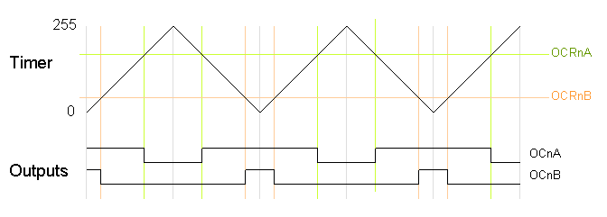

 | Timer 0 | Timer 1 | Timer 2
Digital Pins | 5, 6 | 9, 10 | 3, 11
TCNTn (bits) | 8 | 16 | 8
Timer Mode | Fast PWM (3) | PWM, Phase Correct, 8-bit (1) | PWM, Phase Correct, 8-bit (1)
Clock (MHz) | 16 000 000 | 16 000 000 | 16 000 000
Resolution (steps) | 256 | 256 | 256
Prescaler | 64 | 64 | 64
Frequency (Hz) | 980 | 490* | 490*
* Divided by 2 due to up/down counting of Phase Correct Mode.

Timer0: analogWrite(5, 64) | Timer1: analogWrite(10, 192)
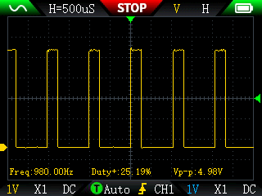 | 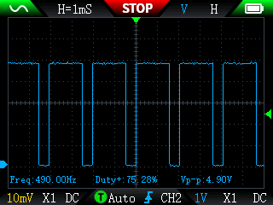

(a) Implement a test sketch that displays the contents of the TCCR2A, TCCR2B, and OCR2B register value after the statement analogWrite(3,127).

(b) Use the results from (a) to develop the sketch Timer2Sweep (register-level as much as possible) that allows the user to control the duty cycle of a PWM signal on OC2B (Pin 3) through the rotation of the shaft of a trim pot. Monitor this on your 2C53T scope.

6. AnalogWrite(): Stable Analog Voltage from Filtered PWM

This investigation ties together numerous concepts introduced in previous years. These include voltage division, capacitor concepts, PWM and DACs to name a few.

“Having a component expect an analog voltage signal and receiving a PWM is similar to
asking for a gentle massage on the head and getting hit with a hammer every 20 seconds
(the average will be the same but… it’s not the same).” – Luis Llamas.

References
- Secrets of Arduino PWM: https://www.righto.com/2009/07/secrets-of-arduino-pwm.html
- Arduino PWM and analogWrite() Explained: https://controllerstech.com/arduino-pwm-analogwrite-tutorial/
- How Low Pass Filters Work: https://www.youtube.com/watch?v=oHKwwvcn77Y
- Analog Output from PWM and a Low Pass Filter: https://www.luisllamas.es/en/analog-output-pwm-low-pass-filter/
- Analog output from PWM and an LPF: https://www.youtube.com/watch?v=Fsb7kxDxYGw
- Digikey Low Pass Filter Calculator: https://www.digikey.ca/en/resources/conversion-calculators/conversion-calculator-low-pass-and-high-pass-filter

Fundamental Concepts
(a) Opposition to current flow by the three passive components is called impedance (Z).
(i) Impedance in resistors is simply called resistance (R).
(ii) Impedance in capacitors is called capacitive reactance (X).
(iii) Impedance in inductors is called inductive reactance (L).
(iv) Impedance is a combination of resistance and reactance and measured in Ohms (Ω).
(v) Impedance lends itself to Ohm’s Law.

(b) The output of a voltage divider constructed from two or more passive components in series (R, L, or C) is of interest here and can be expressed by,

$V_{\text{out}}=V_{\text{in}}×\frac{Z_{2}}{Z_{1}+ Z_{2}}$ (1)

(c) The Grade 10 course introduced the R-R voltage divider concept resulting from two resistors in series under steady DC voltage (below, left). The DC voltage out is given by,

$V_{\text{out}}=V_{\text{in}}×\frac{R_{2}}{R_{1}+ R_{2}}$ (2)
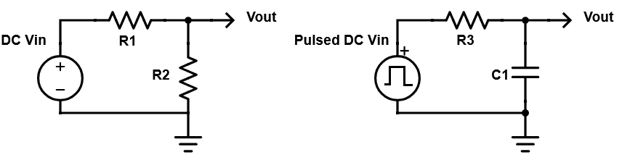

(d) The Arduino’s analogWrite() function produces a bistable, pulsed DC square wave intended to mimic an average analog voltage over the time domain. While not strictly an AC signal in that it does not change polarity, a pulsed DC can be analyzed mathematically as such as a combination of a stable DC offset with ripple (AC component).

(e) Capacitors are frequency dependent in their opposition to current that decreases with increased frequencies. The formula for capacitor reactance is given by,

$X_{C}=\frac{1}{2πfC}$ (3)

(d) Through the use of a properly constructed R-C voltage divider, the square edges of the wave can be made to produce a smooth, constant analog voltage (above, right). This RC configuration is called a (Passive) Low Pass Filter (LPF).

7. Sinusoidal Pulse Width Modulation (SPWM)

The goal of the previous investigation was to generate and maintain a stable analog voltage from a pulsed DC source. Since sinusoidal waveforms have broad applications it would be useful to create one from a similar PWM source.

Reference:
- Sine Look Up Table Generator Calculator: https://www.daycounter.com/Calculators/Sine-Generator-Calculator.phtml

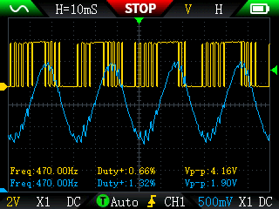
Examine the scope capture to the right. The CH1 trace at the top depicts a PWM signal with varying duty cycle on digital pin 3. Applying a low pass filter to this signal smooths it out into sinusoidal form as captured on CH2.

(a) Use the reference above to generate a Sine Lookup table with 256 points and a maximum amplitude of 255.

(b) Create the sketch SPWM that uses register-level code to establish Fast PWM Mode 3 on Timer2. Configure OC2B to clear on a Compare match. Use a 128 prescaler for now. Monitor the state of OC2B (Pin 3) in CH1.

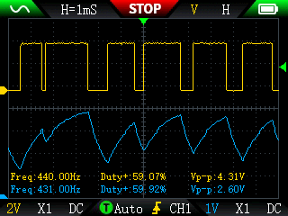
(c) Within the loop() function, increments a count variable by 1 to index the sine lookup table created in step (a). Justify, arithmetically, the scope’s frequency determination.

(d) On your prototype add a low-pass filter (1 kΩ resistor and 10 μF capacitor) to smooth the PWM signal and capture it on CH2. Determine, arithmetically, this filter’s cutoff frequency.

(e) Press the left and right arrows to find the suitable horizontal period of 10 mS.
8. Direct Digital Synthesis (DDS): Sine Wave

This investigation explores a DAC strategy resulting in a sinusoidal waveform from digital input.

Reference:
- How DDS Works: https://www.youtube.com/watch?v=WwHouxujrNc
- Sine Look Up Table Generator Calculator: https://www.daycounter.com/Calculators/Sine-Generator-Calculator.phtml

(a) Watch the Youtube video above.

The only full 8-bit I/O Port on the Nano is the ATmega328p’s PORT D that maps to digital Pins 0 through 7. We’ll use the Sparkfun Pocket Programmer’s on the Nano’s ISP header to have access to the full 8 bits.

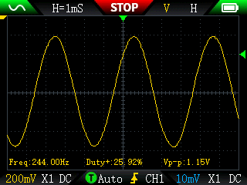
(b) Wire all of PORTD to the R2R Resistor network you have been supplied with (10X-R2R-103LF) and place a 0.1 μF capacitor on the output of the R2R ladder to smooth the waveform (see video). Connect your scope to the output of the R2R ladder.

(c) Create the sketch DDSSineWave. Maximizing the use of register-level code, translate the code provided in the video to create a sine wave similar to the capture to the right. The link above can be used to generate a Lookup Table (LUT) of Sine values that can been impressed upon PORTD. Initially, step through the table with a count value of one.

(d) Add a potentiometer as a voltage divider to your prototype that maps its output to the range from 1 to 8. Use this mapped value as the count value to vary the step size. Monitor the change in frequency on your scope.

Appendix.

Low-Pass Filter

