1. TLD: Two Port
A four-state logic array, with potential denoted by V, is presented cyclically on two ports, A and B. The sequence starts with A and B indexed as shown, with each advancing on every phase. All resistors are 10kΩ.

a) For the schematic provided, complete the table, below right.

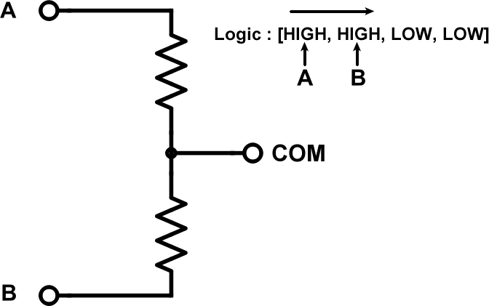 | PHASE A B COM  0  1  2  3  0  1  2  3

b) Graph COM.

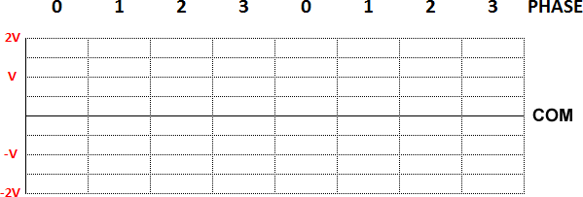

2. TLD: Three Port
The same four-state logic array is presented, cyclically, now on three ports, A, B, and C, with starting indices as shown.

a) For the schematic provided, complete the table, below right.

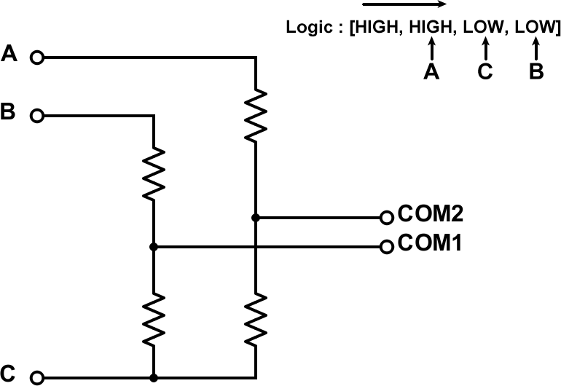 | PHASE A B C COM1 COM2  0  1  2  3  0  1  2  3

b) Graph the COM1 and COM2 output signals on their respective charts.
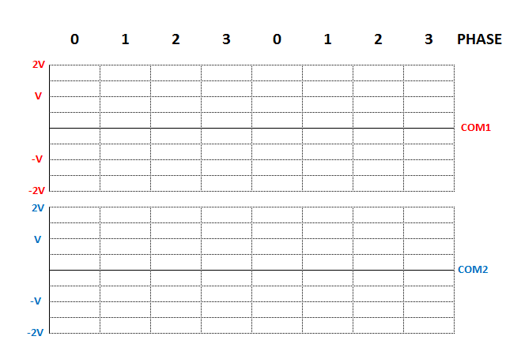
c) Are the two outputs in phase? If yes, by how many degrees are they out of phase?

