LED Flowing Lights SMD Solder Practice Board Instructions (ZY-TP143)
Solder Instructions:
- When soldering, choose a 0.6 mm 63% tin soldering wire. Use 25 w – 35 w soldering iron with conical/knife tip.
- First, solder the components in the 1206 package, then the components in the 0805 package, then the components in the 0603 and 0402 package, and finally the parts in the middle.
- There are 6 columns of solder practice area, they just need the same encapsulation, no need to match the part numbers since this is for practice. The middle area can do things, so matching the part numbers is necessary for the LED flowing lights to work.
- This step just says how to SMD solder using hot air
- Do not solder the LEDs too long, otherwise it will break the LEDs. For polarity of the LEDs and 4148, look at the diagram on the back.
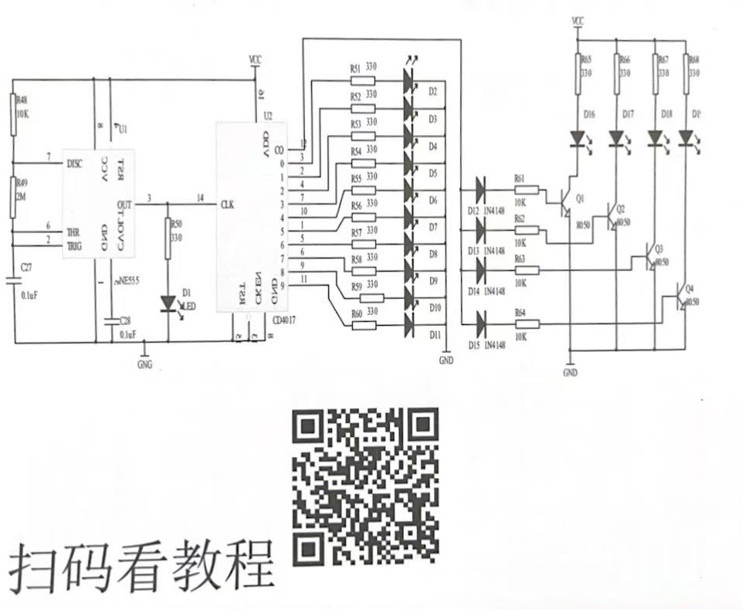

- Circuit Diagram:

Component Placement Map:

Solder Practice Area 4148(Match Polarity using Black Edge) Solder Practice Area
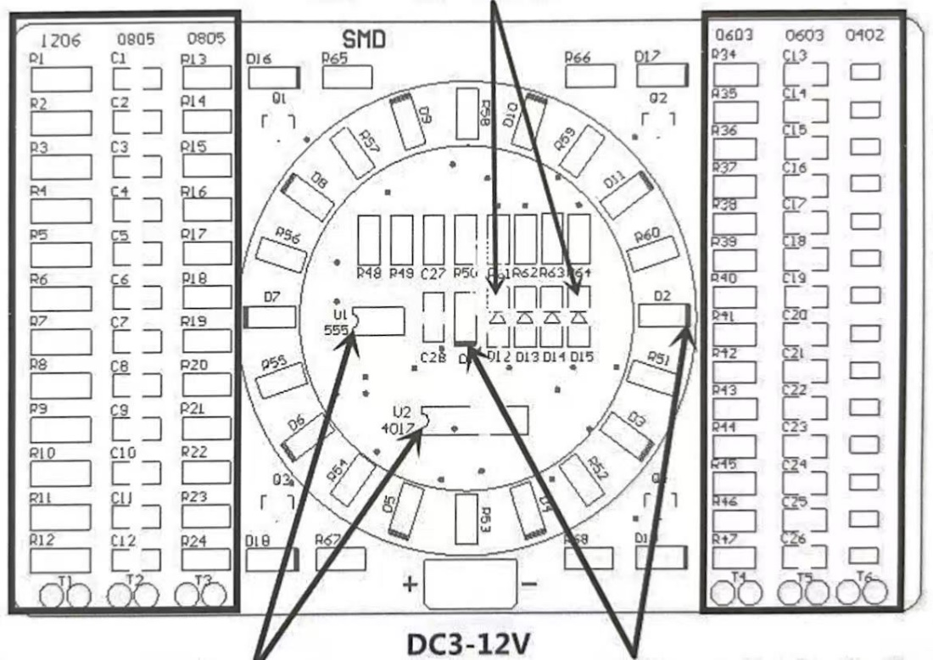

Match Indent on Chip with Indent on Board Match the Green Spot on the LED

Parts List
Encapsulation & Model | Amount | Serial Number
1206 R Solder Practice Area | 12 (1 extra) | First Column on the Left(R1-R12)
0805 C Solder Practice Area | 12 (1 extra) | Second Column on the Left(C1-C12)
0805 R Solder Practice Area | 12 (1 extra) | Third Column on the Left(R13-R24)
0603 R Solder Practice Area | 14 (1 extra) | First Column on the Right(R34-R47)
0603 C Solder Practice Area | 14 (1 extra) | Second Column on the Right(C13-C26)
0402 R Solder Practice Area | 14 (1 extra) | Third Column on the Right
0805 383-499 | 15 (1 extra) | R50-R60/R65-R68
0805 Red | 15 (1 extra) | D1-D11/D16-D19
8050 SOT-23 J3Y | 4 | Q1-Q4
1206 4148 | 4 | D12-D15
0805 10 k | 5 (1 extra) | R48/R61-R64
0805 2 M | 1 (1 extra) | R49
0805 104 | 2 | C27-C28
Sop8 NE555 | 1 | U1
Sop16 CD4017 | 1 | U2
PCB board | 1 | Free Extra Parts are Given for Backup

