// PROJECT  :Timer1FastPWMMode15

// PURPOSE  :Base for the Buck Converter Project

// COURSE   :ICS4U

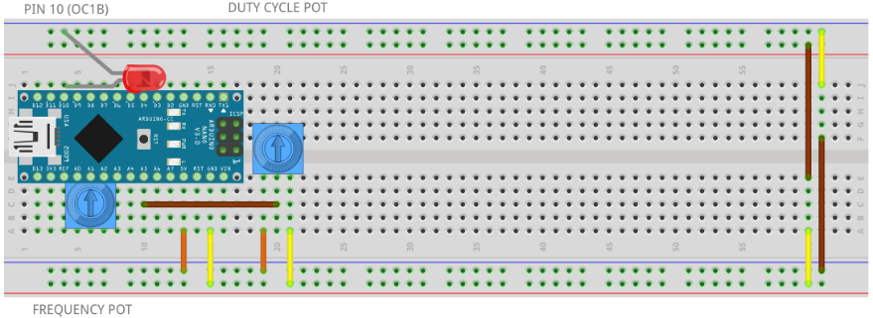// AUTHOR   :C. D'Arcy

// DATE     :2024 12 17

// MCU      :328P

// STATUS   :Working...

// NOTE     :

#include "Support.h"

#define OCR1AMAX 159

#define OCR1BMAX (OCR1AMAX >> 1)

#define PRESCALER T1psNone

#define FREQPIN A1

#define DUTYPIN A5

void setup() {

  Serial.begin(9600);

  while (!Serial);

  pinMode(A0, OUTPUT);      //support for optional FREQuency pot (OCR1A)

  pinMode(A2, OUTPUT);      //

  digitalWrite(A0, LOW);    //

  digitalWrite(A2, HIGH);   //

  configureTimer1Mode15();  //Fast PWM with OCR1A as TOP with 50% duty cycle

}

void configureTimer1Mode15() {

  DDRB |= 1 << PB2;         //pinMode(10, OUTPUT);        OCR1B

  //DDRB |= 1<<PB1;         //optional  pinMode(9, OUTPUT); OCR1A

  //  WGM parameters for Fast PWM Mode 15

  // Place an LED on Pin 10 (PB2). Observe. Measure frequency with a DMM...

  TCCR1A = _BV(COM1A1) | _BV(COM1B1) | _BV(WGM11) | _BV(WGM10);  // non-inverting mode

  // Set prescaler and further WGM parameters for Fast PWM Mode 15

  TCCR1B = _BV(WGM13) | _BV(WGM12) | PRESCALER;

  // Formula for calculating OCR1A for 100Hz with prescaler of 1 chosen:

  //  f = Fclk/(1*(OCR1A + 1)) -> OCR1A = (16000000/(100000*1))-1 = 159

  OCR1A = OCR1AMAX;

  OCR1B = OCR1BMAX;  // |___|___|___ ...

}

void loop() {

  // OCR1A = map (analogRead(FREQPIN),0,1024,0,65536);

  // Serial.println(OCR1A);

  // Serial.println(analogRead(DUTYCYCLE));

  //employ a pot to adjust the duty cycle (OCR1B)

   OCR1B = map(analogRead(DUTYPIN), 0, 1024, 0, OCR1A);

}