Efficient code design goes hand-in-hand with optimum data design. In this review, we examine how J. Dolgin’s efficient Arduino C design can be reworked into a similar GPIO Register-Level strategy.

Watch Microchip’s 1:55 minute video summary of the 8-bit AVR Port/Pin manipulation:
https://www.youtube.com/watch?v=bDPdrWS-YUc

1. Arduino C Version
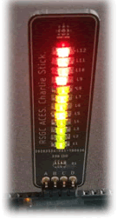

// PROJECT :CharlieStick
// PURPOSE :Create an animation for the ACES CharlieStick
// COURSE :ICS4U
// AUTHOR :J. Dolgin
// DATE :2019 10 25
// MCU :328P
// STATUS :Working

#define PinCon 0 //Column 0: I/O Direction (INPUT/OUTPUT)
#define PinState 1 //Column 1: Signal State (HIGH/LOW)
#define LED_COUNT 12 //Number of LEDs on the CharlieStick
#define numPin 4 //How many pins are used for the stick

uint8_t stick[] = {10, 11, 12, 13}; //What pins are being used
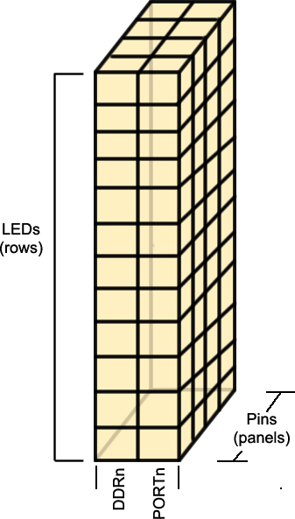
uint8_t configuration[LED_COUNT][2][numPin] = {
{ { INPUT, INPUT, OUTPUT, OUTPUT }, { LOW, LOW, LOW, HIGH } }, // 1
{ { INPUT, INPUT, OUTPUT, OUTPUT }, { LOW, LOW, HIGH, LOW } }, // 2
{ { INPUT, OUTPUT, OUTPUT, INPUT }, { LOW, LOW, HIGH, LOW } }, // 3
{ { INPUT, OUTPUT, OUTPUT, INPUT }, { LOW, HIGH, LOW, LOW } }, // 4
{ { OUTPUT, OUTPUT, INPUT, INPUT }, { LOW, HIGH, LOW, LOW } }, // 5
{ { OUTPUT, OUTPUT, INPUT, INPUT }, { HIGH, LOW, LOW, LOW } }, // 6
{ { INPUT, OUTPUT, INPUT, OUTPUT }, { LOW, LOW, LOW, HIGH } }, // 7
{ { INPUT, OUTPUT, INPUT, OUTPUT }, { LOW, HIGH, LOW, LOW } }, // 8
{ { OUTPUT, INPUT, OUTPUT, INPUT }, { LOW, LOW, HIGH, LOW } }, // 9
{ { OUTPUT, INPUT, OUTPUT, INPUT }, { HIGH, LOW, LOW, LOW } }, // 10
{ { OUTPUT, INPUT, INPUT, OUTPUT }, { LOW, LOW, LOW, HIGH } }, // 11
{ { OUTPUT, INPUT, INPUT, OUTPUT }, { HIGH, LOW, LOW, LOW } } // 12
};

void setup() {}

void loop() {
for (uint8_t l = 0; l < LED_COUNT-1; l++) { //Runs as many times as there are LEDs
for (uint8_t i = 0; i < numPin; i++) { //Runs as many times as the pins on the stick
digitalWrite(stick[i], configuration[l][PinState][i]); //Sets the pin state first!
pinMode(stick[i], configuration[l][PinCon][i]); //Sets the pin configuration
}
delay(100);
}
for (uint8_t l = LED_COUNT-1; l > 0; l--) { //Counts back down
for (uint8_t i = 0; i < numPin; i++) {
digitalWrite(stick[i], configuration[l][PinState][i]); //Sets the pin state first!
pinMode(stick[i], configuration[l][PinCon][i]); //Sets the pin configuration
}
delay(100);
}
}

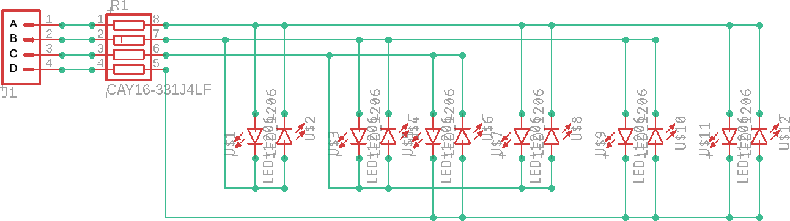

Tasks
Reference the CharlieStick EAGLE schematic above for the tasks you are about to undertake. With your CharlieStick in the same position as the previous sketch, supply logic level (0 or 1) for EACH of the empty register bits to accomplish the requested task.

a) Turn on only LED1.

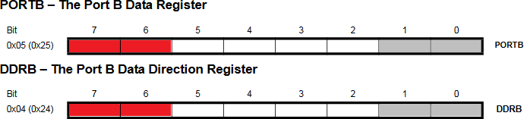

b) Turn on only LED4.

c) Turn on only LED12.

2. Register-Level Version

Copy the code shell below and let’s use it to optimize JD’s high-level Arduino C code from page 1.

// PROJECT :SimonStickRegisterLevelUNO
// PURPOSE :Register-level demonstration of ACES’ Charlieplexed SimonStick
// DEVICE :UNO + SimonStick
// AUTHOR :J. Dolgin, C. D'Arcy
// DATE :2020 01 30
// MCU :328P
// COURSE :ICS4U
// STATUS :Not Working

#define PORT PORT?
#define DDR DDR?
#define pinA 1<<?
#define pinB ?
#define pinC ?
#define pinD ?
uint8_t pinMask = pinA | pinB | pinC | pinD; //compose a convenient mask

struct LED { //TIGHT binding of related GPIO registers
uint8_t port;
uint8_t ddr;
};

LED stick [] = {
{pinA, pinA | pinB}, //this should get only LED1 to turn on
?,?,…,?
};
uint8_t ledCount = sizeof(stick) / sizeof(LED);

void setup() {}

void loop() {
for (uint8_t i = 0; i < ledCount; i++) {
?
}
for (uint8_t i = ledCount-1; i > 0; i--) {
?
}
}

3. Your Turn! DDP: CharlieStick with TMP36

Capitalize on your understanding of the previous discussion to have your CharlieStick respond (in bar mode) to the user pinching the TMP36 sensor. (have it range from room temperature to the maximum healthy human)

http://darcy.rsgc.on.ca/ACES/TEI4M/DolginDevPlatform/index.html#SimonStick

You are asked to complete this for homework and bring your prototype to our next class for a demonstration.

