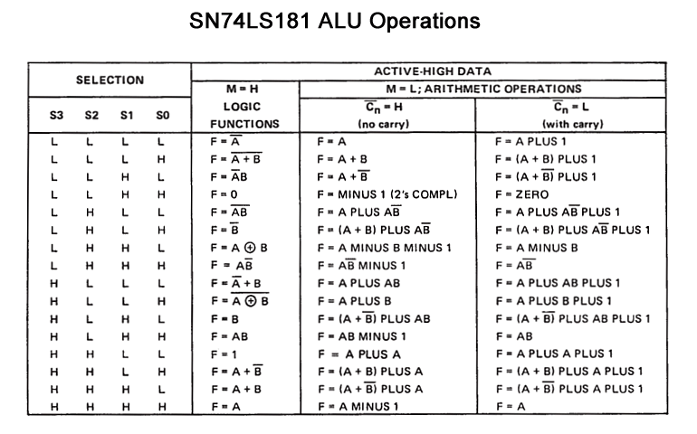
//Ensure EEPROM_PAGE set to LOW (Page 0)
#define PAGE LOW
byte code [] = {//Common 2020/2021 Control Codes
// REF: http://www.righto.com/2017/03/inside-vintage-74181-alu-chip-how-it.html
// SSSSMCAR/W //S3..S0-Select, M-Mode, C-Carry, A-Accum, R/W-Addr Read/~Write
0b10101000, //0xA8 0000 LOAD const ALU:B
0b10101001, //0xA9 0001 LOAD IT ALU:B
0b10010101, //0x95 0010 ADD const ALU:A plus B
0b10010101, //0x95 0011 ADD IT ALU:A plus B
0b01100001, //0x61 0100 SUBTRACT const ALU:A minus B
0b01100001, //0x61 0101 SUBTRACT IT ALU:A minus B
0b00000010, //0x02 0110 STORETO const ALU:ignore
0b00000010, //0x02 0111 STORETO IT ALU:ignore
0b00000011, //0x03 1000 READ const ALU:ignore
0b00000011, //0x03 1001 READ IT ALU:ignore
//--------------------------------------------------------
// Place USER function here pushing branch instructions
// ie Shift Left instruction exploiting the ALU function: A PLUS A
0b11000100, //0xC5 1010 SHL const ALU:A PLUS A
0b11000100, //0xC5 1011 SHL IT ALU:A PLUS A
//-------------------------------------------------------
// Generate a Logic 1 on F0..F3, disable the Accum
0b11001011, //0xCB 1100 GOTO const ALU:Logic 1 Z Flag to PC’s LOAD
0b11001011, //0xCB 1101 GOTO IT ALU:Logic 1 Z Flag to PC’s LOAD
// Generate a NOT A on F0..F3, disable the Accum
0b00001011, //0x0B 1110 IFZERO const ALU:Not A
0b00001011 //0x0B 1111 IFZERO IT ALU:Not A
};
