Here is an excerpt from K. Shirriff’s blog, Inside the vintage 74181 ALU chip: how it works and why it's so strange (https://www.righto.com/2017/03/inside-vintage-74181-alu-chip-how-it.html)
The 16 Boolean logic functions
There's actually a system behind the 74181's set of functions: the logic functions are the 16 possible Boolean functions f(A,B). Why are there 16 possible functions? If you have a Boolean function f(A,B) on one-bit inputs, there are 4 rows in the truth table. Each row can output 0 or 1. So there are 2⁴ = 16 possible functions. Extend these to 4 bits, and these are exactly the 16 logic functions of the 74181, from trivial 0 and 1 to expected logic like A AND B to contrived operations like NOT A AND B. These 16 functions are selected by the S0-S3 select inputs.
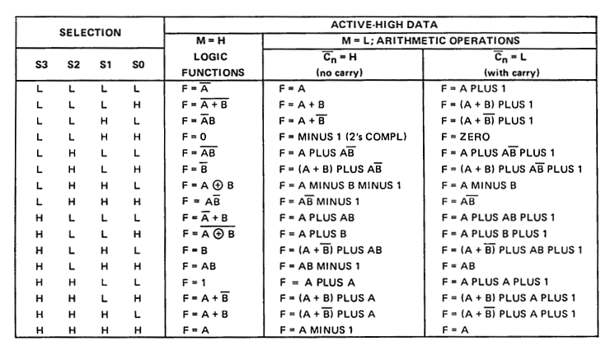
Table 1. Shirriff
Here is similar summary taken from M. Mano’s Digital Design 5e text that we’ll examine more closely in the third term,
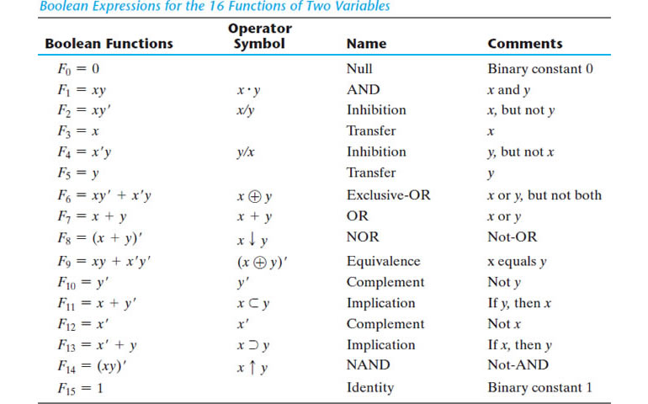
Table 2. Mano

Task. Using the order of functions listed in Shirriff’s Table 1 and the names from Mano’s Table 2, complete the 16 truth tables below. Insert this into your DER within the ALU Report Summary.
  Complement
  F₀ |  | B
   |  | 0 | 1
  A | 0 | 1 | 1
  A | 1 | 0 | 0
  F₁ |  | B
   |  | 0 | 1
  A | 0
  A | 1
  F₂ |  | B
   |  | 0 | 1
  A | 0
  A | 1
  F₃ |  | B
   |  | 0 | 1
  A | 0
  A | 1
  F₄ |  | B
   |  | 0 | 1
  A | 0
  A | 1
  F₅ |  | B
   |  | 0 | 1
  A | 0
  A | 1
  F₆ |  | B
   |  | 0 | 1
  A | 0
  A | 1
  F₇ |  | B
   |  | 0 | 1
  A | 0
  A | 1
  F₈ |  | B
   |  | 0 | 1
  A | 0
  A | 1
  F₉ |  | B
   |  | 0 | 1
  A | 0
  A | 1
  F₁₀ |  | B
   |  | 0 | 1
  A | 0
  A | 1
  F₁₁ |  | B
   |  | 0 | 1
  A | 0
  A | 1
  F₁₂ |  | B
   |  | 0 | 1
  A | 0
  A | 1
  F₁₃ |  | B
   |  | 0 | 1
  A | 0
  A | 1
  F₁₄ |  | B
   |  | 0 | 1
  A | 0
  A | 1
  F₁₅ |  | B
   |  | 0 | 1
  A | 0
  A | 1

