To best support your post-RSGC goals and aspirations I would ask you to provide me with some feedback at the start of our final course together. It is natural for your plans to change over the course of the year as your interests adapt and realities become clearer, so expect that I will check in from time to time to ensure I am providing you with the best possible support you need to achieve your dreams.
1. Your Name

2. Domain Preferences
Position a dot within the triangle below that best reflects your current relative interest in ACES’ three major domains.

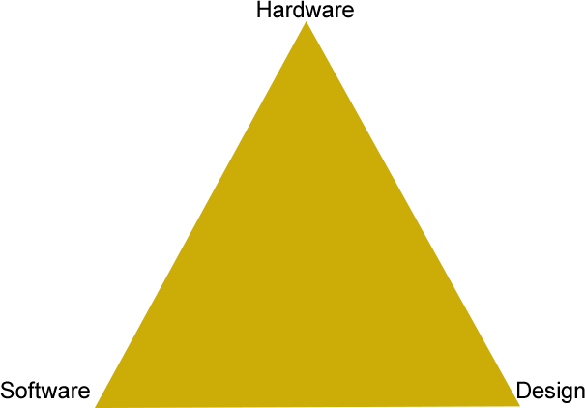

3. University and Program
Indicate the September aspirations for the three universities and programs at the top of your list for next fall.

1. University: Program:

2. University: Program:

3. University: Program:

4. Day 1 Courses
Please list the courses you take on Cycle 1, Day 1, by period.

1. Hardware

2.

3.

4.

