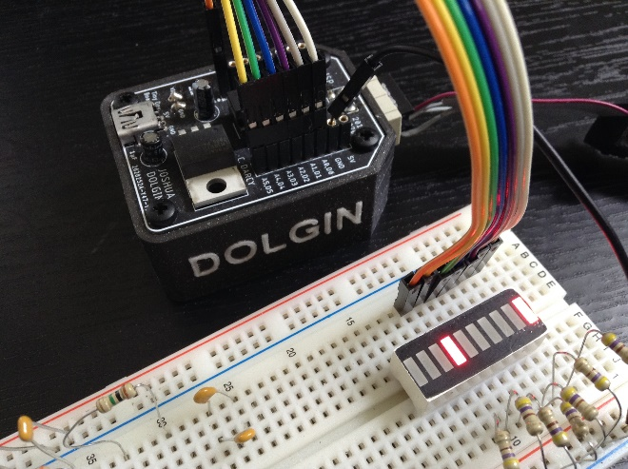
ATMEL Studio 7 (Variables.asm)

;PROJECT :Variables84
;PURPOSE :INITIAL introduction to variables in SRAM
;AUTHOR :C. Darcy
;DATE :2020 04 16
;DEVICE :Dolgin Development Platform
;MCU :ATtiny84
;COURSE :ICS4U
;STATUS :Working
.def util = r16 ;use aliases Registers
.def alt = r17 ;alternate register
.equ DDR = DDRA ;we'll need DDRA and
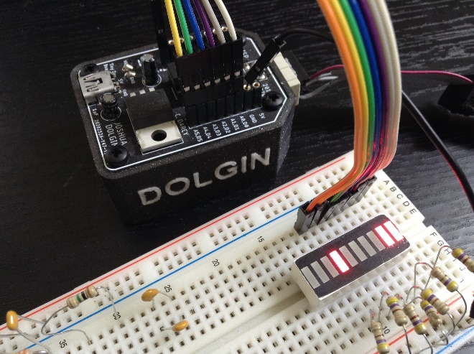
.equ PORT = PORTA ;PORTA

; DATA Segment declarations
.dseg
.org 0x0100 ;locate for SRAM
vars: .BYTE 4 ;reserve 4 bytes

; CODE Segment (default)
.cseg ;locate for FLASH
; ***** INTERRUPT VECTOR TABLE ******************
.org 0x0000 ;start of (IVT)
rjmp main ;highest priority!

.org 0x0011 ;locate just beyond 84's 17 (word) size IVT
varp:
.db 'A' ;AVR-ASM2 uses .DB instead of .BYTE

; ***** START OF CODE ********************************************************
.org 0x0100 ;well clear of IVT
main: ;PC jumps to here (start of code) on reset interrupt...
ser util ;prepare to set ALL port bits for output
out DDR,util ;set ddr pins for output

;let's assign a value to an SRAM Variable...
ldi util,'A' ;note acceptable use of character constants
sts vars,util ;assign the register contents to the SRAM address
ldi util,'C' ;load a different constant
sts vars+1,util ;store it in the byte of the address in SRAM

;OK, let's read the contents of an SRAM location
lds alt,vars ;load a register with the value in the SRAM address
out PORT,alt ;dump it on the PORT to confirm it visually
rcall delay1s ;admire...

lds alt,vars+1 ;load a register with the value in a different SRAM address
out PORT,alt ;dump ACSII value on the PORT to confirm it visually
rcall delay1s ;admire...
rjmp main ;repeat...
ret

delay1s:
ldi r18, 41
ldi r19, 150
ldi r20, 128
L1: dec r20
brne L1
dec r19
brne L1
dec r18
brne L1
ret

Arduino IDE (Variables.S)
// PROJECT :Variables
// PURPOSE :INITIAL introduction to variables in Data Memory(SRAM)
// COURSE :ICS4U
// AUTHOR :C. D'Arcy
// DATE :2020 04 16
// MCU :84
// STATUS :Working
// REFERENCE:http://darcy.rsgc.on.ca/ACES/TEI4M/Assembly/AVR8AssemblyLanguage.html
#include <avr/io.h> //required to reference ports (-0x20 offset required)
#define util r16 //improve readability with aliases
#define alt r17 //alternate register
.equ OFFSET, 0x20 //avr-as requires offset address for PORTS
.equ PORT,PORTA-OFFSET //328P: 0x28 (C)
.equ DDR, DDRA-OFFSET //328P: 0x27 (C)
.equ PIN, PINA-OFFSET //328P: 0x26 (C)
.section .data ;SRAM segment directive (.section is optional)
.org 0x060 ;0x060 is first available address beyond register space
vars:
.byte 4 ;reserves # of byte(s) of SRAM storage

.section .text ;FLASH (PROGMEM) directive. (.section is optional)
.org 0 ;set the Program Counter (PC) to the start of program memory (IVT)
rjmp main ;jump to the beginning of executable code

.org 0x11 ;set the Program Counter (PC) beyond the start of the 84's IVT
varp: ;create a label (address) in which to place constants
.byte 'A' ;example of a variable stored in Program memory

.org 0x100 ;places code at a specific location (this is sufficient)
.global main ;eliminates Arduino C requirement of setup & loop functions
main:
ser util ;prepare to set ALL port bits for output
out DDR,util ;set ddr pins for output

;let's assign a value to an SRAM Variable...
ldi util,'A' ;note acceptable use of character constants
sts vars,util ;assign the register contents to the SRAM address
ldi util,'C' ;load a different constant
sts vars+1,util ;store it in the byte of the address in SRAM

;OK, let's read the contents of an SRAM location
lds alt,vars ;load a register with the value in the SRAM address
out PORT,alt ;dump it on the PORT to confirm it visually
rcall delay1s ;admire...

lds alt,vars+1 ;load a register with the value in a different SRAM address
out PORT,alt ;dump ACSII value on the PORT to confirm it visually
rcall delay1s ;admire...
rjmp main ;repeat...
ret

delay1s:
ldi r18, 41
ldi r19, 150
ldi r20, 128
L1: dec r20
brne L1
dec r19
brne L1
dec r18
brne L1
ret

