ATMEL Studio 7 (Variables.asm)

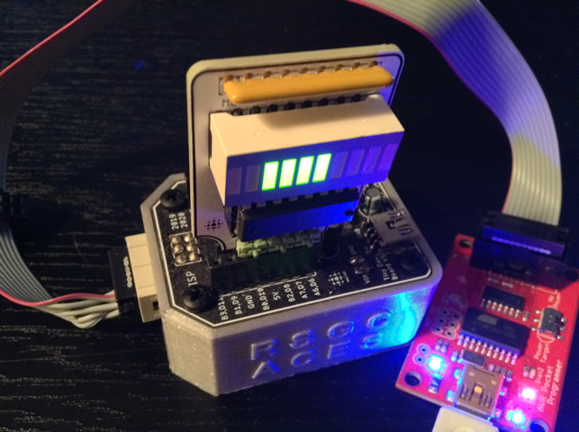
;PROJECT :Shiftout (Solution)
;PURPOSE :ICS4U RSGC ACES Project (link below)
;AUTHOR :C. D'Arcy
;DATE :2020 04 19
;DEVICE :Dolgin Development Platform
;MCU :ATtiny84
;COURSE :ICS4U
;STATUS :Working
;REFERENCE :https://mail.rsgc.on.ca/~cdarcy/Datasheets/doc0856.pdf
;NOTES :http://darcy.rsgc.on.ca/ACES/TEI4M/1920/Tasks.html#shiftout
.def util = r16 ;utility register
.def value = r17 ;holds the value to be displayed
.def mask = r18 ;byte with one set bit to act as a mask
.def dir = r19 ;shift direction: LSBFIRST:0, MSBFIRST:1
.equ OE = PA6 ;595 output enable pin
.equ LATCH = PA7 ;595 latch pin
.equ DATA = PB2 ;595 data pin
.equ CLOCK = PB0 ;595 clock pin
.equ n = 0xF0 ;constant to be presented in binary on the bargraph
.equ LSBFIRST= 0 ;same familiar constants from Arduino days
.equ MSBFIRST= 1 ;ditto
; CODE Segment (default)
.cseg ;locate for Code Segment (FLASH)
; ***** INTERRUPT VECTOR TABLE ***********************************************
.org 0x0000 ;start of Interrupt Vector Table (IVT) aka. Jump Table
rjmp reset ;lowest interrupt address == highest priority!
; ***** START OF CODE ********************************************************
.org 0x0100 ;well clear of IVT

reset: ;PC jumps to here (start of code) on reset interrupt
ldi util,1<<LATCH|1<<OE ;create an OR'ed flag set for output pins
out DDRA,util ;set 'em
ldi util,1<<DATA|1<<CLOCK ;create an OR'ed flag set for output pins
out DDRB,util ;set 'em
;ready to shift n, simply request shift order: either LSBFIRST or MSBFIRST
ldi dir,MSBFIRST ;change this manually (M or L)
rcall shiftout ;invoke the shiftout function
wait: ;done!
rjmp wait ;hold...finished
shiftout: ;shifts constant n into MBv3
ldi mask,0x80 ;assume order is MSBFIRST
sbrs dir,0 ;if bit 0 is set, it's MSBFIRST
ldi mask,0x01 ;OK, it's LSBFIRST so redefine the mask
cbi PORTA,LATCH ;pull LATCH pin LOW
again:
cbi PORTB,CLOCK ;pull CLOCK pin LOW
ldi value,n ;reload the value to be presented
and value,mask ;mask off the target bit
breq lo ;was it 0?
sbi PORTB,DATA ;no, so pull DATA pin HIGH
rjmp clockit ;ready to clock the 1
lo: cbi PORTB,DATA ;else, it was a 0, so pull DATA pin LOW
clockit:
sbi PORTB,CLOCK ;pull CLOCK pin HIGH
; hmmm, must decide what direction to shift the mask...
sbrs dir,0 ;if bit 0 is set, it's MSBFIRST
rjmp shiftLeft ;OK, it's LSBFIRST
lsr mask ;MSBFIRST so shift the mask right
brne again ;repeat if there are still more bits to stuff in
rjmp done ;we're done, so only one more thing to do
shiftLeft:
lsl mask ;LSBFIRST, so shift the mask left
brne again ;repeat if there are still more bits to stuff in
done:
sbi PORTA,LATCH ;pull LATCH pin HIGH to present internal
ret ;finished, return.

Arduino IDE (Variables.S)
;PROJECT :Shiftout (Solution)
;PURPOSE :Response to 2019-2020 ICS4U Project (link below)
;AUTHOR :C. D'Arcy
;DATE :2020 04 19
;DEVICE :Dolgin Development Platform
;MCU :ATtiny84
;COURSE :ICS4U
;STATUS :Working
// REFERENCE:http://darcy.rsgc.on.ca/ACES/TEI4M/Assembly/AVR8AssemblyLanguage.html
// REFERENCE:http://darcy.rsgc.on.ca/ACES/TEI4M/1920/Tasks.html#shiftout
#include <avr/io.h> //required to reference ports by name (-0x20 offset)
#define util r16 //improve readability with aliases
#define value r17 //alternate register
#define mask r18 //byte with one set bit to act as a mask
#define dir r19 //shift direction: LSBFIRST:0, MSBFIRST:1
.equ OFFSET, 0x20 ;avr-as requires offset address for PORTS
.equ PRTA, PORTA-OFFSET ;0x3B – 0x20 = 0x1B
.equ DRA, DDRA-OFFSET ;0x3A – 0x20 = 0x1A
.equ PRTB, PORTB-OFFSET ;0x38 – 0x20 = 0x1A
.equ DRB, DDRB-OFFSET ;0x37 – 0x20 = 0x17
.equ OE, PA6 ;595 output enable pin
.equ LATCH, PA7 ;595 latch pin
.equ DATA, PB2 ;595 data pin
.equ CLOCK, PB0 ;595 clock pin
.equ n, 0xF0 ;constant to be presented in binary on the bargraph
.equ LSBFIRST, 0 ;same familiar constants from Arduino days
.equ MSBFIRST, 1 ;ditto
; CODE Segment (default)
.text ;locate for Code Segment (FLASH)
; ***** INTERRUPT VECTOR TABLE ***********************************************
.org 0x0000 ;start of Interrupt Vector Table (IVT) aka. Jump Table
rjmp main ;lowest interrupt address == highest priority!
; ***** START OF CODE ********************************************************
.org 0x0100 ;well clear of IVT
.global main
main:
ldi util,1<<LATCH|1<<OE ;create an OR'ed flag set for output pins
out DRA,util ;set 'em
ldi util,1<<DATA|1<<CLOCK;create an OR'ed flag set for output pins
out DRB,util ;set 'em
;ready to shift n, simply request shift order: either LSBFIRST or MSBFIRST
ldi dir,MSBFIRST ;change this manually (M or L)
rcall shiftout ;invoke the shiftout function
wait: ;done.
rjmp wait ;hold...finished!
shiftout: ;shifts constant n into MBv3
ldi mask,0x80 ;assume order is MSBFIRST
sbrs dir,0 ;if bit 0 is set, it's MSBFIRST
ldi mask,0x01 ;OK, it's LSBFIRST so redefine the mask
cbi PRTA,LATCH ;pull LATCH pin LOW
again:
cbi PRTB,CLOCK ;pull CLOCK pin LOW
ldi value,n ;reload the value to be presented
and value,mask ;mask off the target bit
breq lo ;was it 0?
sbi PRTB,DATA ;no, so pull DATA pin HIGH
rjmp clockit ;ready to clock the 1
lo:
cbi PRTB,DATA ;else, it was a 0, so pull DATA pin LOW
clockit:
sbi PRTB,CLOCK ;pull CLOCK pin HIGH
;hmmm, must decide what direction to shift the mask...
sbrs dir,0 ;if bit 0 is set, it's MSBFIRST
rjmp shiftLeft ;OK, it's LSBFIRST
lsr mask ;MSBFIRST so shift the mask right
brne again ;repeat if there are still more bits to stuff in
rjmp done ;we're done, so only one more thing to do
shiftLeft:
lsl mask ;LSBFIRST, so shift the mask left
brne again ;repeat if there are still more bits to stuff in
done:
sbi PRTA,LATCH ;pull LATCH pin HIGH to present 595's internal latches on output pins
ret ;finished, return.

