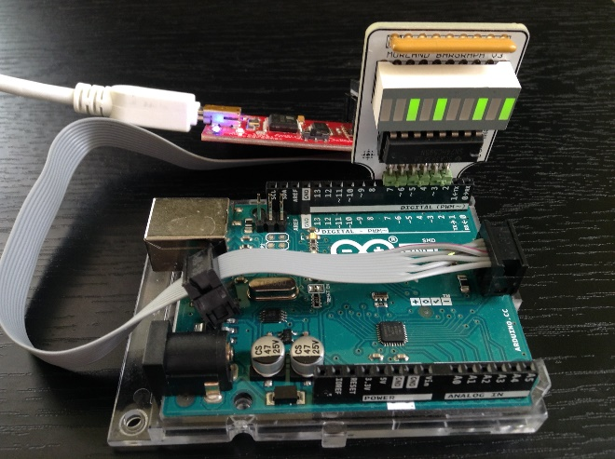
/*
* MorlandShiftBar.c
*
* Created: 4/11/2020 10:56:20 AM
* Author: Chris Darcy
* Notes: Upload with SPP. MB3 in UNO PORTD to avoid ISP pins
*/
#include <avr/io.h>
uint8_t ground = 1<<PD7;
uint8_t clock = 1<<PD6;
uint8_t power = 1<<PD5;
uint8_t data = 1<<PD4;
uint8_t latch = 1<<PD3;
uint8_t enable = 1<<PD2;

#define LSBFIRST 0 //order of presentation
#define MSBFIRST 1 //

#define ddr DDRD //place on PORTD, avoids ISP
#define port PORTD
#define BLINK_DELAY_MS 1000 //Not currently implemented

#define n 0xA5 //alternate binary constant
//AVR GNU C requires initializers to be constants: does not like OR'd syntax:clock | latch | ground | power :(
#define params 0xFC

//declare function template as convention
void shiftOut(uint8_t d, uint8_t c, uint8_t dir, uint8_t value);

int main(void) {
ddr = params; //set data direction of port bits
port |= power; //supply power from a port pin
shiftOut(data, clock, LSBFIRST, n);
while(1); //wait indefinitely
}

void shiftOut(uint8_t d, uint8_t c, uint8_t dir, uint8_t value){
uint8_t mask; //must handle either bit order...

port &= ~latch; //first, pull latch low

//structure to shift in (serially) a full byte
for (uint8_t i=0; i<8; i++){

port &= ~clock; //pull clock bit low

if (dir) //is it MSBFIRST?
mask = value & (0x80>>i); //then mask from MSB to LSB..
else
mask = value & (1<<i); //else, from LSB to MSB…

if (mask) //mount the correct data
port |= data;
else
port &= ~data;

port |= clock; //clock in this bit
}

//lastly, set latch HIGH to present registers on the output
port |= latch;
}

