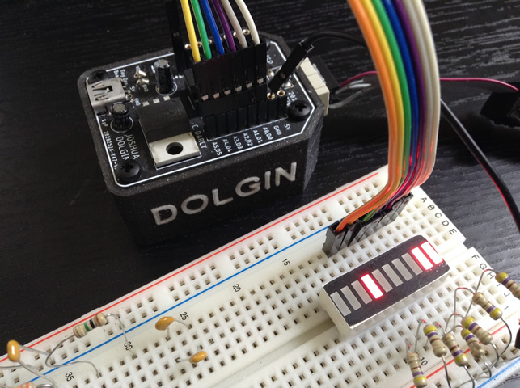
ATMEL Studio 7 (DataAndLabels.asm)
;PROJECT :DataAndLabels
;PURPOSE :Investigation of use of data and array access
;AUTHOR :C. D'Arcy
;DATE :2020 04 20
;DEVICE :Dolgin Development Platform
;MCU :ATtiny84
;COURSE :ICS4U
;STATUS :Working
.def util = r16 ;use aliases for GP Registers
; DATA Segment declarations
.dseg ;locate for Data Segment (SRAM) requirements (default start at 0x0060)
.org SRAM_START
numbers: .BYTE 8 ;reserve data storage (the label is the symbol)
; CODE Segment
.cseg ;locate for Code Segment (FLASH)
; ***** INTERRUPT VECTOR TABLE ***********************************************
.org 0x0000 ;start of Interrupt Vector Table (IVT) aka. Jump Table
rjmp reset ;lowest interrupt address == highest priority!
; ***** START OF CODE ********************************************************
.org 0x0011 ;above the IVT
varStart: ;label (address) for start of data sequence stored in FLASH
.DB 'R','G','R','G'
varEnd: ;label (address) for end of this data sequence (useful)
arrStart: ;label (address) to mark the start of an array with initialization
.DB 2,0 ;reserves 2 bytes (not sure if second parameter used for fill)
arrEnd: ;(past) end of array
str1Start: ;start address of str1 array
.DB "RSGC" ;
str1End: ;(past) end of str1 array
str2Start: ;start address of str2 array
.DB "ACES.",0 ;append a 0 as necessary to to maintain even byte boundaries
str2End: ;(past) end of str2 array
str3Start: ;start address of st3 array
.DB "AVR Assembly" ;
str3End: ;(past) end of str3 array
.org 0x0100 ;a good place to start
reset: ;PC jumps to here (start of code) on reset interrupt...
ser util ;prepare to set ALL port bits for output
out DDRA,util ;set ddr pins for output

ldi XL,low(str3Start<<1) ;set 16-bit X register to point to the start of array
ldi XH,high(str3Start<<1) ;this requires 2 statements for the low and high bytes
ldi YL,low(str3End<<1) ;set 16-bit Y register to point to the start of array
ldi YH,high(str3End<<1) ;this requires 2 statements for the low and high bytes
again:
movw Z,X ;use 2-byte move to position Z as array index pointer
next:
;use post-increment mode to acquire byte from current index and advance the pointer
lpm util,Z+
out PORTA,util ;place the byte on the output port
rcall delay1s ;admire
cp ZL,YL ;are we at the end of the array (Z==Y?)
brne next ;if not, continue to next byte in the array
rjmp again ;if so, start over, do continuously
ret ;return

delay1s:
; Assembly code auto-generated
; by utility from Bret Mulvey
; Delay 8 000 000 cycles
; 1s at 8.0 MHz

ldi r18, 41
ldi r19, 150
ldi r20, 128
L1: dec r20
brne L1
dec r19
brne L1
dec r18
brne L1
ret

Arduino IDE (DataAndLabels.S)
// PROJECT :DataAndLabels
// PURPOSE :Investigation of the use of data declarations and array access with X,Y,and Z Registers
// COURSE :ICS4U
// AUTHOR :C. D'Arcy
// DATE :2020 04 20
// MCU :84
// STATUS :Working
// REFERENCE:http://darcy.rsgc.on.ca/ACES/TEI4M/Assembly/images/GPRegisters.jpg
#include <avr/io.h> //required to reference ports by name (-0x20 offset required)
#define util r16 //improve readability with aliases
.equ OFFSET, 0x20 ;avr-as requires offset address for PORTs
.equ PORT,PORTA-OFFSET ;0x3B – 0x20 = 0x1B
.equ DDR, DDRA-OFFSET ;0x3A – 0x20 = 0x1A
.section .data ;SRAM segment directive (use of .section is optional)
.org RAMSTART ;optional (0x060 is first available address) See:iotn84.h
numbers: ;a label is the identifier (name of variable)
.byte 8 ;reserves # of byte(s) of SRAM storage

.section .text ;FLASH segment directive
.org 0x0000 ;set the Program Counter (PC) to the start of program memory (IVT)
rjmp main ;jump to the beginning of executable code
.org 0x11 ;set the Program Counter (PC) beyond the start of the 84's IVT
varStart: ;label (address) for start of data sequence stored in FLASH
.byte 'R','G','R','G'
varEnd: ;label (address) for end of this data sequence (useful)
arrStart: ;label (address) to mark the start of an array with initialization
.space 2,66 ;reserves 2 bytes and (optionally) initializes each to 66
arrEnd: ;(past) end of array
str1Start: ;start address of str1 array
.ascii "RSGC" ;
str1End: ;(past) end of str1 array
str2Start: ;start address of str2 array
.asciz "ACES." ;appends 0 at end
str2End: ;(past) end of str2 array
str3Start: ;start address of st3 array
.string "AVR Assembly" ;same as asciz
str3End: ;(past) end of str3 array

.org 0x100 ;places code at a specific location (this is sufficient)
.global main ;eliminate (artificial) Arduino C requirement of setup & loop functions
main:
ser util ;prepare to set ALL port bits for output
out DDR,util ;set ddr pins for output

ldi XL,lo8(str3Start) ;set 16-bit X register to point to the start of array
ldi XH,hi8(str3Start) ;this requires 2 statements for the low and high bytes
ldi YL,lo8(str3End) ;set 16-bit Y register to point to the start of array
ldi YH,hi8(str3End) ;this requires 2 statements for the low and high bytes

again:
movw Z,X ;use 2-byte move to position Z as array index pointer
next:
;use post-increment mode to acquire byte from current index and advance the pointer
lpm util,Z+
out PORT,util ;place the byte on the output port
rcall delay1s ;admire
cp ZL,YL ;are we at the end of the array (Z==Y?)
brne next ;if not, continue to next byte in the array
rjmp again ;if so, start over, do continuously
ret ;return

delay1s:
; Assembly code auto-generated
; by utility from Bret Mulvey
; Delay 8 000 000 cycles
; 1s at 8.0 MHz

ldi r18, 41
ldi r19, 150
ldi r20, 128
L1: dec r20
brne L1
dec r19
brne L1
dec r18
brne L1
ret

