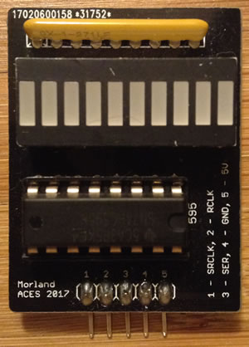
/* MorlandShiftBar.c
* Created: 1/13/2019 3:18:20 PM
* Author: Chris Darcy
* Notes: Ensure ShiftBar device NOT in MOSI,MISO,SCK pins
* (interferes with ICE ISP programming)
*/
#include <avr/io.h>
//#define F_CPU 16000000 //N/A
//#include <util/delay.h> //N/A

uint8_t clock=1<<PD7; //ShiftBar in PORTD avoids // conflict with ISP pins
uint8_t latch=1<<PD6; //
uint8_t data= 1<<PD5; //
uint8_t ground = 1<<PD4; //
uint8_t power = 1<<PD3; //Not the best to have port pin supply power…but…

#define LSBFIRST 0 //order of bit presentation
#define MSBFIRST 1 //
#define ddr DDRD //place on PORTD to avoid ISP interference
#define port PORTD
#define BLINK_DELAY_MS 1000 //Not currently implemented

#define n 0xA5 //alternate binary constant syntax: 0b10100101
#define params 0xF8 //AVR GNU C requires initializers to be constants:
//does not like OR'd syntax as in:
// clock | latch | ground | power :(

//declare function template as per convention
void shiftOut(uint8_t d, uint8_t c, uint8_t dir, uint8_t value);

int main(void) {
ddr = params; //set data direction of port bits
port |= power; //supply power from a port pin (not the best)
shiftOut(data, clock, LSBFIRST, n);
while(1); //wait indefinitely
//_delay_ms(BLINK_DELAY_MS); //included for syntax reference purposes
}

void shiftOut(uint8_t d, uint8_t c, uint8_t dir, uint8_t value){
port &= ~latch; //pull latch low (syntax only works if defined
// as a variable)
uint8_t mask; //must handle either bit order...
for (uint8_t i=0; i<8; i++){ //structure to shift in (serially) a full byte
port &= ~clock; //pull bit clock low
if (dir) //is it MSBFIRST?
mask = value & (0x80>>i); //if so, mask from left to right..
else
mask = value & (1<<i); //else, from right to left

if (mask) //place the correct bit on the data pin
port |= data; //
else //
port &= ~data; //
port |= clock; //clock in this bit
}
port |= latch; //set latch HIGH to present registers on
// the output pins
}

