1. Representing Venn Diagrams as Binary Numbers…
a) In our last class we let U be the universe of all RSGC students, the set A stand for the set of all Grade 5 students and B be set of students that like Brussels sprouts. A really simple way to create a binary number from a Venn Diagram is to let 1 stand for whether someone is in the set and 0 if they are not in the set. Using this strategy the diagram from Question 2 in our previous worksheet can be coded in Binary shown below.

Venn Diagram of Two Sets | Binary Representation of Venn Diagram
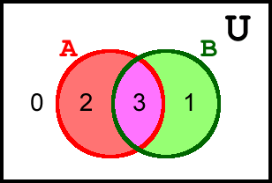 | Base 10 A B  0 0 0  1 0 1  2 1 0  3 1 1

b) In this next exercise you are asked to extend your understanding of the previous question to include three sets.

You might start by filling in the counting sequence of binary numbers in the second column of the table below right, before filling in the equivalent base 10 (decimal) number in the first column.

Finally, use your understanding of the previous question to place the correct decimal number in the appropriate coloured region in the Venn Diagram.

Venn Diagram of Three Sets | Binary Representation of Venn Diagram
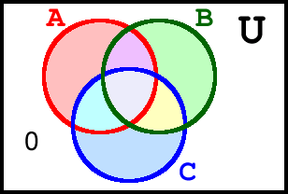 | Base 10 A B C  0 0 0 0

Reference: https://github.com/lawrancej/COMP278-2014/blob/master/lectures/lecture3.adoc

2. Double Dabble I: Convert Binary to Decimal
Convert 10110101₂ to decimal using the double dabble algorithm (show evaluation)

3. Complete the table of Gray Codes  Binary BCD Gray Code  0000 0000  0001  1111 | 4. Convert Binary to Gray Code  (show work).  100110111₂
5. Convert Gray Code to Binary
(show work)

100110111_{g}

6. Double Dabble II: Convert 8-bit Binary to 3-byte Packed BCD
Reference: https://en.wikipedia.org/wiki/Double_dabble

Convert 10110101₂ to 3-bit packed BCD using the double dabble algorithm (show evaluation)

BCD |  |  | Original | Comment
Hundreds | Tens | Ones
0000 | 0000 | 0000 | 11110011₂ | Initialization
0000 | 0000 | 0001 | 11100110₂ | Shift
0000 | 0000 | 0011 | 11001100₂ | Shift
0000 | 0000 | 0111 | 10011000₂ | Shift
0000 | 0000 | 1010 | 10011000₂ | Add 3
0000 | 0001 | 0101 | 00110000₂ | Shift
0000 | 0001 | 1000 | 00110000₂ | Add 3
0000 | 0011 | 0000 | 01100000₂ | Shift
0000 | 0110 | 0000 | 11000000₂ | Shift
0000 | 1001 | 0000 | 11000000₂ | Add 3
0001 | 0010 | 0001 | 10000000₂ | Shift
0010 | 0100 | 0011 | 00000000₂ | Shift
2 | 4 | 3

