1.0 Prototype

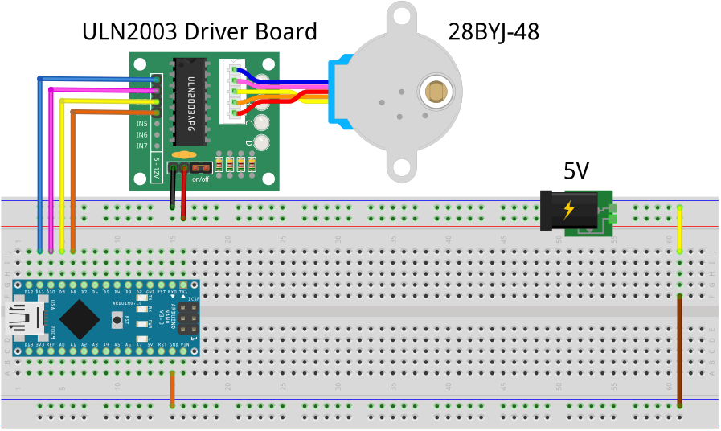

2.0 Direct Drive Code

// PROJECT :Stepper28BYJ48
// PURPOSE :Support for demonstration to ICS3U class
// COURSE :ICS3U
// AUTHOR :C. D'Arcy
// DATE :Updated 2024 05 16. 2020 04 28. Confirmed: 2023 05 02.
// MCU :328P (Nano)
// MOTOR :MOT-28BYJ-48 (32 teeth, 11.25 degrees between teeth)
// STATUS :Working
// REFERENCE:https://www.youtube.com/watch?v=B86nqDRskVU
// REFERENCE:https://www.instructables.com/id/BYJ48-Stepper-Motor/
//#include <Stepper.h> //This libary is OK but (can be) problematic for beginners
//Provide separate 5V supply for motor and time control and motor grounds together

#define IN1 11 //BLUE
#define IN2 10 //PINK
#define IN3 9 //YELLOW
#define IN4 8 //ORANGE
#define TIMEOUT 1000 //control pacing

//------------------------------------------------------------------------------
//For the software-inclined ACES, consider improved code design between barriers
struct driveMode { //package up the essentials for each drive mode
uint16_t increments;
uint8_t sequence[8];
uint8_t steps;
};
// populate the characteristes of each driving mode
driveMode waveStepping = {32 * 64, {0, 2, 4, 6, 0, 0, 0, 0}, 4}; //
driveMode fullStepping = {32 * 64, {1, 3, 5, 7, 0, 0, 0, 0}, 4}; //
driveMode halfStepping = {64 * 64, {0, 1, 2, 3, 4, 5, 6, 7}, 8}; //
//Activate ONE of the three driving options...
//driveMode active = waveStepping; //fast, little torque
//driveMode active = fullStepping; //fast, maximum torque
driveMode active = halfStepping; //slower, average torque
//------------------------------------------------------------------------------
int8_t step; //drive steps 0-3 or 0-7 (allow for negative)
boolean clockwise = true; //direction
uint16_t stepsRemaining = active.increments; //# of steps for 1 full rotation

void setup() {
pinMode(IN1, OUTPUT); //set drive pins for output
pinMode(IN2, OUTPUT); //
pinMode(IN3, OUTPUT); //
pinMode(IN4, OUTPUT); //
Serial.begin(9600);
while (!Serial);
Serial.println(active.increments);
for (uint8_t i = 0; i < active.steps; i++)
Serial.println(active.sequence[i]);
Serial.println(active.steps);
Serial.println(stepsRemaining);
}

void loop() {
//loop through one full shaft rotation at a controlled pace...
while (stepsRemaining > 0) {
takeStep();
delayMicroseconds(TIMEOUT); // control the pace
stepsRemaining--;
}
delay(TIMEOUT); //pause before changing direction
clockwise = !clockwise; //change direction
stepsRemaining = active.increments; //reset the total number of steps for this drive option
}

//Single step through the firing sequence for the active drive option...
//Note1: A HIGH to the ULN2003 pulls the coil end low.
//Note2: This code can be optimized significantly but is shwn in this manner
// for clarity of interpretation
void takeStep() {
//be sure to fire the correct sequence for the active drive mode
switch (active.sequence[step]) {
case 0:
digitalWrite(IN1, HIGH); //BLUE
digitalWrite(IN2, LOW); //PINK
digitalWrite(IN3, LOW); //YELLOW
digitalWrite(IN4, LOW); //ORANGE
break;
case 1:
digitalWrite(IN1, HIGH);
digitalWrite(IN2, HIGH);
digitalWrite(IN3, LOW);
digitalWrite(IN4, LOW);
break;
case 2:
digitalWrite(IN1, LOW);
digitalWrite(IN2, HIGH);
digitalWrite(IN3, LOW);
digitalWrite(IN4, LOW);
break;
case 3:
digitalWrite(IN1, LOW);
digitalWrite(IN2, HIGH);
digitalWrite(IN3, HIGH);
digitalWrite(IN4, LOW);
break;
case 4:
digitalWrite(IN1, LOW);
digitalWrite(IN2, LOW);
digitalWrite(IN3, HIGH);
digitalWrite(IN4, LOW);
break;
case 5:
digitalWrite(IN1, LOW);
digitalWrite(IN2, LOW);
digitalWrite(IN3, HIGH);
digitalWrite(IN4, HIGH);
break;
case 6:
digitalWrite(IN1, LOW);
digitalWrite(IN2, LOW);
digitalWrite(IN3, LOW);
digitalWrite(IN4, HIGH);
break;
case 7:
digitalWrite(IN1, HIGH);
digitalWrite(IN2, LOW);
digitalWrite(IN3, LOW);
digitalWrite(IN4, HIGH);
break;
default:
digitalWrite(IN1, LOW);
digitalWrite(IN2, LOW);
digitalWrite(IN3, LOW);
digitalWrite(IN4, LOW);
// break;
}
nextStep();
}

void nextStep() {
// determine the next step...
step = clockwise ? step + 1 : step - 1;
// check and adjust for wraparound...
if (step == active.steps)
step = 0;
else if (step < 0)
step = active.steps - 1;
Serial.println(step);
}

