1.0 Minimal Confirmation Prototype (Trim Pot not used)
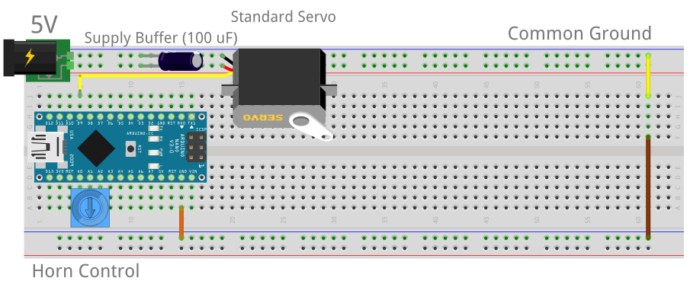

ATmega328 Datasheet: http://darcy.rsgc.on.ca/ACES/Datasheets/ATMEGA328P.pdf#page=111

1.1 ATmega328P Timers: 3 Options

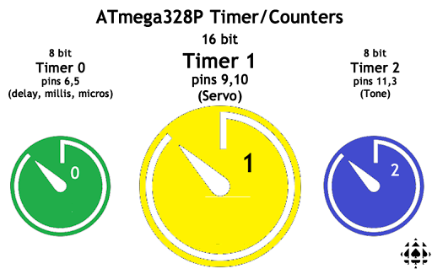
1.2 ATmega328P Timer Presentation Pins (Timer1 Mapped to Digital Pins 9 and 10)

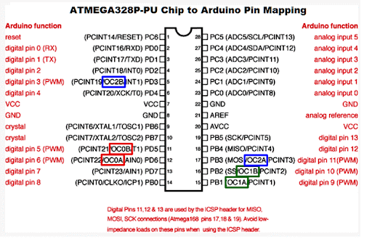

1.3 Timer1 (Fast PWM Mode 15): Servo Waveform Generation

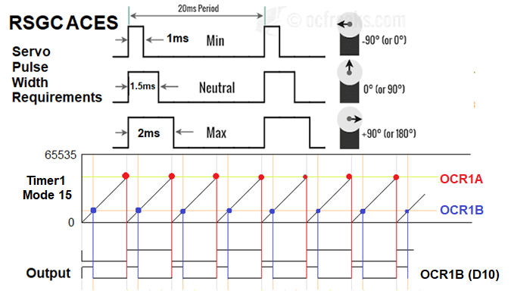

1.4 Timer1 Waveform Generation Modes
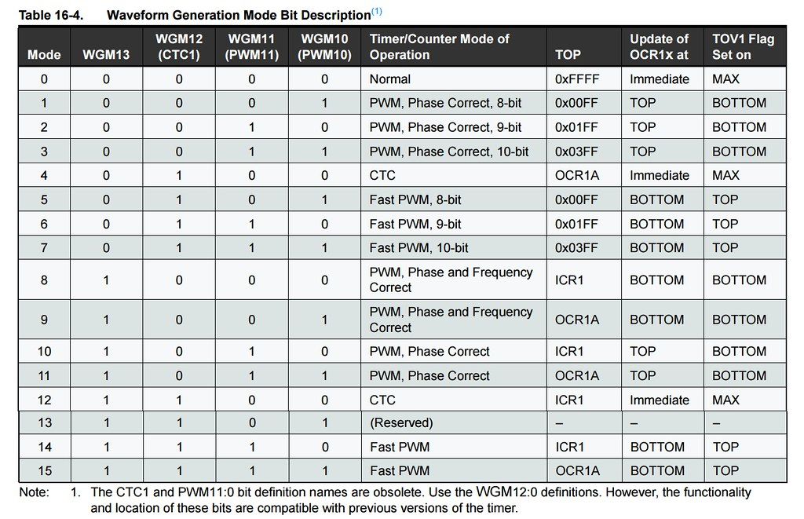

1.5 Timer1 Mode 0 Waveform with Interrupt
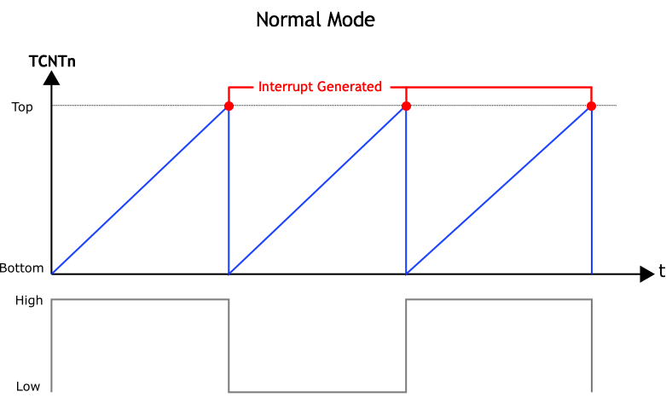

1.5.1 Code Example: Register-Level Blink Sketch
// PROJECT :Timer1NormalMode0Blink
// PURPOSE :Simplest introduction to Register Level Coding
// COURSE :ICS3U-E
// AUTHOR :C. D'Arcy
// DATE :2025 05 02
// MCU :328P
// STATUS :Working

void setup() {

// pinMode(LED_BUILTIN, OUTPUT);
DDRB |= (1 << PB5); // pinMode(13,OUTPUT);

// Register level...
cli(); //NoInterrupts();

// Normal Mode
TCCR1A = 0;
// set up timer with CLKio/256 prescaler
TCCR1B = 1<<CS12;
// Enable Timer1 interrupt ability
TIMSK1 = 1 << TOIE1;

// Enable global interrupt ability...
sei(); //Interrupts();
}

// Timer 1 Interrupt Service Routine
ISR(TIMER1_OVF_vect) {
PORTB ^= (1 << PB5); //toggle state of pin 13
}
void loop() {} //nothing to do...

1.6 ATmega328P Interrupt Vector Table: Column 2 Suitable for Direct Code Use

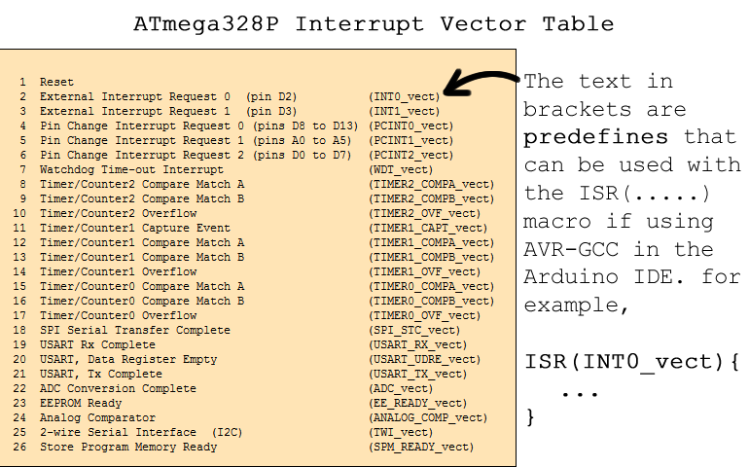

1.6.1 ISR Code Template

// Timer/Counter 1 Interrupt Service Routine
ISR(TIMER1_OVF_vect) {
PORTB ^= (1 << PB5);
}

1.7 Timer 1 Primary Control Registers and Prescalers

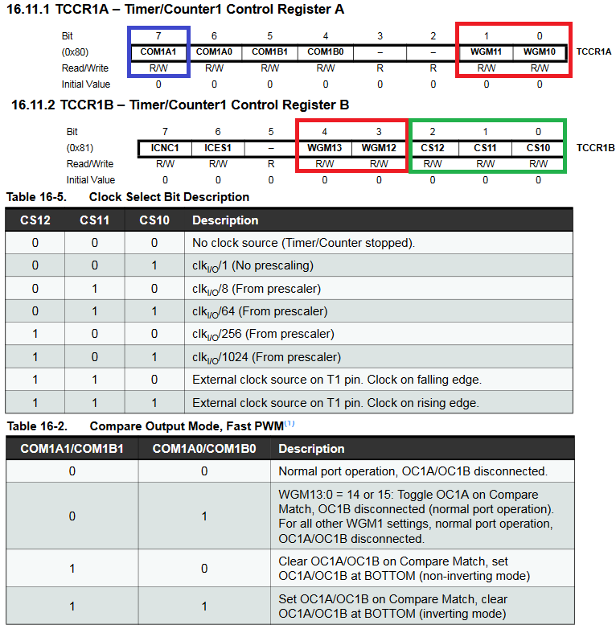
1.8 Timer 1 Secondary Registers

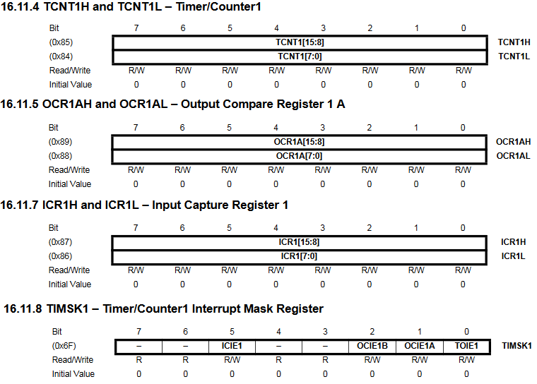

1.9 Timer1 Mode 14 Configuration Considerations

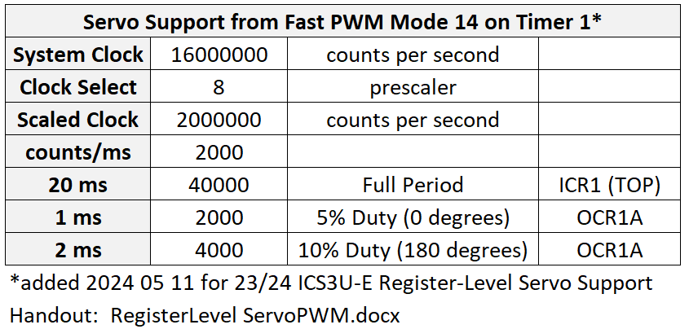

1.10.2 Register-Level PWM Waveform for Servo Rotation (ATmega328P Timer1 Mode 15)

// PROJECT :ServoTimer1FSB103B2025
// PURPOSE :Timer1 (Mode 15) Register Level Coding of an FSB10B Servo
// COURSE :ICS3U-E
// AUTHOR :C. D'Arcy
// DATE :2025 05 02
// MCU :328P (Standalone)
// PERIOD :20ms > Frequency: 50Hz
// HIGH :0Deg:1ms, 90Deg:1.5ms, 180Deg:2ms (Duty Cycle Range:5% to 10%)
uint8_t clkDiv1 = 1 << CS10;
uint8_t clkDiv8 = 1 << CS11;
uint8_t clkDiv64 = 1 << CS11 | 1 << CS10;
uint8_t clkDiv256 = 1 << CS12;
uint8_t clkDiv1024 = 1 << CS12 | 1 << CS10;
// The values of 0 and 38 arrived at from trial and error....
volatile uint8_t lowerLimit = 4; //close to 0 degrees
volatile uint8_t upperLimit = 38; //close to 180 degrees
volatile uint8_t hornSpeed = 4; //# of Overflows reached before changing angle (duty cycle) in OCR1B
volatile uint8_t ovfCount = 0;
int main() {
cli(); // Suspend interrupts while we set up ours
// Configure for Fast PWM on OC1B (Arduino Pin 10)
// OC1A/OC1B: Set on Compare Match; Clear on BOTTOM
// Define WGM bits for Fast PWM (Mode 15)
TCCR1A |= (1 << COM1A1) | (1 << COM1B1) | (1 << WGM11) | (1 << WGM10);
// Set prescaler and additional WGM bits for Fast PWM
TCCR1B |= (1 << WGM13) | (1 << WGM12) | (1 << CS12) | (1 << CS10);
// Define TOP (See D'Arcy Excel worksheet)
// OCR1A = 328;
OCR1AH = 0x01; // this is the same as the line
OCR1AL = 0x48;
// Define Duty Cycle for 0 degree horn angle...
// OCR1B = lowerLimit;
OCR1BH = 0; // this is the same as the line
OCR1BL = lowerLimit;
// Enable Output Compare for Timer 1 interrupt
TIMSK1 = (1 << OCIE1A);
// Declare related peripheral pin(s) output
DDRB = (1 << PB2) | (1 << PB1);
// Enable Global Interrupt
sei();
// Stand down and admire your engineering
while (1);
}
// Timer1 Output Compare triggered on TCNT1 == TOP (OCR1A)
ISR(TIMER1_COMPA_vect) {
// adjust hornSpeed limit as required to affect speed or rotation...
ovfCount++;
if (ovfCount == hornSpeed) {
ovfCount = 0;
OCR1B++;
if (OCR1B == upperLimit)
OCR1B = lowerLimit;
}
}

