1.0 Minimal Confirmation Prototype (Trim Pot not used)
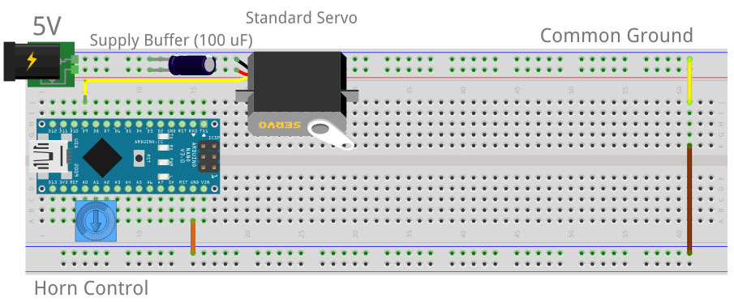

ATmega328 Datasheet: http://darcy.rsgc.on.ca/ACES/Datasheets/ATMEGA328P.pdf#page=111

1.1 ATmega328P Timers: 3 Options

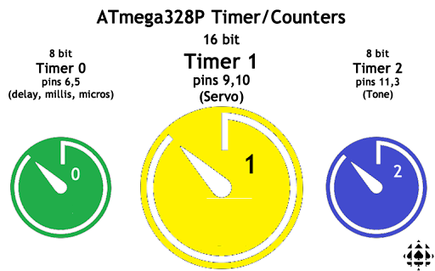
1.2 ATmega328P Timer Presentation Pins (Timer1 Mapped to Digital Pins 9 and 10)

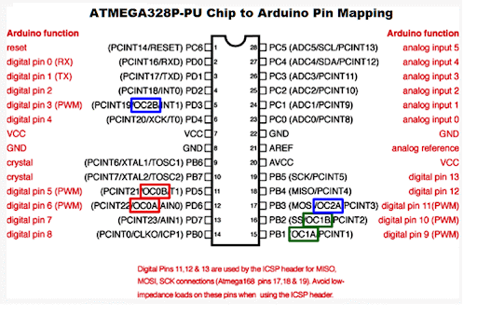

1.3 Timer1 (Fast PWM Mode 14): Servo Waveform Generation

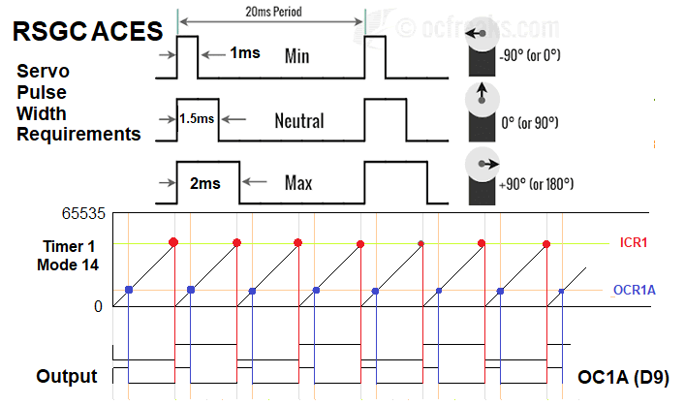

1.4 Timer1 Waveform Generation Modes
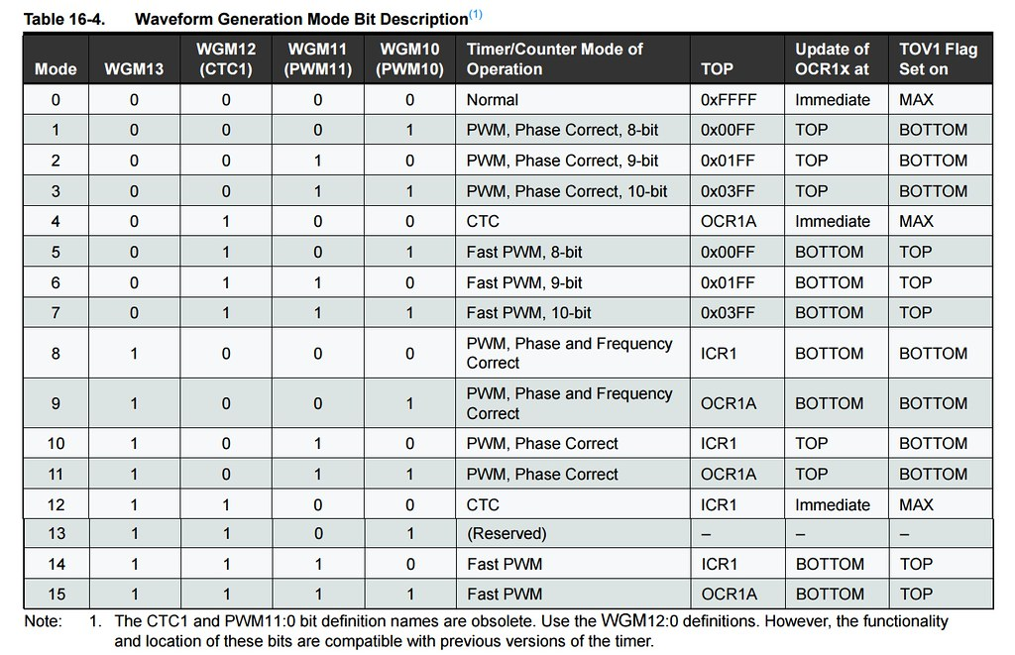

1.5 Timer1 Mode 0 Waveform with Interrupt
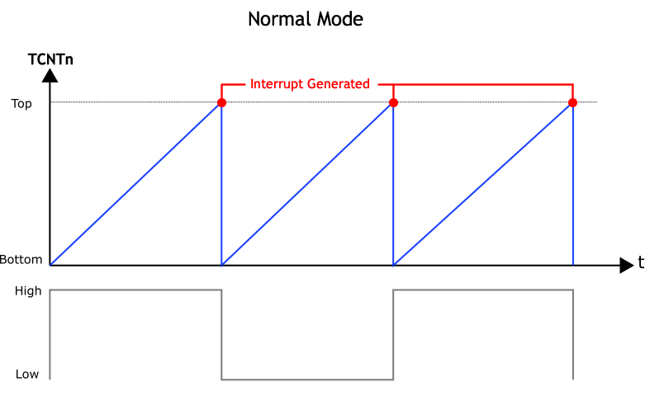

1.5.1 Code Example: Register-Level Blink Sketch
http:darcy.rsgc.on.ca/ACES/TEI3M/ArduinoCode/Timer1NormalMode0Blink.ino

1.6 ATmega328P Interrupt Vector Table: Column 2 Suitable for Direct Code Use

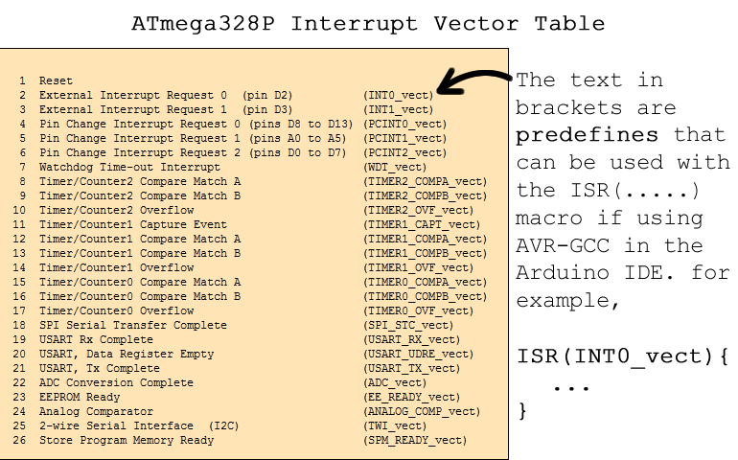

1.6.1 ISR Code Template

// Timer/Counter 1 Interrupt Service Routine
ISR(TIMER1_OVF_vect) {
PORTB ^= (1 << PB5);
}
1.7 Timer 1 Primary Control Registers and Prescalers

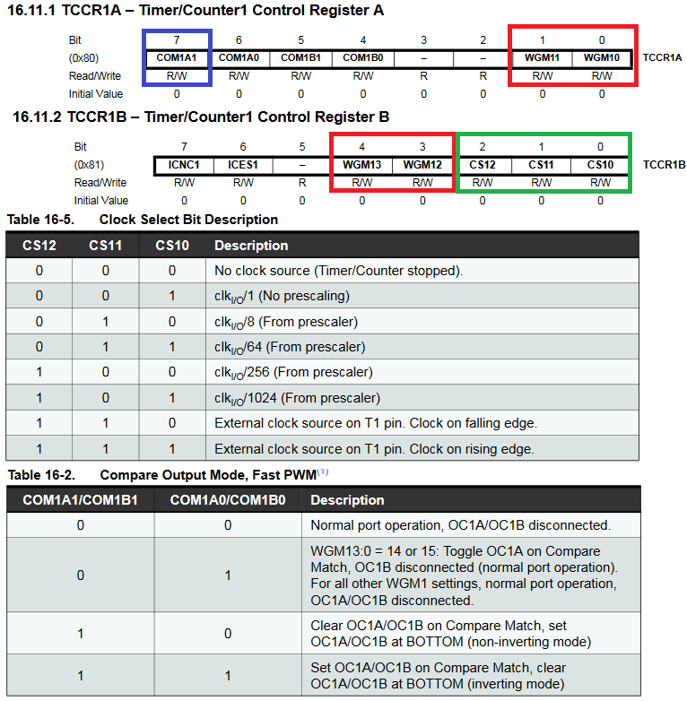

1.8 Timer 1 Secondary Registers

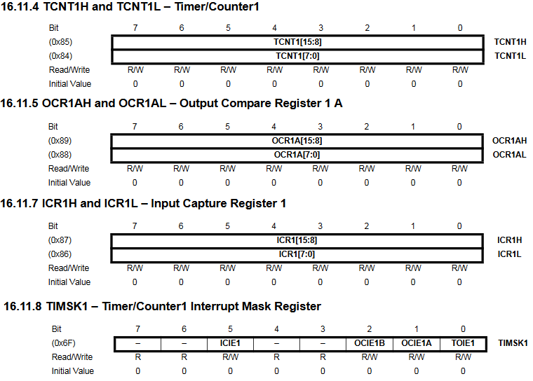
1.9 Timer1 Mode 14 Configuration Considerations

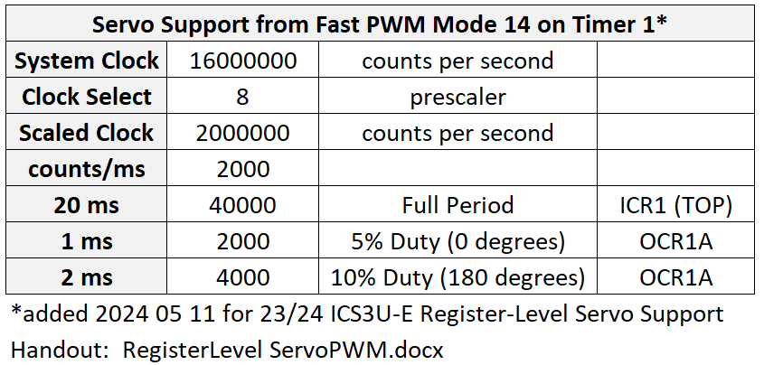

1.10.1 Code Example: Register-Level Blink Sketch
http://darcy.rsgc.on.ca/ACES/TEI3M/ArduinoCode/Timer1FastPWMMode14.ino

// PROJECT :MyTimer1NormalMode0Blink
// PURPOSE :Gentle introduction to AVR Timers. Sets up SERVO PWM (Mode 14)
// COURSE :ICS3U
// AUTHOR :C. D'Arcy
// DATE :2024 05 11
// MCU :328P
// STATUS :Working
// REFERENCE:
void setup() {
// pinMode(LED_BUILTIN, OUTPUT);
// Register level...
DDRB |= (1 << PB5);
// Normal Mode
TCCR1A = 0;
// set up timer with CLKio/8 prescaler
TCCR1B = 1<<CS12;
// Enable Timer1 interrupt ability
TIMSK1 = 1 << TOIE1;
// Enable global interrupt ability...
sei();
}
// Timer 1 Interrupt Service Routine
ISR(TIMER1_OVF_vect) {
PORTB ^= (1 << PB5);
}

void loop() {}

1.10.2 Register-Level PWM Waveform for Servo Rotation (ATmega328P Timer1 Mode 14)
// PROJECT :Timer1FastPWMMode14
// REFERENCE:http://darcy.rsgc.on.ca/ACES/TEI3M/RegisterLevelServoPWM.docx
// NOTES :Frequency and duty cycle depend on Timer configuration
// :Optimum thresholds vary with particular Servo
// Trial & Error on an FS5103B Servo from ABRA
#define LOWER 1200 // Lower bound for OCR1A: 0°
#define UPPER 4800 // Upper Bound for OCR1A: 180°
#define TOP 10*UPPER // Threshold for 50Hz servo waveform
// Trial & Error on an HXT5010 Servo
//#define LOWER 1200 // Lower bound for OCR1A: 0°
//#define UPPER 4800 // Upper Bound for OCR1A: 180°
//#define TOP 10*UPPER // Threshold for 50Hz servo waveform
// flag to signal interrupt occurence
volatile boolean triggered = false;
int8_t delta = 50; // influences the speed or the servo horn rotation
void setup() {
Serial.begin(9600);
while (!Serial);

//disable global interrupt system while configuring...
cli();

// Define OC1A (Arduino pin 9) for output
DDRB |= (1 << PB1); //aka pinMode(9, OUTPUT);

// Configure OC1A pin to clear on Compare Match (non-inverting)
// and WGM parameters for Fast PWM Mode 14 (ICR1 as TOP)
// NOTE: Do not use |= as the Arduino Toolchain sets some flags before this
TCCR1A = (1 << COM1A1) | (1 << WGM11);
// Set prescaler and further WGM parameters for Fast PWM Mode 14
TCCR1B = (1 << WGM13) | (1 << WGM12) | (1 << CS11); //CLKDIV8

// Configure PWM characteristics
ICR1 = TOP; // Establish frequency of 50Hz (period of 20ms)
OCR1A = LOWER; // Duty cycle:

// Enable Output Compare Interrupt ability
TIMSK1 = 1 << OCIE1A;

//reenable global interrupt system...
sei();
}
// Timer1 Output Compare triggered on TCNT1 == TOP (ICR1)
ISR(TIMER1_COMPA_vect) {
triggered = true;
}
void loop() {
if (triggered) { // did a Compare Match occur between TCNT1 and OCR1A?
triggered = false; // if so, prepare to recognize the next one...
//Serial.println("OCR1A Compare Match"); // say so, if necessary...
OCR1A += delta; // prepare to rotate the horn
if (OCR1A < LOWER || OCR1A > UPPER) //rverse direction if necessary...
delta = -delta;
}
}

