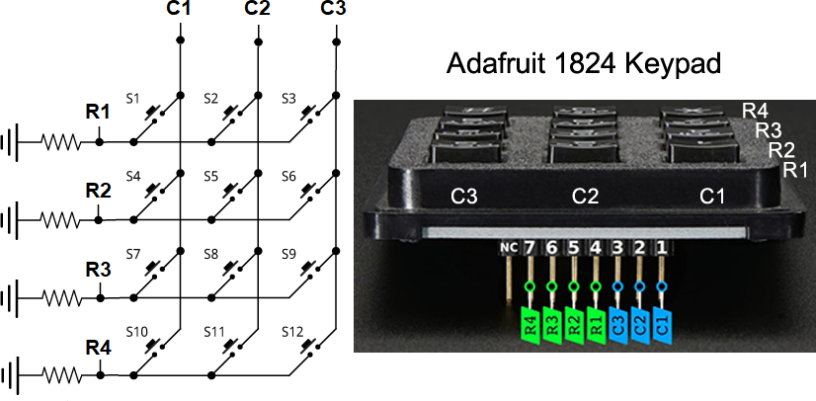

// PROJECT :KeypadScanning
// PURPOSE :Present the scanning (aka polling) algorithm behind the Keypad library
// COURSE :ICS3U
// AUTHOR :Modified from Arduino Forum post
// DATE :2023 03 01
// MCU :328P
// STATUS :Working (need to debounce...)
// REFERENCE:https://forum.arduino.cc/t/keypad-without-keypad-library/656198/7
// REFERNCE :https://www.adafruit.com/product/1824

#define C1 10 //Arduino digital pins
#define C2 9
#define C3 8
#define R1 7
#define R2 6
#define R3 5
#define R4 4

#define PAUSE 100

uint8_t pinCols[3] = {C1, C2, C3}; //pins of the different columns
uint8_t pinRows[4] = {R1, R2, R3, R4}; //pins of the different rows
uint8_t numRows = sizeof(pinRows);
uint8_t numCols = sizeof(pinCols);

int8_t trueCol; //active key pressed
int8_t trueRow; //

char keys[4][3] = { //correspondence with the keys of the keypad
{'1', '2', '3'},
{'4', '5', '6'},
{'7', '8', '9'},
{'*', '0', '#'}
};

void setup() {
Serial.begin(9600);
while (!Serial);

for (uint8_t c = 0; c < numCols; c++) { //Columns as HIGH output pins
pinMode(pinCols[c], OUTPUT);
digitalWrite(pinCols[c], HIGH);
}
for (uint8_t r = 0; r < numRows; r++) { //Rows as input pins
pinMode(pinRows[r], INPUT);
}
}

void loop() {
readKey(); //scan the matrix
if (trueRow >= 0 && trueCol >= 0) //anything?
Serial.println(keys[trueRow][trueCol]); //if so, display the active key
delay(PAUSE);
}

void readKey() {
trueRow = -1; //assume nothing
trueCol = -1; //
for (uint8_t i = 0; i < numRows; i++) {
if (digitalRead(pinRows[i])/* == HIGH*/) { //read each row for a HIGH
trueRow = i; //identified the row! Now,
for (uint8_t x = 0; x < numCols; x++) { //present LOW on all columns
for (uint8_t c = 0; c < numCols; c++) //but 1 while reading the true row
digitalWrite(pinCols[c], LOW); //to see what comes through...
digitalWrite(pinCols[x], HIGH); //
//if true row is HIGH we have also discovered the column!
if (digitalRead(pinRows[trueRow])/* == HIGH*/) {
trueCol = x;
}
}
}
}
//restore columns to HIGH
for (uint8_t c = 0; c < numCols; c++) {
pinMode(pinCols[c], OUTPUT);
digitalWrite(pinCols[c], HIGH);
}
}

