There are two separate circuits to explore in this investigation (with and without MCU Control).
- The circuit below right exploits a compatible pair of IR LEDs (same wavelengths). The (clear) emitter provides a source of IR radiation, the (analog) strength of which can be detected by the (dark) detector. With the 5 mm LEDs pointing straight upward, the emitter signal can be reflected off of a barrier and sensed by the detector. The voltage from the detector’s anode lead can be used to interpret the distance between the LEDs and the barrier. The circuit below employs an opAmp (as a comparator) to determine a (digital) trigger for a distance threshold to the barrier.
- The circuit below left uses an IR receiver to decode an incoming IR signal from an IR remote control. Typical RCs places the data bits of a command on a 38 kHz carrier frequency (a process called modulation). The receiver, tuned to the same frequency, removes the carrier wave from the signal (demodulation), thereby, exposing just the data. The dark exterior of the receiver (and detector) filters out other light frequencies.

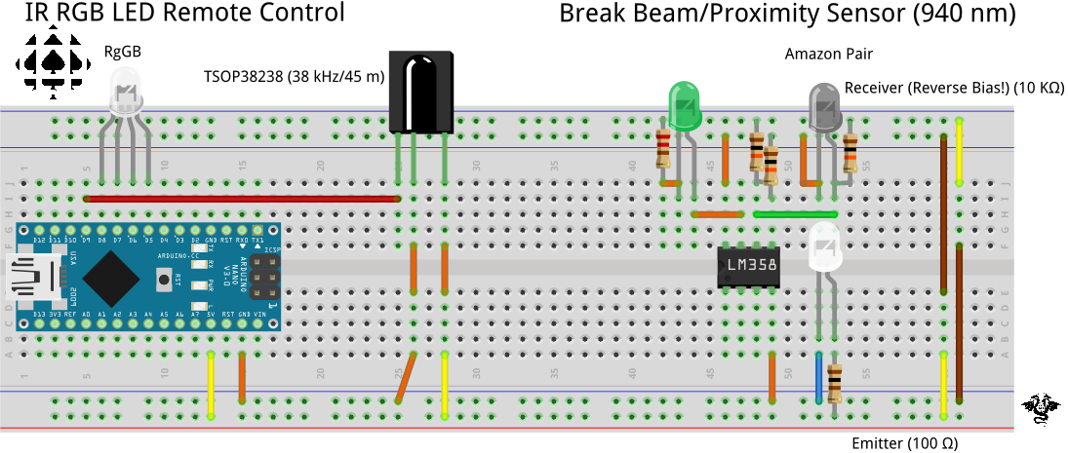

//PROJECT :IRRecvDump
//REFERENCE: https://tinyurl.com/3enz5tm2
#include <IRremote.h>
IRrecv irrecv(9);
decode_results results;

void setup(){
Serial.begin(9600);
irrecv.enableIRIn();
irrecv.blink13(true);
}

void loop(){
if (irrecv.decode(&results)){
Serial.println(results.value, HEX);
irrecv.resume();
}
delay(100);
}

Task.
1. Using the matched Emitter/Detector pair of IRs provided you, test the prototype above right.
2. Using the TSOP38238 IR Receiver provided you, assemble the prototype above left. Ensure the ground of your CC RGB LED is in pin 7.
3. Open the Arduino IDE and ensure Version 2.5 of the IRremote library is the active version.
4. Create the project IRRecvDump and paste in the code from the previous page and upload.
5. Using your RC, press any four buttons and note the unique hexadecimal codes (RED, GREEN, BLUE and CLEAR ALL)
6. Create a new project IRRGBControl and paste in the code below. Change the four case codes to yours before uploading the sketch. Test!

//PROJECT : IRRGBControl
//REFERENCE : https://tinyurl.com/3enz5tm2
//VERSION : Works with Version 2.5.0 of IRremote library
#include <IRremote.h>
IRrecv irrecv(9);
decode_results results;

#define RED PB0
#define GND PD7
#define GREEN PD6
#define BLUE PD5

void setup() {
Serial.begin(9600);
irrecv.enableIRIn();
irrecv.blink13(true);
DDRB |= 1 << RED;
DDRD |= 1 << GND | 1 << GREEN | 1 << BLUE;
PORTD &= ~(1 << GND);
}

void loop() {
if (irrecv.decode(&results)) {
switch (results.value) {
case 0x61D620DF:
//digitalWrite(RED, HIGH);
PINB |= 1 << RED;
break;
case 0x61D6A05F:
PIND |= 1 << GREEN; //digitalWrite(GREEN, HIGH);
break;
case 0x61D6609F:
PIND |= 1 << BLUE; //digitalWrite(BLUE_LED_PIN, LedState);
break;
case 0x61D648B7:
PORTB &= ~(1<<RED);
PORTD &= ~(1<<GREEN | 1<< BLUE);
break;
}
irrecv.resume();
}
delay(500);
}

