Instructions to 2014 TEI3M ACES
- A copy of this exam can be downloaded from,
http://mail.rsgc.on.ca/~cdarcy/Exams/2014TEI3MFinalExam.docx
- This exam contributes 30% towards your final mark
- Access to your Engineering Report and the project workbook is permitted
- Access to your former project files on your laptop is permitted
- Internet access is permitted for research and reference
- Evaluation will consider accuracy and build quality
- You are to demonstrate your circuit to me before leaving the room. A completed ER submission is to be sent to handin under the Subject Line: Graphic Equalizer by 7 pm this evening. See end.

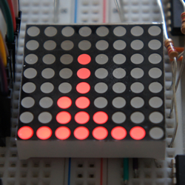
Graphic Equalizer

The photo of the LED matrix to the right is the output of a circuit similar to the one you are required to assemble, code, and communicate for this exam.

The purpose of this circuit is to enable an audio input to be separated into seven different frequencies and have these levels displayed on an LED matrix over seven columns. Follow the link below to see a 25s video of the circuit in action (minus the audio, of course)
http://www.youtube.com/watch?v=G8lIpZ-EgxY&feature=youtu.be

Output
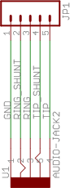
Over the past few weeks you have gained facility with addressing the LED matrix through 74HC595 shift registers. Since only one column of output is to be displayed at a time, round -robin style, the two 74HC595 ICs will provide both the local addressing and power drive (anode and cathode) for the display.

Input
The 3.5mm cable and input jack and breakout board you have been provided with supply an audio signal from your laptop to your circuit. The left and right channel audio signals are presented on the TIP and RING pins of the breakout board. The only other pin of the breakout board you need to wire in is its GND pin.

MSGEQ7
The splitting of the audio signal is performed by a (magical?) 8-Pin DIP known as the MSGEQ7 from Mixed Signal Integration. You‘ll find the datasheet at,

http://darcy.rsgc.on.ca/ACES/Datasheets/MSGEQ7.pdf

The Pin Configuration and Typical Assembly diagrams are provided here for your convenience and can be also found on pp. 3-4 of the datasheet.

MSGEQ7 Pin Configuration | MSGEQ7 Typical Assembly
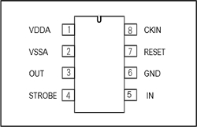 | 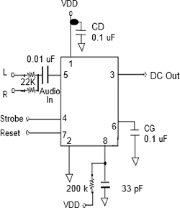

Online Support
Whereas the datasheet can be taken as accurate, two online references (at the time of writing this document) that you might find useful (I offer no assurance as to their accuracy) include two simple tutorials,

- http://nuewire.com/info-archive/msgeq7-by-j-skoba/
- http://tronixstuff.com/2013/01/31/tutorial-arduino-and-the-msgeq7-spectrum-analyzer/

and a Fritzing diagram,

- http://fritzing.org/projects/msgeq7-audio-equalizer

Code
After wiring up the front end (audio input > MSGEQ7) I recommend studying the code from Link 1 above and then creating a sketch using it, exactly. If you have followed the tutorial it will work as expected. View your Serial Monitor to confirm the analog values you are getting are similar to those Skoba reports for each of the 7 channels halfway down his web page.

Now, create a sketch entitled, Equalizer, and blend Skoba’s code into your existing code to display the analog value for each channel as a column of lit LEDs. Again, the general concept is to obtain an analog reading on A0 for the first frequency (a value between 0 and 1023), convert it to a binary data value consisting of a string of (0 to 7) 1s, before shifting the data for the column (0) and row (data) out to the 74HC595s. Continuous this procedure, round-robin style, using pin A0 for each one of the seven channels.

Parts List
The parts kit you have been provided with, is as follows,

Quantity | Part | Details | Description
1 | Cable | male/male | 3.5mm stereo audio cable, 3 ft
1 | Jack | Stereo | 3.5mm female audio jack with breakout board (TRRS)
1 | MSGEQ7 | 8-Pin DIP | Seven Band Graphic Equalizer
1 | R2 | 200K Ω | Fixed, ¼ W
2 | R3, R4 | 22K Ω | Fixed, ¼ W
1 | C1 | 33 pF | Ceramic Radial Capacitor (330)
1 | C2 | 0.01 μF | Ceramic Radial Capacitor (103)
2 | C3, C4 | 0.1 μF | Ceramic Radial Capacitor (104)
Provided Earlier
1 | Breadboard | XL | Lots of space
1 | Arduino | UNO | With ATmega328 and cable
1 | LED Matrix | Red | Small 1.2" 8x8 Ultra Bright Red LED Matrix
2 | 74HC595 | Shift Reg. | 8-bit serial-in parallel-out shift register with output latches
8 | R1 | 220 Ω | Fixed, ¼ W
n | wires | male/male | Breadboard wires

Task: Graphic Equalizer

- (Knowledge, Application, Thinking & Problem-Solving) Complete the project and demonstrate to me that it functions as best as you are able to, on or before the end of the exam
- (Communication) Take photos and a video of your circuit and include them in your final ER submission for this course entry under the activity name, Final Exam: Graphic Equalizer.
- Include in your report the documented code you employed, the Parts List as well as including standard and creative sections.
- Submit Equalizer.ino and your ER to handin by 7 pm tonight under the Subject Line: Graphic Equalizer.

~~~~~~~~~~~~~~~~~~~~ END OF THE EXAM~~~~~~~~~~~~~~~~~~~~

