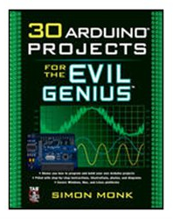

Instructions to ACES
- This exam contributes 30% towards your final mark.
- Access to your Engineering Report and Project workbook is required
- Access to your is former project files on your laptop is permitted
- Internet access is available for research and reference
- Evaluation will consider accuracy, build quality, and creativity.
- You are to demonstrate your completed circuit to me before leaving the room. A completed ER submission is to be sent to handin under the Subject Line: Servo-Controlled Laser by 8 pm this evening.

Servo-Controlled Laser

Project 25 Servo-Controlled Laser, starts in the right column of page 138 and continues through page 143.

Towards the bottom of the left column on page 138, the author begins a brief introduction to servo motors. You may want to find a deeper discussion of the device online. A description of the specific model you have been provided with can be found at:
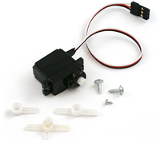
http://www.sparkfun.com/products/9065

Be sure to read both the commentary and the user feedback for as much information of the device as you can get.

Two additional items you have been provided with for working with your mini servo are a set of mini screwdrivers and epoxy for adhering your servo to the plastic shell.

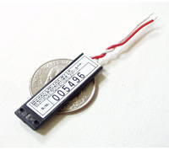
A description of the Laser Card Module you have been provided with can be found at:

http://www.sparkfun.com/products/594

Please read the description, the datasheet, and the user feedback. Note since this is a 3V/0.8mW module an appropriately sized resistor is required.

Finally, under the title, Servo-Controlled Laser, write up this activity in your ER and submit by 8pm this evening.

As your reading of the online comments on the SparkFun site revealed, a lot of experimenters whine about not making this device behave properly at first. Typically they’ve got the device connected improperly. Before you receive the entire parts kit, you’ll avoid the whine & cheese by familiarizing yourself with the simple back and forth motion of a single servo motor.

Pre-Task: Servo

- Your servo has a red-black-white wire set. Red is 5V, black is ground and white is your signal/control wire.
- Motors tend to draw higher current than many other parts so attach the 9V DC Adaptor to your Arduino so the USB is not required to supply the full power.
- Assemble the Arduino/breadboard/servo circuit, making sure the red servo lead is connected to 5V.
- Lightly press fit one servo arm onto your motor so you can simply observe that it is actually moving in the next step.
- Under the Examples menu of the Arduino IDE you’ll find Servo>Sweep. Load this sketch and upload it to your Arduino. Observe the range of motion. It may be 180°; it may be less. Don’t worry too much, as long as it’s rotating back and forth. You’re good to go. Call me over to confirm.

Pre-Task: Laser Card

- The Laser Card you will be using is only rated for 0.8mW, not the 3mW the author uses. So we have to design with care to not burn the device out.
- From the SparkFun web page, datasheet and comments you can see this device is rated for 3.1V±10%. Although the project calls for a 100Ω resistor, you’ll use a 270Ω resistor to reduce the voltage further.
- Handling it with great care, wire up a simple circuit with the 270Ω resistor and Laser Card to confirm it is working.
- Call me over to confirm.

Task: Servo-Controlled Laser

- Complete Project 25: Servo-Controlled Laser
- Call me over to confirm it functions as expected.
- Take the circuit home and use it to complete your Engineering Report.
- Submit to handin by 8pm under the Subject Line: Servo-Controlled Laser.

