// PROJECT :DCMotorControlwith5VRelay
// PURPOSE :DC Hobby Motor (Sparkfun's ROB-11696) with 5V Relay under control of 328P
// AUTHOR :C. D'Arcy
// DATE :Confirmed. 2024 05 03.
// uC :328p (Nano)
// STATUS :Working
// MOTOR :(3-12V) https://www.sparkfun.com/products/11696
// RELAY :https://www.amazon.ca/dp/B0874MC6D3?ref=ppx_yo2ov_dt_b_product_details&th=1
// PHOTO :
// NOTES :Demonstrates Forward, Reverse, and Coasting (Relay Power OFF)
#define OUTPUTSPEEDPIN 3 //PWM to MOSFET
#define RELAYCOIL 7 //2N3904 BJT controls direction (NC or NO)
#define DIRECTIONVCC 9 //Slide Switch (as stick shift)
#define DIRECTIONPIN 10 //1: Forward; 0: Reverse
#define DIRECTIONGND 11 //
#define INPUTSPEEDGND A0 //potentiometer (as accelerator)
#define INPUTSPEEDPIN A1 //potentiometer
#define INPUTSPEEDVCC A2 //potentiometer
#define MOTORSPEEDMAX 255
#define MOTOROFF 0
#define DURATION 3000
uint8_t motorSpeed;

uint8_t direction; //hold the active preference for motor rotation

void setup() {
Serial.begin(9600);
while (!Serial);

pinMode(OUTPUTSPEEDPIN, OUTPUT);
analogWrite(OUTPUTSPEEDPIN, MOTOROFF); // aka. digitalWrite(OUTPUTSPEEDPIN,LOW);

pinMode(RELAYCOIL, OUTPUT);
digitalWrite(RELAYCOIL, HIGH);
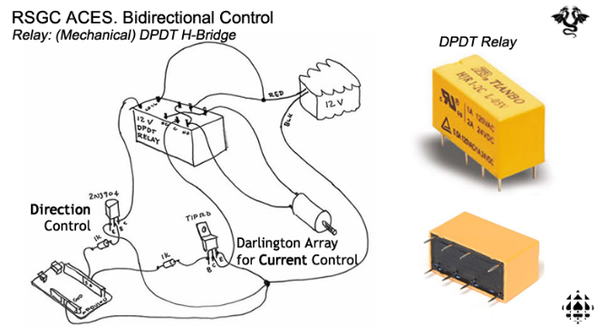
pinMode(DIRECTIONVCC, OUTPUT);
pinMode(DIRECTIONGND, OUTPUT);
digitalWrite(DIRECTIONVCC, HIGH);
digitalWrite(DIRECTIONGND, LOW);

pinMode(INPUTSPEEDGND, OUTPUT);
pinMode(INPUTSPEEDVCC, OUTPUT);
digitalWrite(INPUTSPEEDGND, LOW);
digitalWrite(INPUTSPEEDVCC, HIGH);
}

void loop() {
direction = digitalRead(DIRECTIONPIN);
digitalWrite(RELAYCOIL, direction);
motorSpeed = analogRead(INPUTSPEEDPIN) >> 2;
Serial.print(direction ? "Forward:\t" : "Reverse:\t");
Serial.println(motorSpeed);
analogWrite(OUTPUTSPEEDPIN, motorSpeed); //convert [0,1023]->[0,255]->[0,5V]
}

