Adafruit 861 (Green) 8x8 Mini Matrix Datasheet: https://cdn-shop.adafruit.com/datasheets/861datasheet.pdf
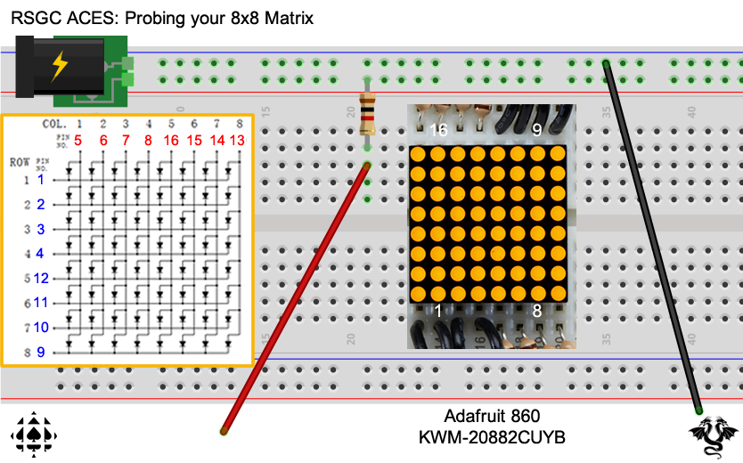
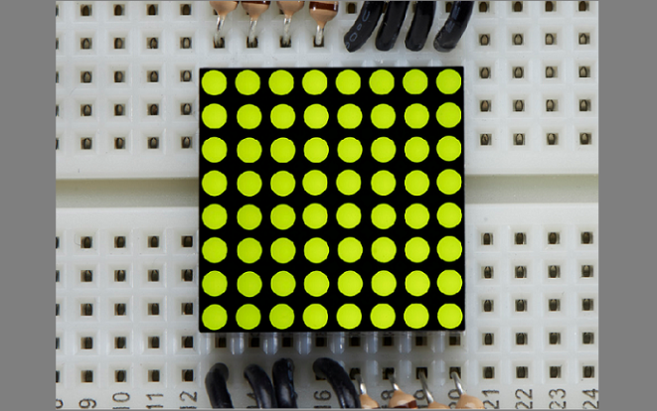

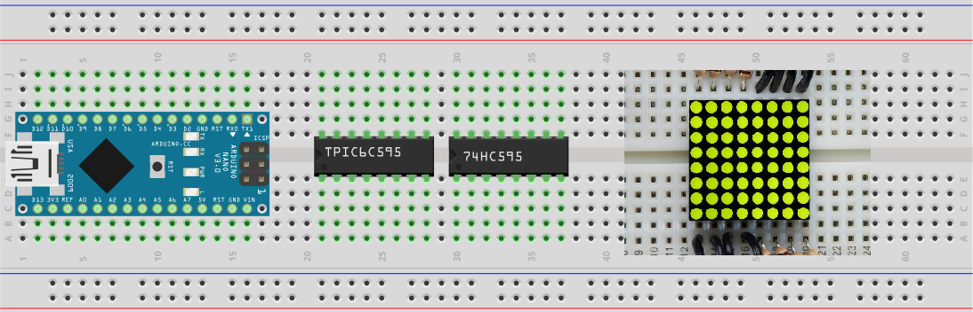
TPIC6C595  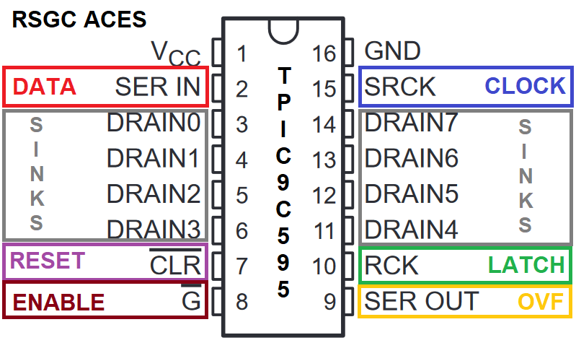 | 74HC595
