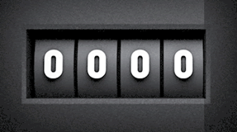
For simplicity, consider a 4-bit binary odometer. This nibble-sized counter is capable of representing 16 different integers.
For the unsigned range of numbers, the binary representation of the decimal values from 0 to 15 are obvious.
For a signed representation, although the range may be less clear at first, it is surprisingly straightforward!
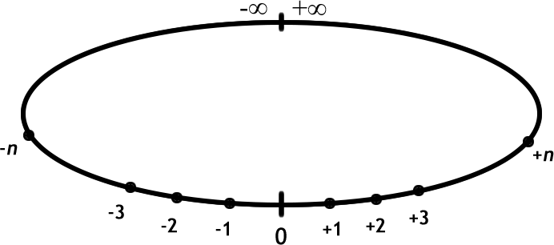
1. Imagine for the sake of illustration that our familiar number line is in fact a 1D projection of a circle of infinite radius. Two observations are useful in this context.
a) Travelling in one direction from 0 would eventually bring you back to your starting position, with the number of positive number and negative numbers being equal, and,
b) The farthest positive distance and the farthest negative distance are adjacent to one another (think, slope).
2. After our class discussion, complete the table below, employing the 2’s Complement Algorithm for signed binary representation of integers.
Representation | Unsigned | Signed
Decimal | Binary
15 | 1111
14
13
12
11
10
9
8
7
6
5
4
3
2 | 0010
1 | 0001
0 | 0000
-1
-2
-3
-4
-5
-6
-7
-8

