Challenge 1. Sensor Monitoring and Display
This collaborative task (pairs) is designed to reinforce and consolidate the knowledge and skills you have been introduced to in the past few weeks with just a hint of added time pressure. No marks will be recorded for your pair’s submissions as the greater purpose is to give you a sense of your readiness to take on additional expectations in January and beyond, in Grade 12. Do NOT ask any questions during this Challenge. Simply make the best decision possible if a requirement can not be met and continue on. Complete as much of this task as possible.

Pairs by Name
Vith & Jacob, Alex & Richard, John & Sydney, Lucas & Jack, Declan & Adrian, Graham & Brevan, John & Liam, Cole & Will, Ben & Andrew.

Prototype
Assemble the breadboard prototype EXACTLY as shown below, right. The LDR voltage divider presents on A0, the TMP36 presents on A2 (VCC) through A4 (GND), and the SPDT slide switch is positioned as shown (D3 to GND with D3 referenced as HIGH). D2 is used to read the slide switch level. Your Morland Bargraph (MBv3) is placed to the right of your Nano. The Output Enable ($\overline{OE}$) pin of the MBv3 is wired from D9 (PWM) of your Nano. The MBv3 supply pins are wired to the power bus. The MBv3’s CLOCK, DATA, and LATCH pins are to be wired from pins D13, D11, and D10, respectively.

Task
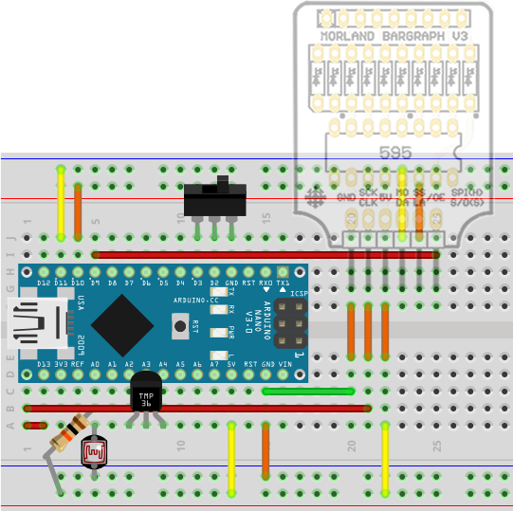
The objective of this challenge is to develop a prototype that continuously presents a scaled temperature reading acquired from the TMP36 on the MBv3. The temperature reading will be constrained to the closed interval [22°C, 29°C], where one LED represents 1°C.
Presentation of the temperature will be in one of two Modes (BAR or DOT) as determined by the slide switch. If the position of the switch is as shown in the graphic, the temperature will be displayed in DOT Mode. If the operator slides the switch to the left, the presentation will in BAR Mode (VU Meter) with multiple bars lit. See the reverse side of this page for specific displays for each temperature and Mode.
The voltage divider (fixed resistor and LDR) controls the brightness of the display and should be as responsive as possible. Full light on the LDR should reflect a very bright MBv3 display. As you move your hand over the LDR, the MBv3 will get dimmer accordingly to almost off when completely covered.

Submission
By 9:35 either an (in tight) photo or, better yet if you have time, the recording of a comprehensive 30s video of your device in action, is underway. One partner can hold the camera still while the other operates the prototype, being sure to cover all required aspects of its functionality.
By 9:45, your pair’s well-documented Arduino sketch entitled, MonitorandDisplay.ino along with your photo or video will be attached to an email to ACESHandin, under the Subject Line: Challenge 1.
The best sketch and the best photo/video, in my opinion, will be mounted on our course page for all to enjoy and aspire to.

Mapping of ADC to Temperature for the TMP36
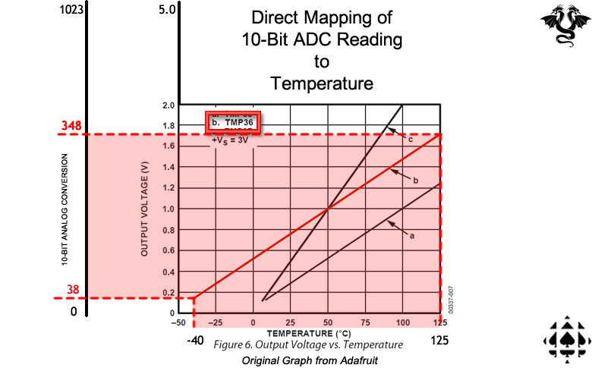

MBv3 Display by Mode
 | BAR Mode: Multiple | DOT Mode: Single
Temperature | 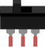 | 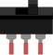
$$≤22℃$$ | 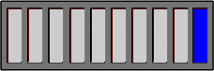
$$23℃$$ | 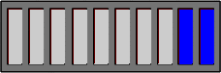 | 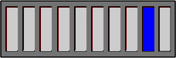
$$24℃$$ | 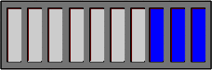 | 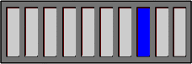
$$25℃$$ | 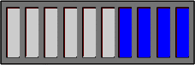 | 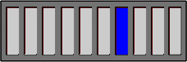
$$26℃$$ | 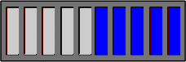 | 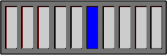
$$27℃$$ | 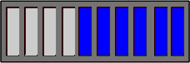 | 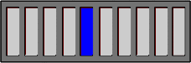
$$28℃$$ | 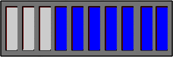 | 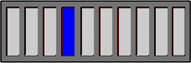
$$≥29℃$$ | 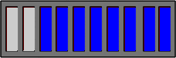 | 