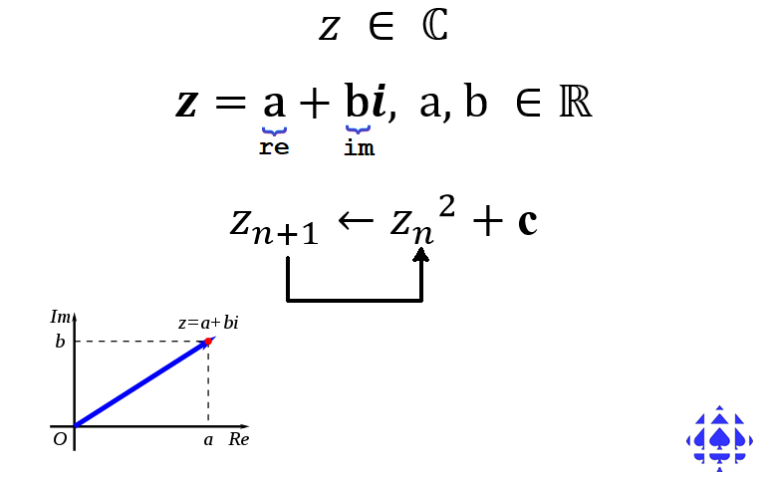
Arduino IDE: ComplexNumbers.ino
Reference: Complex Numbers, Studies.pdf, pp.4-5
Here’s a sample sketch I’ve prepared to lay the foundation for introduction to the Mandebrot Set.

// PROJECT :ComplexNumbers
// PURPOSE :Arithmetics of Complex Numbers for ICS3U
// COURSE :ICS3U
// AUTHOR :C. D'Arcy
// DATE :2020 05 11
// MCU :328P
// STATUS :Working
// REFERENCE:pp. 4-5, http://darcy.rsgc.on.ca/ACES/ICS3U/STUDIES.pdf
//---------------------------------------------------------------------
// NOTES :There are many design options for modeling a comprehensive
// :Complex number class. What appears below was designed to be
// :understandable by the average ACES hardware student.
// :Software-inclined ACES, designing for maximum efficiency
// :would/will create something different.
//---------------------------------------------------------------------
#define PRECISION 6 //number of decimal places in the display
#define DURATION 500 //timeout interval between display of outputs
//---------------------------------------------------------------------
// a struct provide a simple binding of the real and imaginary coefficients
struct Complex{
float re;
float im;
};
//---------------------------------------------------------------------
Complex z0 = {0, 0}; //the origin of the Complex Plane
Complex z1 = {0.2,0.2}; //a sample in the 1st quadrant
Complex z2 = {0.5, 0.5}; //another sample in the 1st quadrant
Complex z3 = {-0.5,0.5}; //a sample in the 2nd quadrant
Complex z4 = {2,-1}; //a sample in the 4th quadrant
//---------------------------------------------------------------------

void setup() {
Serial.begin(9600);
displayComplex(z0); //present the complex numbers we've defined
displayComplex(z1); // "
displayComplex(z2); // "
displayComplex(z3); // "
displayComplex(z4); // "

Serial.println(z0.re,PRECISION);

displayComplex(add(z0,z1)); //sum
displayComplex(subtract(z0,z1)); //difference
displayComplex(multiply(z1,z2)); //product
// displayComplex(divide(z1,z2)); //see if you can develop this function
displayComplex(square(z4)); //multiply a complex number by itself
displayComplex(squareAdd(z2,z3)); //sample compound operation
Serial.println(magnitude(z4),PRECISION);//the distance from the origin

//---------------------------------------------------------------------

//let's begin to examine iterative feedback with complex numbers
Complex z = {0.0,0.0}; //initialize z at the origin
Complex c = z1; //initialize c to a fixed complex number
while (true){ //repeat, forever
displayComplex(z); //display the progress
delay(DURATION); //admire...
z = squareAdd(z,c); //z <- z^2 + c
}
}

void loop() {}

//----Arithmetic functions that operate on complex numbers------------
Complex add(Complex za, Complex zb){
Complex zc = {za.re+zb.re,za.im+zb.im};
return zc;
}

Complex subtract(Complex za, Complex zb){
Complex zc = {za.re-zb.re,za.im-zb.im};
return zc;
}

Complex multiply(Complex za, Complex zb){
Complex zc = {za.re*zb.re-za.im*zb.im,za.re*zb.im+za.im*zb.re};
return zc;
}

Complex square (Complex za){
Complex zc = multiply(za,za);
return zc;
}

Complex squareAdd(Complex za, Complex zb){
Complex zc = add (square(za),zb);
return zc;
}

float magnitude(Complex za){
return sqrt(za.re*za.re+za.im*za.im);
}

void displayComplex(Complex z){
Serial.print("z=");
Serial.print(z.re,PRECISION);
Serial.print(z.im<0.0?'-':'+');
Serial.print(abs(z.im),PRECISION);
Serial.println("i");
}

