// PROJECT :IRLEDControl
// PURPOSE :ACES Adaptation of Shirriff's IRrecvDump Example
// DEVICE :Arduino + Sharp GP1UX511QS (38kHz, 8.5m,5V) + Bicolor LED
// AUTHOR :C. D'Arcy
// DATE :2019 03 25
// uC :328
// COURSE :ICS3U
// STATUS :Working
// REF1 :IRremote library: https://github.com/z3t0/Arduino-IRremote
// REF2:https://en.wikibooks.org/wiki/C_Programming/Preprocessor_directives_and_macros
// REF3 :Shirriff's IR Blog:http://www.righto.com/search?q=IR
// REF4 :Find IR Codes: http://irdb.tk/find/
#include <IRremote.h>
#define RECV_PIN 11 //GP1UX511QS: pin 1 VOUT
#define GND 10 //GP1UX511QS: pin 2 GND
#define VCC 9 //GP1UX511QS: pin 3 5V
//Compiler Preprocessor Directives...
#define DEBUG //conditional serial monitoring (See: REF2)
//#define NEC //https://www.sbprojects.net/knowledge/ir/nec.php
//#define SONY //https://www.sbprojects.net/knowledge/ir/sirc.php
//#define SHARP //https://www.sbprojects.net/knowledge/ir/sharp.php
//#define GENERIC //Generic...labelled: LCD Remote
#define SMARTBOARD //DES Smartboard Remote Control
#ifdef NEC //
#define ON_OFF 0x61A028D7
#else
#ifdef SMARTBOARD
#define ON_OFF 0xD15348B7
#else
#ifdef GENERIC
#define ON_OFF 0x61D648B7
#endif
#endif
#endif
#define TERMINATOR 0xFFFFFFFF //Universal? Not sure…
IRrecv irrecv(RECV_PIN);
decode_results results; //results data structure

#define RED PD7 //Red anode
#define GREEN PD6 //Green anode

void setup() {
Serial.begin(9600);
irrecv.enableIRIn(); //Start the Detector
pinMode(VCC, OUTPUT); //identify supply lines
pinMode(GND, OUTPUT); //
digitalWrite(VCC, HIGH); //provide 5V supply
digitalWrite(GND, LOW); //provide GND supply

DDRD |= 1 << RED | 1 << GREEN; //set LED leads to output
PORTD &= ~(1 << RED | 1 << GREEN); //ground 'em both
showRed(); //start with red to confirm
}
void showRed() { //turn on the Red lamp
PORTD &= ~(1 << GREEN); //set Green lead LOW
PORTD |= (1 << RED); //set Red lead HIGH
}

void showGreen() { //turn on the Green lamp
PORTD &= ~(1 << RED); //set Red lead LOW
PORTD |= (1 << GREEN); //set Green lead HIGH
}

void loop() {
if (irrecv.decode(&results)) { //if there's a signal, demodulate & record
#ifdef DEBUG //suspend this code when deployed
Serial.println(results.value, HEX);
#endif
if (results.value == ON_OFF){
showGreen();
delay(3000);
showRed();
}
irrecv.resume(); //prepare for next IR signal
}
}
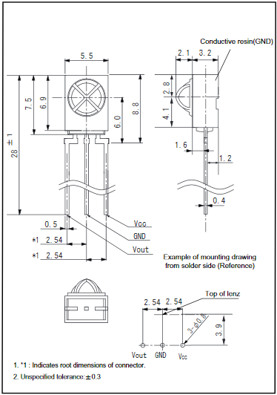 | 