Instruction to Students

- This exam contributes 30% towards your final mark.
- Appropriate coding style and javadoc-style documentation are expected.
- Attach your fully documented Traveller.java source file to an email to Handin, with the Subject Line: Traveller at the end of the exam.
- You are allowed access to your former project files on your laptop.
- Internet access is available for the first 30 minutes to view he simulation. Email access is provided in the last 10 minutes for the sole purpose of submitting your code.

Pandemic

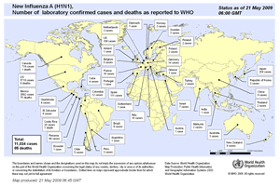
The recent rash of worldwide illnesses attributable to a strain of the Influenza A or H1N1 virus (aka swine flu) has forced the World Health Organization (WHO) to raise its pandemic alert level to 5.

In the interest of tracking the spread of the influenza, WHO has commissioned you to develop a simulation of a traveler that, in the course of moving around the world, comes in contact with the virus.

In this simulation, the Traveller object, nomad, begins in the center of the world facing north as can be seen in Figure 1. In the course of traveling, nomad goes to random intersections in the world, and acquires all the viruses at that location. As could be expected, the accumulation of these viruses has an adverse effect on nomad’s health, according to the following chart,

Number of Viruses (Things) Acquired | Visual Change to nomad
less than 10 | no effect
less than 20 | turns green
less than 30 | turns blue
less than 40 | still blue; transparency set to 50%
less than 50 | still blue; transparency set to 75%
50 | fully transparent; simulation stops

Figures 2 through 4 show the simulation at various discrete stages. Finally, to better monitor the simulation, WHO officials have requested two additional requirements. The first is that as the nomad travels, its label always reflects the number of viruses it’s carrying. Secondly, the random destination (intersection) nomad is headed to, is always reflected in the title of the City’s frame. You have 30 minutes to view the simulation: http://darcy.rsgc.on.ca/ACES/TEE2O/Exams/2009RobotsExam.htm

Figure 1. Initial State of the Simulation | Figure 2. After 10 Viruses are Acquired
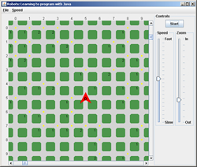 | 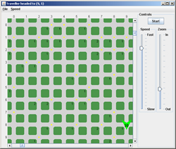
Figure 3. After 40 Viruses are Acquired | Figure 4.Final State of the Simulation
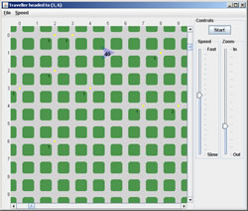 | 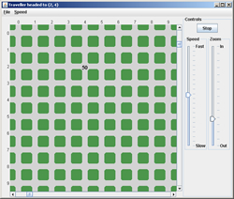

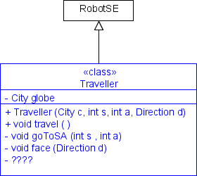
Task
- Review the simulation thoroughly during the first 30 minutes of the exam. After that, internet access will be unavailable.
- Create a project called Pandemic, and type in the code for the driver class you see below.
- Develop the class, Traveller, implementing the resources indicated in the UML diagram to the right. Using a Stepwise Refinement strategy, coordinate a logical sequence of private method calls to accomplish the activity outlined above.
- In the last 10 minutes, submit Traveller.java to Handin.
This is the code for the Pandemic driver class. Type it in exactly as presented. Do not modify it and do not submit at the end of the exam.

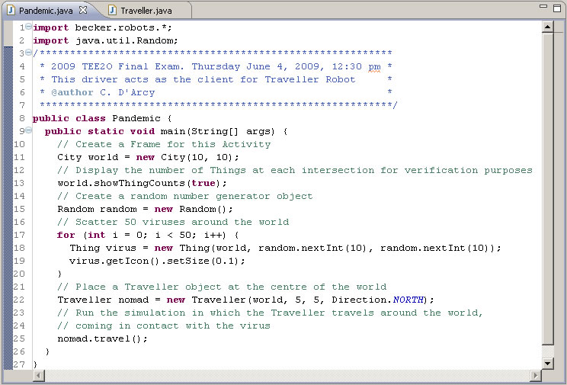

Evaluation
The focus of our introduction to Java this term was not about the use of complex methods, or fancy-looking icons (although we dabbled in both), but rather the creation of well-named, robust, single-purpose methods that reflect the problem-solving skills of the author who has broken a large task into manageable, bite-sized pieces. The highest marks then, will be reserved for those students that submit a Traveller class that,

- reflects sound, well-thought-out Stepwise Refinement strategies
- superior javadoc-style documentation
- efficiency, and,
- follows exactly and complete all aspects of this examination

Have a safe summer and I look forward you deeper into the world of computer engineering
(hardware and/or software) next year

