INSTRUCTIONS TO STUDENTS
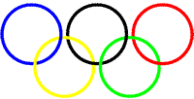
- This exam contributes 30% towards your final mark.
- Appropriate coding style and javadoc-style documentation are expected.
- Attach your RobotPV.java class file and your PoleVault.txt file to an email to handin, with the Subject Line: Robolympics at the end of the exam.
- You are allowed access to your former project files on your laptop.
- No internet or email use is permitted. Email access will be allowed for a short period of time towards the end of the exam, for the purpose of submitting your files.

Robolympics: The Pole Vault

The reigning Men’s Olympic record holder in the pole vault is Tim Mack of the USA, with a jump of 5.95 metres, set in Athens in 2004. karel will attempt to break that record in Beijing this summer. But first he must practice.

In this project, karel begins on intersection (7,0) facing EAST as shown below. The pole vault standard rises upward from (7,10) on the east side of the intersections above (7,10), to some random height between 1 and 7 (as depicted). This represents the height of the bar. By picking up all the Things in the pile situated at (7,0), karel is able to tell the height of the bar.

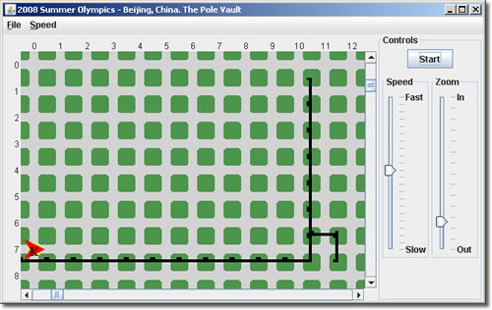
Once karel knows the height of the bar, he runs towards the base of the standards at (7,10), increasing his speed by 2 moves per second per intersection as he approaches. When he arrives, he performs the jump. At each metre (intersection) during his ascent, he leaves a Thing and decreases his speed by 2 metres per second (that gravity problem). When he’s out of Things, he knows it‘s time to cross the bar. He does and begins his descent, increasing his speed by 2 moves per second as he falls. karel lands comfortably in the pit at (6,11) and finishes by facing EAST to acknowledge his adoring fans. The final state of the activity appears below.

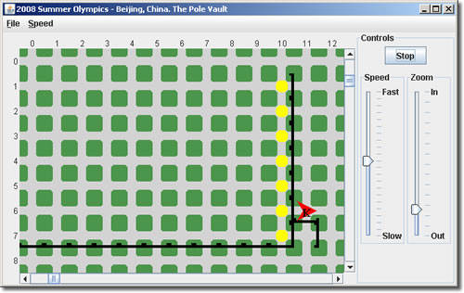

Task
- Create a project called Robolympics
- Create the driver class, Robolympics.java and type in the code exactly as you see below (you are not to modify this code)
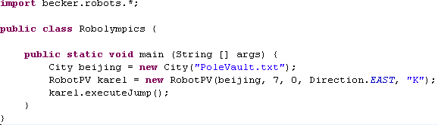
- Create the text file, PoleVault.txt, that has Walls defining the approach runway from (7,0) to (7,10), Walls defining the pole vault standards ranging in height from 1 metre to as many as 7 metres, and a number of Things at (7,0) equal to the height of the standards.
- Develop the class, RobotPV, adding the resources indicated in the UML diagram below. Using a Stepwise Refinement strategy, design, implement and coordinate a logical sequence of private methods that will accomplish the activity outlined above.

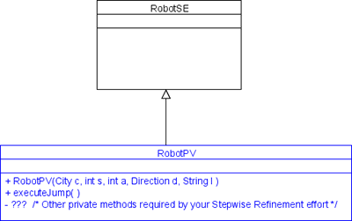

- Develop and include comprehensive javadoc-style documentation for your RobotPV class.

Submission
At the end of the exam, attach your RobotPV.java and PoleVault.txt files to an email to handin under the Subject Line: Robolympics. Don’t forget to Send!

Evaluation
The focus of our introduction to Java this term was not about the use of complex methods, or fancy-looking icons (although we dabbled in both), but rather the creation of well-named, robust, single-purpose methods that reflect the problem-solving skills of the author who has broken a large task into manageable, bite-sized pieces. The highest marks then, will be reserved for those students that submit a RobotPV class that,

- reflects sound, well-thought-out Stepwise Refinement strategies
- superior javadoc-style documentation
- efficiency (look closely at the sample run-there are no unnecessary turns), and,
- follows exactly and complete all aspects of this examination


