The PCB image of our ACES’ One-Wire Keypad appears below. Voltage division is the principle behind recognition of its key presses. From our first ACES course we learned that if R1 and R2 are two resistors in series, spanning VCC and GND, the voltage, V, between the two can be expressed as,
$\text{V=VCC}\left(\frac{\text{R2}}{\text{R1+R2}}\right)$ (1)
The integer value, adc, returned by the ATmega328p’s 10-bit analogRead(An) function can be expressed as,
$\text{adc}\text{=V ×}\left(\frac{\text{1023}}{\text{VREF}}\right)$ (2)
where VREF is 5V by default.
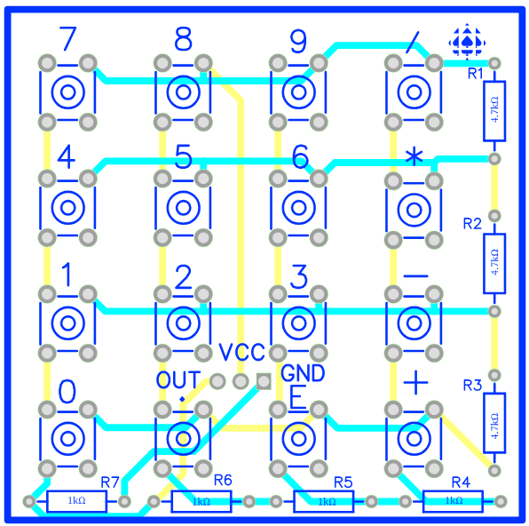

Assuming a VCC value of 5V, resistor values as shown above, determine the value returned by an Arduino 10-bit analogRead(An) function when pressing each of the following using (1) and (2) above.
a) the ‘-’ key

b) the digit key next to your name

