1. Knowledge. What is electricity in your view?

2. Knowledge. Identify some of the sources of electrical energy that you may be familiar with.

a)

b)

c)

d)

3. Knowledge. Identify some of the forms into which electricity can be converted.

a)

b)

c)

d)

4. Research. Why should we do our best to conserve electrical power?

5. Research. What is Phantom Power and what should we do about it?

4. Research. List 4 precautions you must consider when working with, or around, electricity.

a)

b)

c)

d)

4. Research. Some materials are good conductors of electricital energy and some are not (insulators). Indicate as many materials as you can think of that belong to each category.

Conductor | Insulator

5. Research. For the batteries depicted below, identify their name, voltage, and current capacities.

Battery | 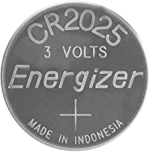 | 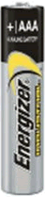 |  | 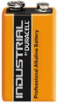
Name
(Initial) Voltage
(Initial)
Current Capacity
(in mAh)

