TST-58114_45_45.jpgIf at any time one of your components gets **hot**, immediately disconnect your battery, consider the probable cause, and then discuss the issues and corrective action with one of the student instructors.

### 1. DES Soldering Resources

Please familiarize yourself with the resources the DES provides is support of your soldering efforts by reviewing the photo below and identifying the assets by name.

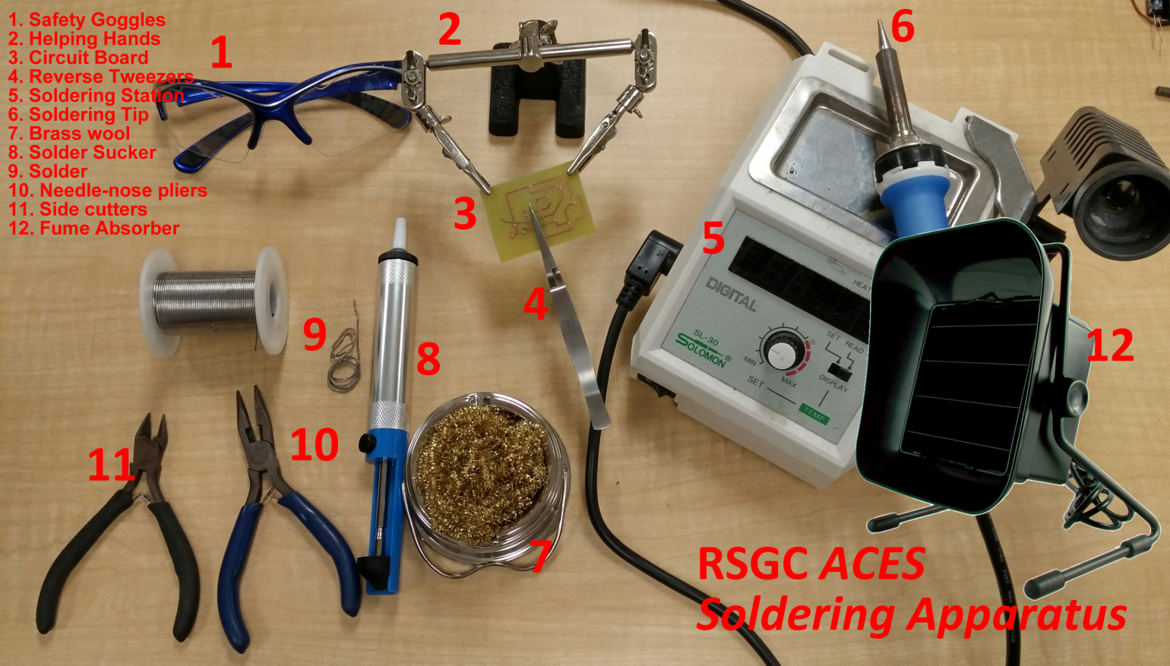

### MiniatureToggleSwitch.jpg2. Miniature (Micro) Toggle Switch Soldering

For your first ‘required’ soldering task you are asked to solder two, **solid core, 22 AWG wire**s to the leads of a miniature toggle switch similar to the one depicted to the right. One wire will be soldered to the **center** lug and the other wire soldered to an **outer** lug (*it doesn’t matter which one*). The remaining outer lug remains free. After soldering, **heat shrink tubing** is applied to strengthen the joints and to guard against a short circuit. Please watch this video prior to soldering day,

<https://www.youtube.com/watch?v=pfbs182mvIc>