We have learned enough to this point to introduce a battery to act as a source of voltage, also known as potential. That is, it gives us the ‘potential’ to do some (electrical) work!

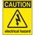
If at any time one of your components gets hot, immediately disconnect your battery. Consider the probable cause and then undertake the corrective action.
Note. The battery should be disconnected while you are assembling a circuit.

1. Wire up up your breadboard in the following standard arrangement.

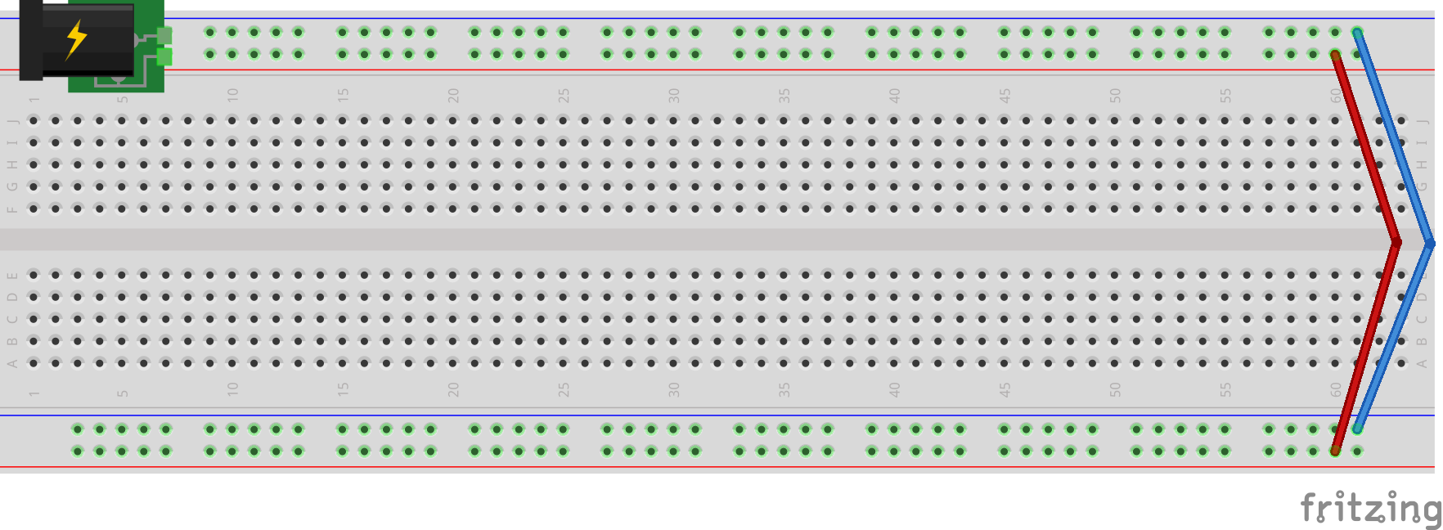
2. The purpose of this worksheet is to understand how the voltage drops throughout a working circuit. The image below is intended to present four different circuits labeled 1 through 4. Using a DMM, determine the amount of voltage between the red and black locations within each circuit.
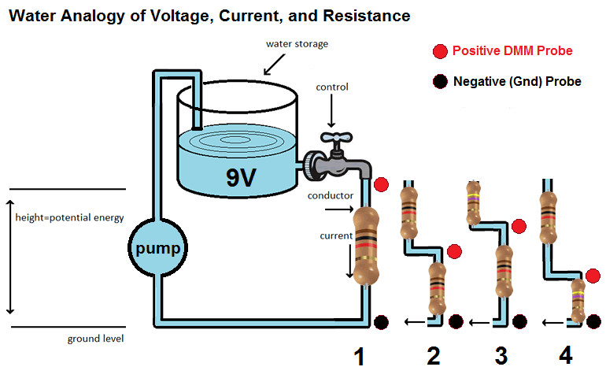

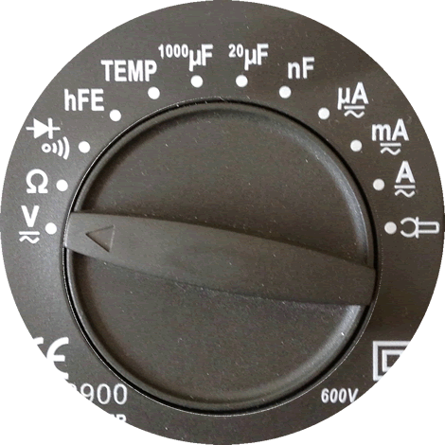
3. a) The previous image appears to suggest that the entire voltage (potential) of the battery is to be consumed by a single 1000Ω (1k Ω) resistor. Wire up the circuit as shown below, before attaching your 9V battery.

b) Set the dial of your DMM to Voltage as shown to the right, making sure the FUNC button is pressed so that DC appears in the LCD screen.

c) Place the red probe of your DMM on the first leg of the resistor and the black (ground) probe on the second leg of the resistor. You have just determined how much voltage remains to be consumed by this single resistor. What does your DMM read? V?

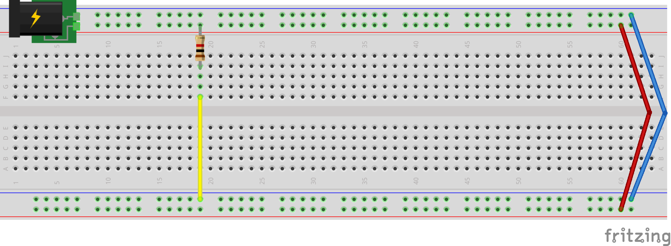
4. So, it could be said that the single resistor in Circuit 1 is responsible for consuming the entire voltage of our battery (as it’s the only resistor in the circuit).

The remaining three circuits each have two resistors in series. We’re interested in how much voltage remains to be consumed by the second resistor. Saying this another way, we’re interested in how the two series resistors divide the 9V of our battery source. Prototype each of the three remaining circuits, obtain the DMM voltage measurements between the red and black test points and fill in all of the blank cells in the table below. Be sure to unplug your battery and remove each circuit completely as you go so it does not interfere with your measurements.

Circuit | R1 (Ω) | R2 (Ω) | Voltage Remaining (V)
2 | 1K
3 | 470
4

