Resistors: Identification and Calculation

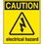
If at any time one of your components gets hot, immediately disconnect your battery, consider the probable cause, and then discuss the issues and corrective action with one of the student instructors.

In the previous exercise you used the resources of the ACES ProtoKit to design simple LED circuits. Assuming the goal is to make your LEDs glow, not blow, it is important for you to review the identification and calculation of fixed, current-limiting resistors in both single and parallel LED circuits.

1. Identification: Reading Resistors
If you know the acronym for colours of the (ROYGBV) and a little arithmetic, reading a resistor value without the assistance for a DMM is easy and a time-saving skill to have!

Things to Know

a) Each of the colours are assigned to a digit as follows: 0-Black, 1- Brown, 2-Red,…,7-Violet, 8-Grey, 9-White (see the Colour Codes below left). The ROYGBV acronym covers the digits from 2 through 7.

b) The first two colours (digits) form a two-digit number. The third colour (digit) represents a power-of-ten multiplier. For example, a resistor with colour bands Brown-Black-Red, has a nominal resistance of 1 0×10² or 1000 Ω, commonly referred to as 1 kilo Ω or, simply, 1kΩ.
Resistor Colour Codes  http://darcy.rsgc.on.ca/ACES/images/resistor-color-chart.jpg | Resistor Applet  http://www.dannyg.com/examples/res2/resistor.htm
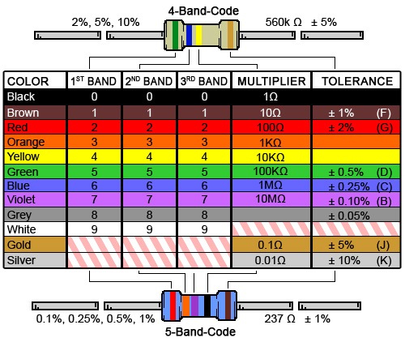 | 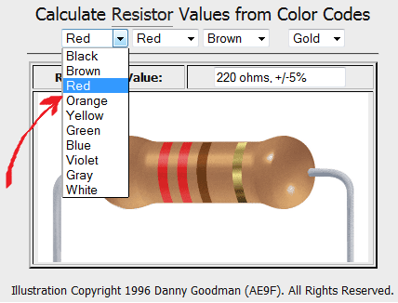

c) What is the resistance of resistor with colour bands, Yellow-Violet-Brown? ________Ω

d) What are the colour bands of a 680 Ω resistor? __________ __________ _________

Use the Resistor Applet at the URL (indicated above right) to confirm your two answers above.

2. LED Calculator: Current Limiting Resistor Value
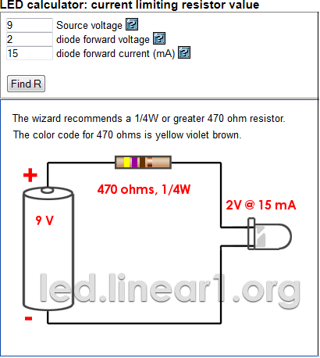
a) The screen capture to the right is taken from an online resource found at,

http://led.linear1.org/1led.wiz

The activity can be used to confirm the exact value of the fixed resistor required to complete a single LED circuit.

In this example, a 9V battery source was supplied, together with the forward voltage (V_{f}) required by your LED (2V for a red LED) and the desired current of 15 mA that is indicated on the LED datasheet.

Pressing Find R yields a recommended of a fixed resistor value of 470 Ω which you know to be yellow-violet-brown.

b) Go to the site referred to above and determine the recommended value for the fixed resistor in each of the following situations.

Single LEDs
i) 5V Source, 1 red LED with V_{f} = 2 V, with forward current of 15 mA ? _______Ω

ii) 5V Source, 1 green LED with V_{f} = 2.2V, with a forward current of 20 mA ? _______Ω

Multiple LEDs
For the final two configurations, use the series/parallel multiple LED wizard found at:

http://led.linear1.org/led.wiz

iii) 9V Source, 4 red LEDs with V_{f} = 2V, with forward current of 20 mA? _______Ω

iv) 4.5V Source, 16 white LEDs with V_{f} = 2.8V, with forward current of 20 mA? _______Ω

