Your First Circuits

In this exercise you will design, assemble, and test three different circuits. The goal is to think deeply about the concepts and ideas that we have been discussing so that your components (and you!) are protected from harm.

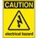
If at any time one of your components gets hot, immediately disconnect your battery, consider the probable cause and then discuss the issues and corrective action with one of the student instructors.

1. Before You Start

a) Since an LED has a positive leg (anode) and a negative leg (cathode) it must be inserted into a circuit with the correct orientation. How can you tell which leg is which by simply looking at the LED? Is there another way?

b) Use your DMM to record the actual voltage of the battery that you have been given. _______V

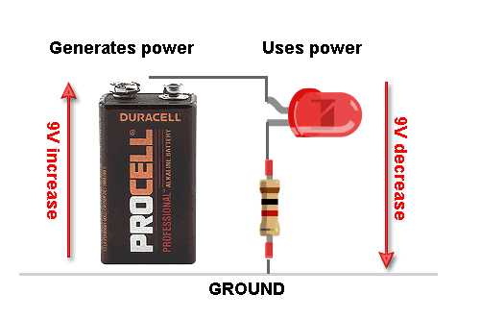
2. A Single LED Circuit
A Circuit Law dictates that the entire voltage of the power source is used up in a working circuit.

Since a red LED consumes 2.2V, a resistor is required to absorb the remaining voltage.

Use the components you have been provided with to assemble the circuit depicted to the right.

Question. How much voltage was the resistor required to absorb? _________________

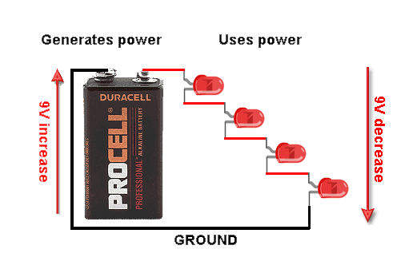
3. LEDs in Series

Since a single red LED drops the voltage by 2.2V and our battery source provides approximately 9V, we may replace the resistor in the previous circuit with a sufficient numbers of LEDs, arranged like a staircase!

Question. To ensure ALL the voltage from the battery is consumed (down to ground (0V) ), how many LEDs should we place in series? In other words, how many steps are in our staircase? ____________

Question. How much voltage remains after you put in your LEDs and does this present a problem?

4. LEDs in Parallel

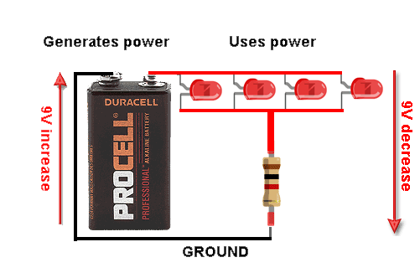
Another way we can arrange our LEDs is in parallel.

In this configuration, all the positive (anode) legs of the LEDs are connected as are the negative (cathode) legs.

Arranged in this way, the combined LEDs only drop the voltage by the same amount as a single LED.

As a result, we must bring back the same resistor that we used in Step 2, when we had a single LED.

Question. If the voltage dropped by multiple LEDs in parallel is the same as by a single LED, something else might be different about the power draw on the battery. What do you think this might be?

5. Battery Recycling

a) Research and explain in your words the proper way to dispose of household batteries.

b) Identify two chains of stores in Toronto that will accept used household batteries.

