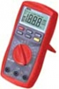
Exploring with the Digital Multimeter (DMM)

1. Conductivity (Continuity)

a) What is continuity (in your own words)?

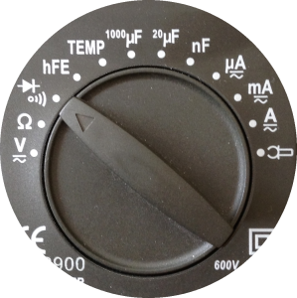

b) Set your Digital Multimeter (DMM) to continuity, walk around the room and identify materials that are either conductors of electricity or insulators. Summarize your results in the table below.

 | Material | Conductor or Insulator?
1.
2.
3.

2. Voltage

a) What voltage is displayed on your AAA battery? _______V

b) What reading did the DMM display for your AAA battery? _______V

c) What voltage is displayed on your AA battery? _______V

d) What reading did the DMM display for your AA battery? _______V

e) What voltage is displayed on your square battery? _______V

f) What reading did the DMM display for your square battery? _______V

