Continuity
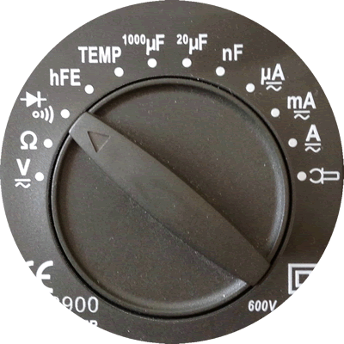
1. Identify the steps required to prepare your digital multimeter (DMM) to measure continuity.

a)

b)

c)

2. How does the DMM inform you if the electrical path is continuous?

3. Set your DMM to continuity, walk around the room and identify materials that are either conductors of electricity or insulators. Summarize your results in the table below.

 | Material | Conductor or Insulator?
1.
2.
3.

Resistors: Role, Identification, and Calculation
4. Role. What purpose do resistors serve in an electrical circuit?

5. What is the unit of measure for resistance?

6. Identification.

a) What are the first three colour bands of a 470 Ω fixed resistor?

__________ __________ _________

b) What are the first three colour bands of a 1000 Ω (1k Ω ) fixed resistor?

__________ __________ _________

c) Research. What is significance of the further colour band on your resistor?

7. Calculation. If you know the acronym for colours of the (ROYGBV) and a little arithmetic, reading a resistor value without the assistance for a DMM is easy and a time-saving skill to have!

Things to Know

a) Each of the colours are assigned to a digit as follows: 0-Black, 1- Brown, 2-Red,…,7-Violet, 8-Grey, 9-White (see the Colour Codes below left). The ROYGBV acronym covers the digits from 2 through 7.

b) The first two colours (digits) form a two-digit number. The third colour (digit) represents a power-of-ten multiplier. For example, a resistor with colour bands Brown-Black-Red, has a nominal resistance of 1 0×10² or 1000 Ω, commonly referred to as 1 kilo Ω or, simply, 1kΩ.
Resistor Colour Codes  http://darcy.rsgc.on.ca/ACES/images/resistor-color-chart.jpg | Resistor Applet  http://www.dannyg.com/examples/res2/resistor.htm
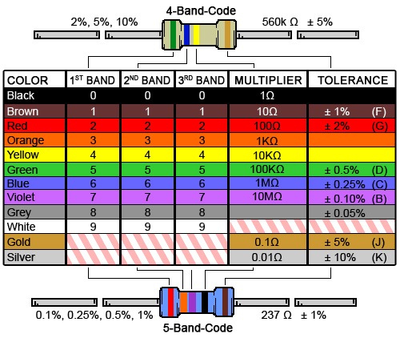 | 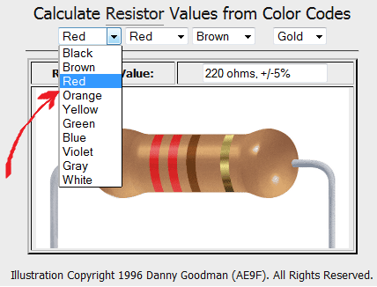

c) What is the resistance of resistor with colour bands, Red-Red-Brown? ________Ω

d) What are the colour bands of a 680 Ω resistor? __________ __________ _________

Use the Resistor Applet at the URL (indicated above right) to confirm your two answers above.

