Breadboard Basics

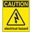
If at any time one of your components gets hot, immediately disconnect your battery, consider the probable cause, and then discuss the issues and corrective action with one of the student instructors.

In the previous exercise you assembled a various LED circuits using wires with alligator clips on each end. This is an important first step, in developing electric circuits but it is somewhat cumbersome and complex designs take up a lot of space.

A breadboard is a more convenient platform to develop a prototype of an electric circuit. Consider it to be your workbench where you test out your ideas and designs.

In this exercise you will familiarize yourself with the basic properties of your breadboard with the help of a DMM.

1. Visual Properties

a) The image of a single, full size breadboard appears below. Using your arithmetic skills, determine the total number of holes it offers. _______

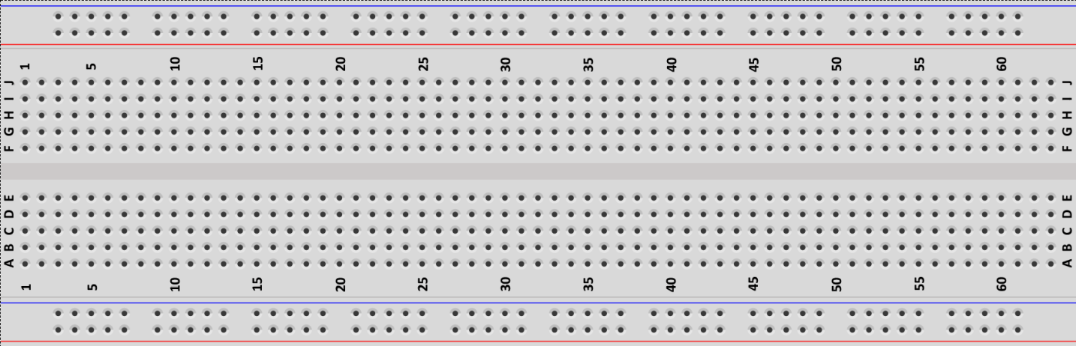

b) Describe the organization of the holes.

c) Identify any colours you see and suggest what the purpose they might serve.

c) Using the numbers and letters, mark the following specific hole locations with your pencil.

i) A1 ii) E1 iii) G1 iv) J1 v) A2 vi) H25

2. Exploring the Breadboard with a DMM
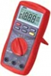
In an earlier worksheet you used the DMM’s ability to detect continuity. Placing the probes at either end of wire resulted the device emitting a beep. Let’s use the same strategy to determine which holes on the breadboard are connected.

Set your DMM to Continuity ( ) and determine if the following sets of holes are connected.

a) All the holes in the blue rail on top side of the breadboard? Answer (Y or N)_____

b) All the holes in both the top blue rail and bottom blue rails? Answer (Y or N)_____

c) All the holes in the top red rail? Answer (Y or N)_____

d) All the holes in both the top red rail and bottom red rail? Answer (Y or N)_____

e) Holes A1 and E1? Answer (Y or N)_____

f) Holes E1 and G1? Answer (Y or N)_____

g) Holes G1 and J1? Answer (Y or N)_____

g) Holes A1 and A2? Answer (Y or N)_____

3. Additional Questions

a) Suggest the simplest way to ensure all the holes in the top and bottom blue rails are connected (continuous).

b) Similarly, suggest the simplest way to ensure all the holes in the top and bottom red rails are connected (continuous).

c) Explain what is meant by a short circuit and the danger it presents.

d) Considering your answers to the above questions, explain the WRONG way to connect the holes in the blue and red rails.

