Using the ACES’ ProtoKit

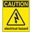
If at any time one of your components gets hot, immediately disconnect your battery, consider the probable cause, and then discuss the issues and corrective action with one of the student instructors.

In the previous exercise you explored and mapped a single breadboard. Knowledge of the underlying connections within the board will help you avoid problems associated with prototyping electric circuits.

1. Breadboard Awareness

2. Common Circuit Prototype Oversights, Mistakes, Problems, and Issues

The intent of the prototype below was to have an LED turn on. In each of the five cases below it did not work as expected. In the space provided to the right of each image, explain fully the oversight mistake, problem, or issue the circuit designer is facing.

Circuit | Oversight / Mistake / Problem / Issue
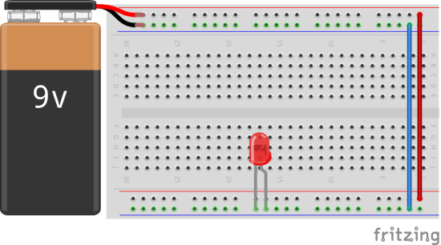
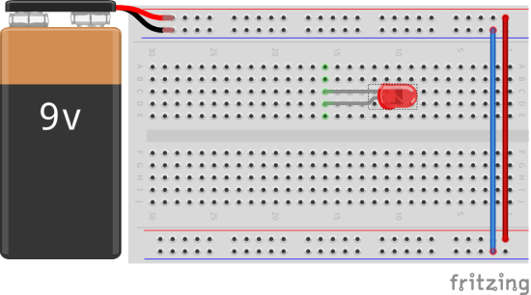
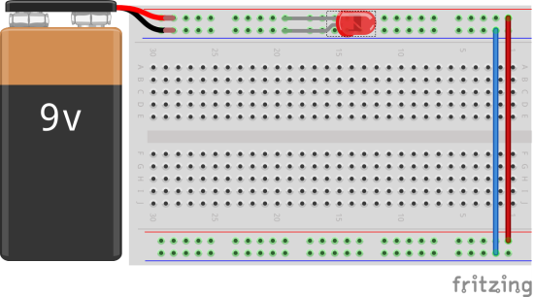
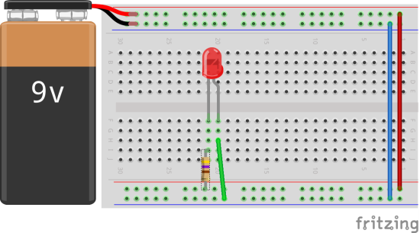
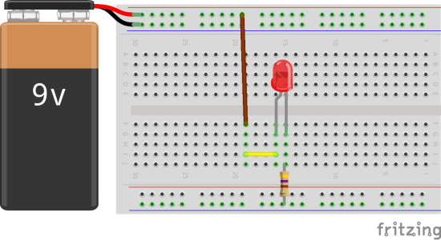

2. The ACES’ ProtoKit

Senior RSGC ACES’ students have designed a convenient prototyping kit for your use. You may notice they have used VHS cases to house the components (finding new uses for existing items around your house is a highly encouraged application of your creativity). Use the table below to indicate the quantity and description of the parts that make up your kit.

Quantity | Description

