1. Physical Characteristics of the Breadboard

The platform on which you will assemble (prototype) your circuits is referred to as breadboard. You can think of it as your workbench where you convert your circuits drawing (schematics) to a practical model. Knowledge of the underlying connections within the board will help you avoid problems associated with prototyping electric circuits.

1. [Research and Communication] Using your research skills determine the origin of the term breadboard and summarize it in your own words.

2. [Analysis] The image of a single, full size breadboard appears below. Using your arithmetic skills, determine the total number of holes it offers.
_______

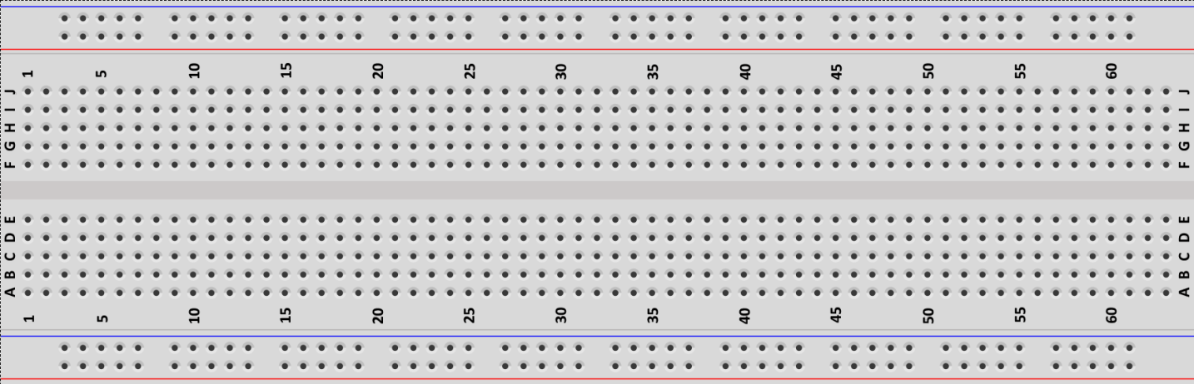

c) [Communication] Describe the organization of the holes.

d) [Communication] Identify any colours you see and suggest what the purpose they might serve.

e) [Knowledge and Thinking] From our previous workshop do you recall whether the holes closest to the red rail at the top connected to the holes closest to the red rails along the bottom?

f) Using the numbers and letters, mark the following specific hole locations with your pencil.

i) A1 ii) E1 iii) G1 iv) J1 v) A2 vi) H25

2. Exploring the Breadboard with a DMM
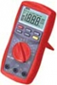
In an earlier worksheet you used the DMM’s ability to detect continuity. Placing the probes at either end of wire resulted the device emitting a beep. Let’s use the same strategy to determine which holes on the breadboard are connected.

Set your DMM to Continuity ( ) and determine if the following sets of holes are connected.

a) All the holes in the blue rail on top side of the breadboard? Answer (Y or N)_____

b) All the holes in both the top blue rail and bottom blue rails? Answer (Y or N)_____

c) All the holes in the top red rail? Answer (Y or N)_____

d) All the holes in both the top red rail and bottom red rail? Answer (Y or N)_____

e) Holes A1 and E1? Answer (Y or N)_____

f) Holes E1 and G1? Answer (Y or N)_____

g) Holes G1 and J1? Answer (Y or N)_____

g) Holes A1 and A2? Answer (Y or N)_____

3. Additional Questions

a) Suggest the simplest way to ensure all the holes in the top and bottom blue rails are connected (continuous).

b) Similarly, suggest the simplest way to ensure all the holes in the top and bottom red rails are connected (continuous).

c) Explain what is meant by a short circuit and the danger it presents.

d) Considering your answers to the above questions, explain the WRONG way to connect the holes in the blue and red rails.

