1. Common Circuit Prototype Oversights, Mistakes, Problems, and Issues
The intent of the half-size prototypes below was to have an LED turn on. In each of the five cases below the circuit did not perform as designed. In the space provided to the left of each image, explain fully the reason for the oversight, mistake, problem, or issue.

Oversight / Mistake / Problem / Issue | Circuit
a) | 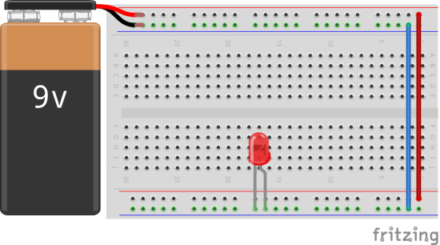
b) | 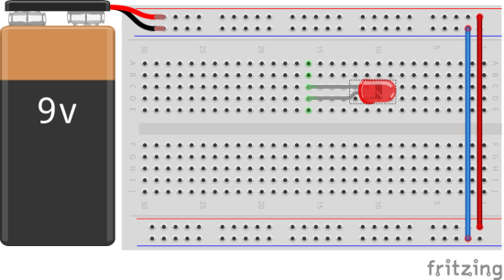
c) | 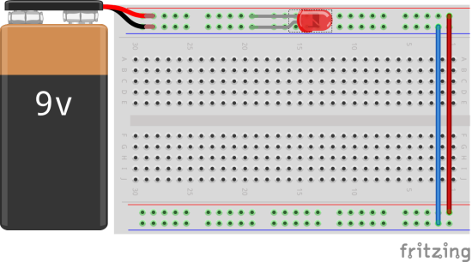
d) | 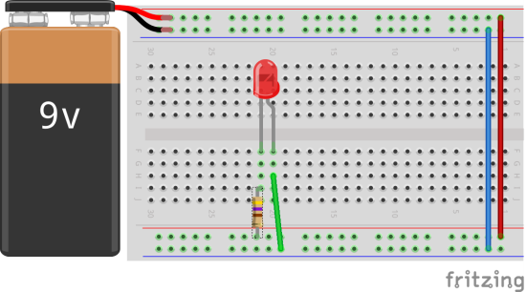
e) | 